Subham Adhikari

Coventry University Student ID Number: 14812262

B.Sc. (Hons.) Computing, Softwarica College of IT and E-commerce, Coventry University

ST5008CEM: Programming for Developers

Shrawan Thakur

March 02, 2025

**1. a) Ans:**

The main goal is to find the minimum number of measurement or attempts to find the critical temperature for the identical materials to change their properties.

**Approach**

To solve this, we use a dynamic programming (dp) approach. We have to determine the optimal plan to minimize the number of measurements/attempts needed to find the critical temperature. We consider the following given condition:

* If the material changes properties at a given temperature, it cannot be used for the further measurement and we cannot go past that temperature level.
* If the material does not change properties, the material can be reused for further tests.

Let **dp[k][n]** is the maximum number of temperatures that can be checked with given **n** temperature levels and **k** identical sample materials to find the critical temperature **f**.

**Algorithm and Steps**

* Initialize a 2D array **dp[k][n]** where **k** represents number of sample materials and **n** represents the number of temperature levels to find the critical temperature **f**.
* Enter a loop until **k** materials is iterated. For each material **k**, iterate for each temperature levels **n**. Make sure to start the iteration from 1, since material and levels cannot be 0.
* Create a **DP** table for the easy understanding. The row represents **n** temperature level and column represents **k** sample materials.
* Inside the nested loop, for each combination of **i** (samples) and **j** (temperature levels) check whether **i** > 1 and **j** > 1. If true then enter a loop which tracks a **cj** current row and **pj** previous row. And if **i** = **j** = 1 then, assign **dp[i][j]** = **j** or **dp[i][j]** = 1 respectively.
* For each possible temperature levels **x** (assumed) from 1 to **j**, calculate the cases:
* If material does not change its property, then use same number of materials and test temperature levels below. Then the number of measurements becomes **value1** = **dp[i][cj]** or **value1** = **dp[i][j-x]**.
* If material changes its property, then use one less material and test temperature levels below. Then the number of measurements becomes **value2** = **dp[i-1][pj]** or **value2** = **dp[i-1] [x-1]**.
* Take the maximum measurements **val** of these two cases to handle the worst-case.
* Find the minimum number of measurements **min** (minimum of maximum measurements **val**) across all possible temperature levels to find the optimal measurement or attempts.
* Populate the table, for each **i** and **j**, set **dp[i][j]** = **min** + 1, where **min** is the minimum worst-case attempts found and extra addition of 1 represents the attempts taken before hand.
* After filling the DP table, the final result is stored in **dp[k][n]**, which gives the minimum measurements required to find the **f** critical temperature with **k** sample materials and **n** temperature levels.

**Dynamic Programming (DP) Table**

|  |  |  |  |  |  |  |  |  |  |  |  |  |
| --- | --- | --- | --- | --- | --- | --- | --- | --- | --- | --- | --- | --- |
| **DP** | **n** temperature levels | | | | | | | | | | | |
| **k** sample materials |  | **0** | **1** | **2** | **3** | **4** | **5** | **6** | **7** | **8** | **9** | **10** |
| **0** | 0 | 0 | 0 | 0 | 0 | 0 | 0 | 0 | 0 | 0 | 0 |
| **1** | 0 | 1 | 2 | 3 | 4 | 5 | 6 | 7 | 8 | 9 | 10 |
| **2** | 0 | 1 | 2 | 2 | 3 | 3 | 3 | 4 | 4 | 4 | 4 |
| **3** | 0 | 1 | 2 | 2 | 3 | 3 | 3 | 3 | 4 | 4 | 4 |
| **4** | 0 | 1 | 2 | 2 | 3 | 3 | 3 | 3 | 4 | 4 | 4 |
| **5** | 0 | 1 | 2 | 2 | 3 | 3 | 3 | 3 | 4 | 4 | 4 |

**Code Implementation**

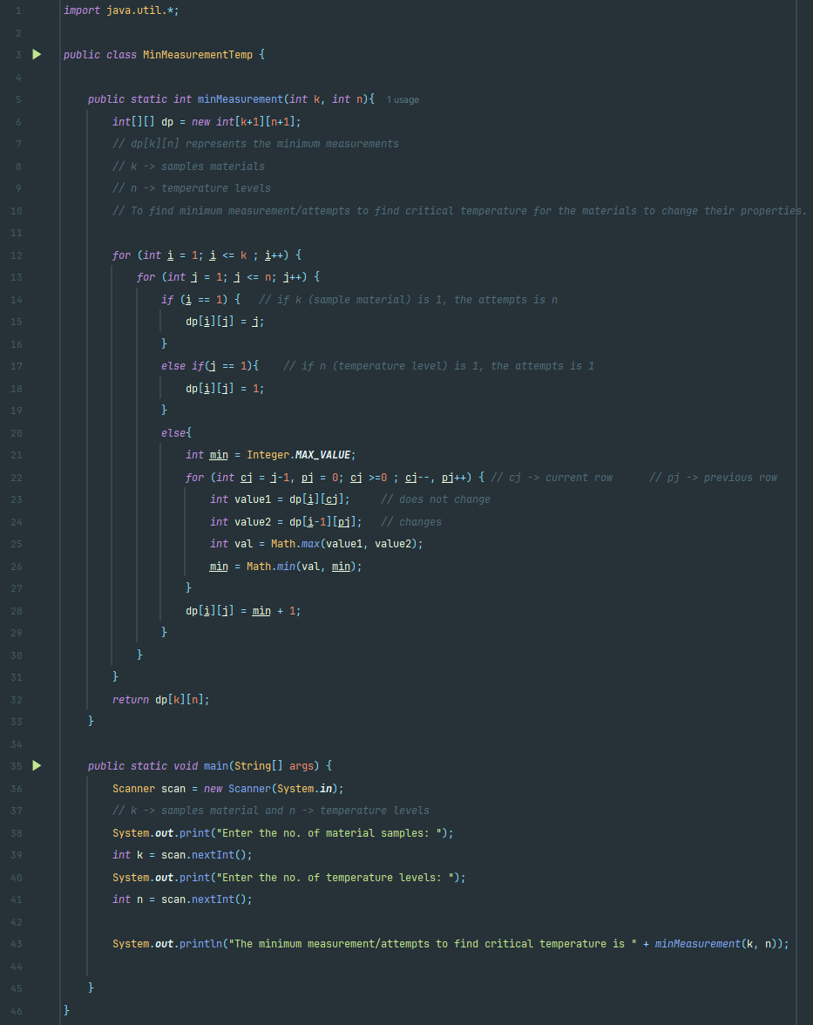

**Example-1**

Input: k = 2, n = 5

Output (no of attempts): 3

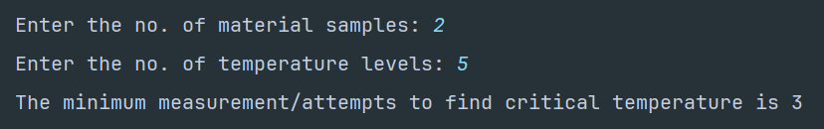

**Example-2**

Input: k = 5, n = 7

Output (no of attempts): 3

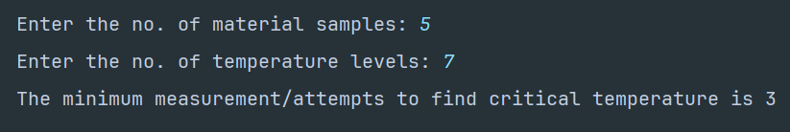

**Example-3**

Input: k = 15, n = 20

Output (no of attempts): 5

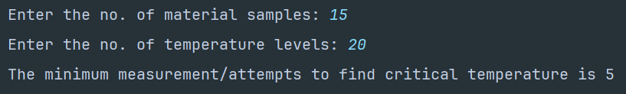

**1. b) Ans:**

The goal is to find the **k**th lowest combined return where we select one element from each of the two sorted arrays and calculating their product.

There are two sorted arrays: **returns1** and **returns2** given to calculate kth smallest combined return from both arrays.

**Approach**

To solve this problem, we can use a Binary Search Tree (BST). The main approach is to

* Insert all the possible combinations into the BST.
* Traverse through nodes in sorted order from smallest product to largest.
* The **k**th node visited during the traversal will give the **k**th lowest combined return.

**Algorithm and Steps**

* Initialize a Binary Search Tree (BST) class **BST** and node class **BSTNode** where **i**, **j** represents indices of **returns1** and **returns2** respectively and **product** represents the product between the indices of **returns1** and **returns2** i.e., **product = returns1[i] * returns2[j]** and **left**, **right** represent child nodes – left and right of BST.
* In **BST** class, define methods **insert()** and **insertRec()** which adds a new node into the BST based on product value. The smaller products go to the left side and larger products go to the right side of the tree.
* Similarly in **BST** class, define another method **kthSmallest(int k)** which performs an in-order traversal by visiting every nodes in increasing order. It uses a counter **count** to track the number of nodes visited. When **count** equals **k**, it records the product of current node.
* In main class, define a method **findKthSmallestProduct()** where it uses nested loops to iterate through all indices **i** from **returns1** and **j** from **returns2**. Insert all possible product combinations into the BST.
* For each pair, compute **product = returns1[i] * returns2[j]** and insert a new **BSTNode(i, j, product)** into the BST. If **product** is smaller, insert into the left subtree and if **product** is larger, insert into the right subtree.
* After building the BST with all possible combinations, an in-order traversal is performed to get the **k**th smallest product return. In-order traversal approach:
* Traverse the left subtree.
* Visit the current node and increment a count.
* If count equals **k**, store the product of node.
* Traverse the right subtree.
* The **k**th visited node in in-order traversal holds the **k**th smallest product.
* The product at the **k**th lowest product return which is based on sorted order is returned as the output.

**Time and Space Complexity Analysis**

1. Time Complexity:

* To build BST:
* There is **m * n** possible products where **m = returns1.length**, **n = returns2.length**.
* Each insertion into the BST takes **O(log(m * n))** in the worst case.
* Total BST insertions take **O(m * n log(m * n))**.
* To find the kth smallest product, in-order traversal takes O(k) time to reach the kth node.

Total Time Complexity in the worst case: **O(m * n log(m * n) + k) ≈ O(m * n log(m * n))**.

1. Space Complexity:

* To store BST in the memory, it takes up to **O(m * n)** nodes in all product pairs.
* The recursive stack for in-order traversal requires **O(m * n)** space in worst case.

**Code Implementation**

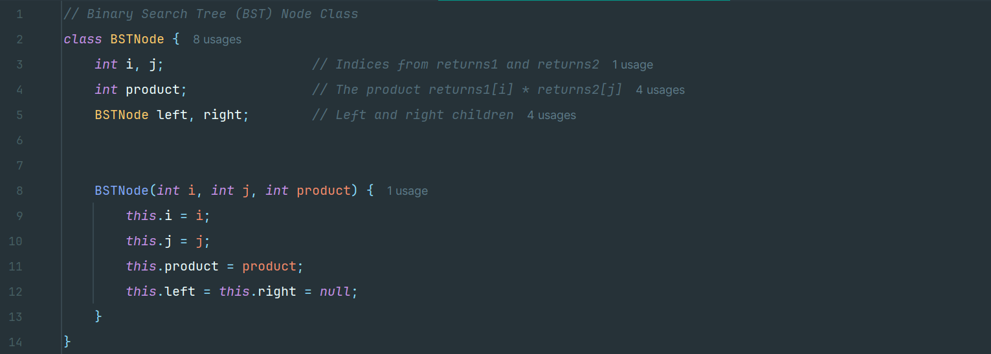

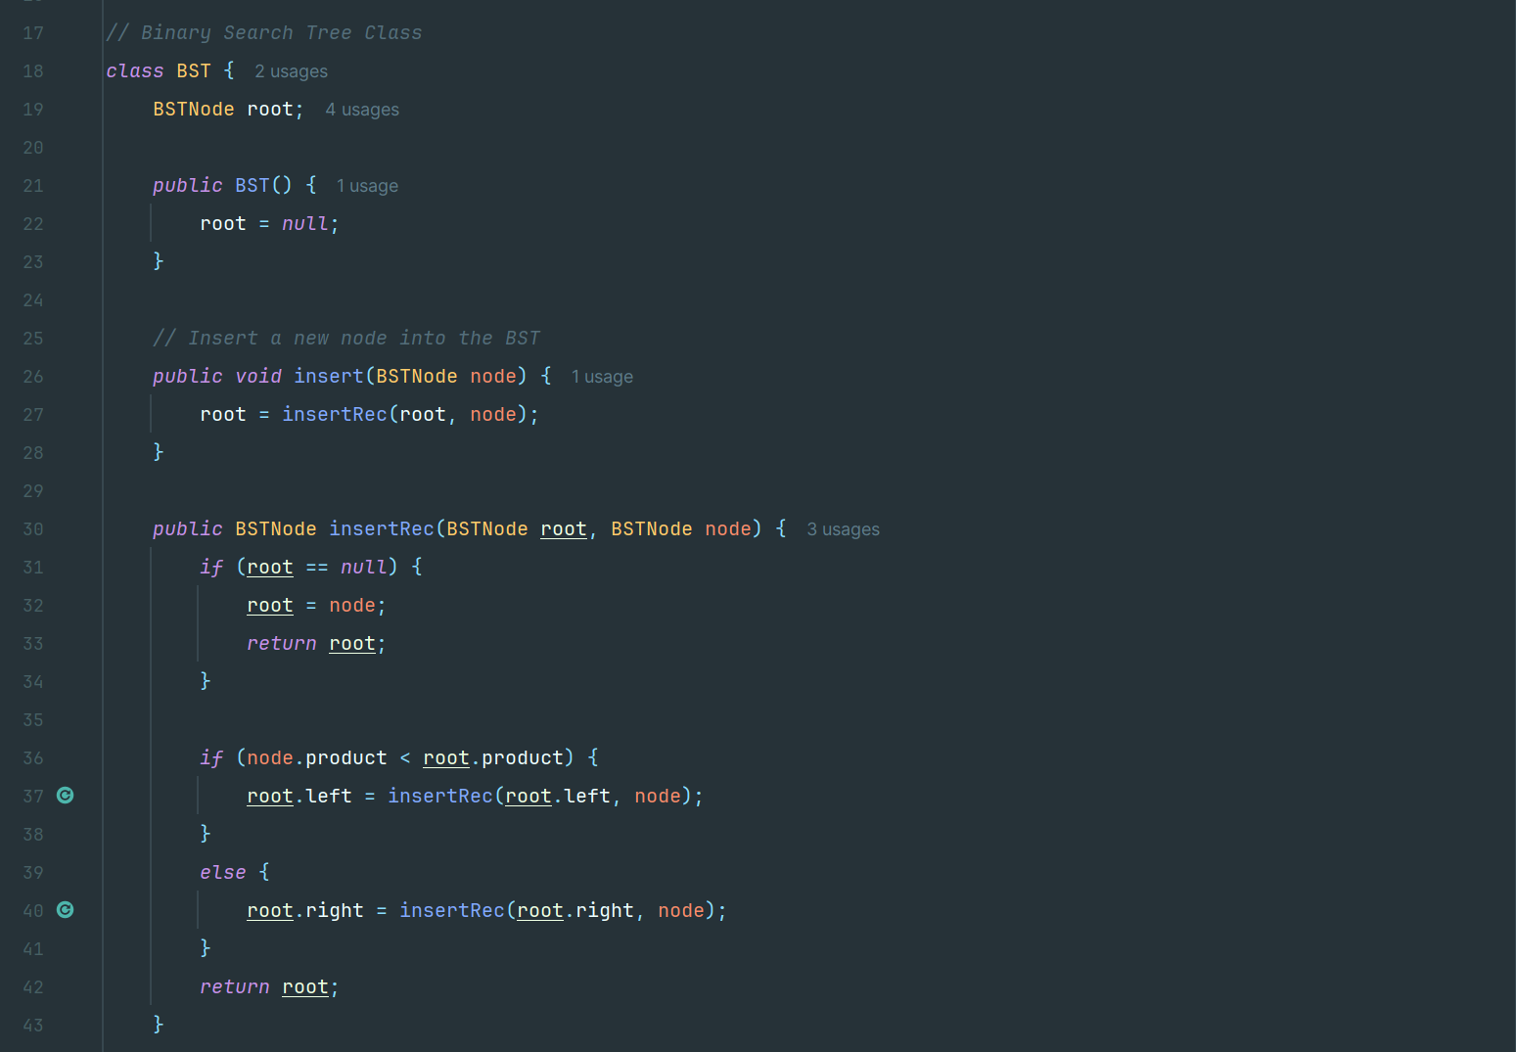

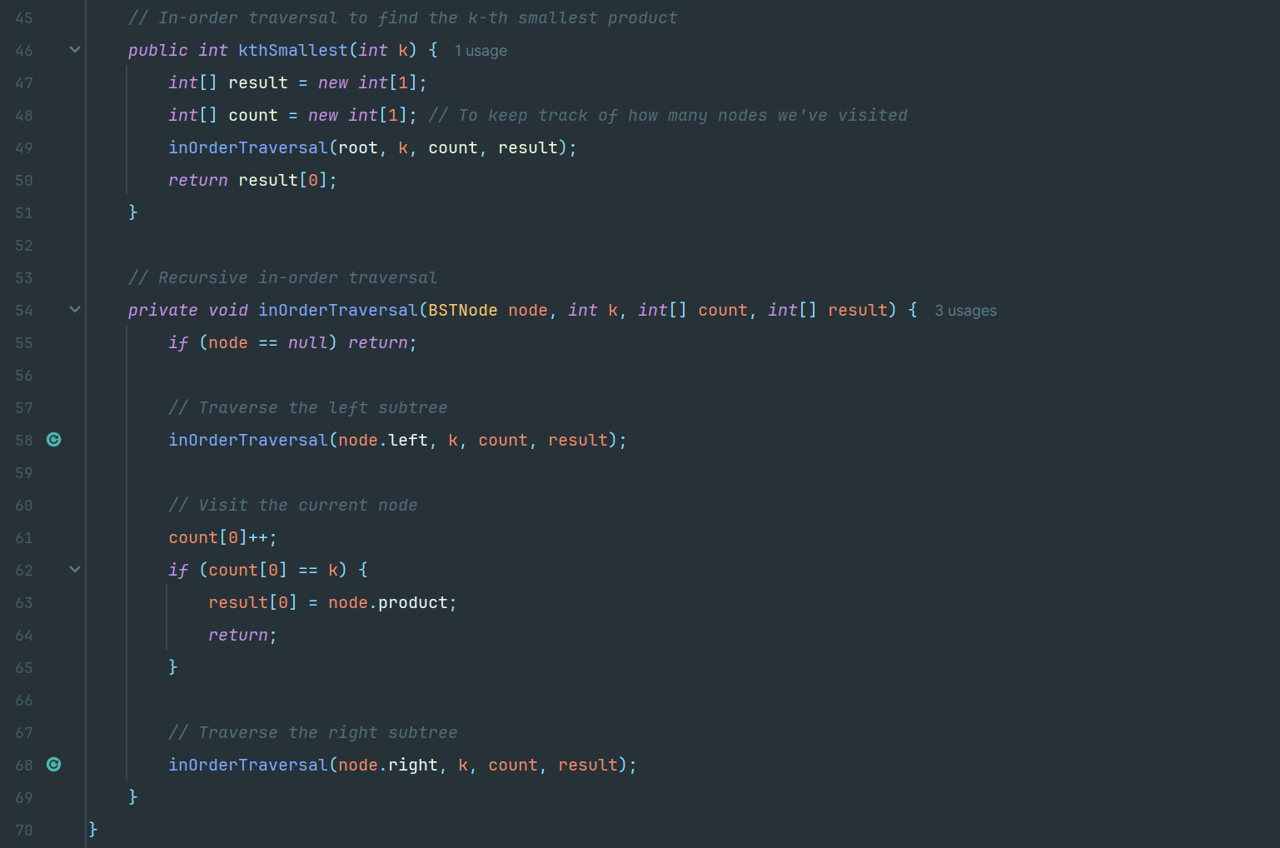

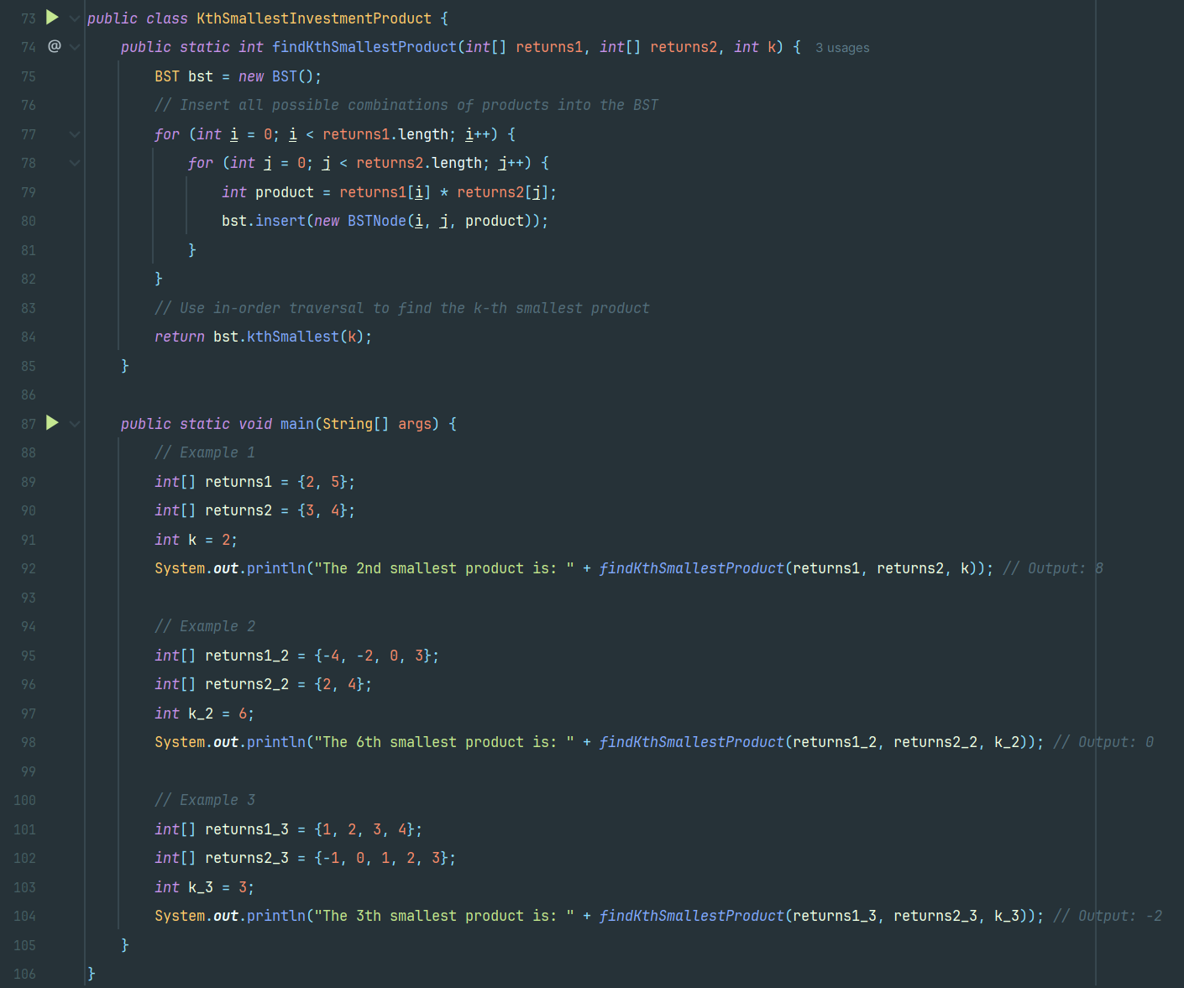

**Example-1**

Input: returns1 = {2, 5}, returns2 = {3, 4}, k = 2

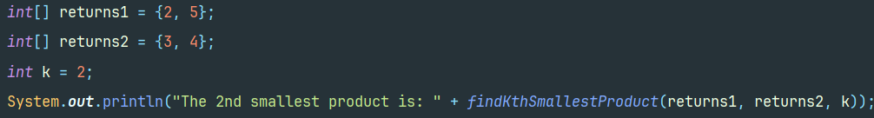

Output:8

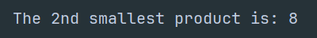

**Example-2**

Input: returns1 = {-4, -2, 0, 3}. returns2 = {2, 4}, k = 6

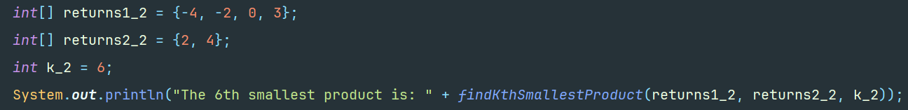

Output: 0

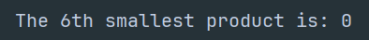

**Example-3**

Input: returns1= {1000, 200, 3000, 400, 2500}, returns2= {1000, 100, 3500, 2000, 500}, k = 5

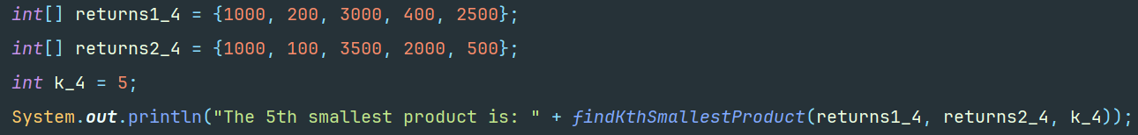

Output: 200000



**2. a) Ans:**

The goal is to assign the minimum number of rewards to a team of **n** employees where each employee is given at least one reward and the employees with a high-performance rating more rewards than other employees.

There is given an integer array rating: **ratings**

**Approach**

In this, the two-pass greedy approach is used. We assume an array **ratings** such that the rating of each employee is stored.

* Left-to-Right Pass:

If the rating of an employee is higher than the previous employee, they receive one more reward than the previous employee.

* Right-to-Left Pass:

If the rating of an employee is higher than the next employee, they receive at least one more reward than the next employee.

The two-pass greedy method ensures that both left and right conditions are satisfied.

**Algorithm and Steps**

* Define a method **calculateMinRewards()** which takes a integer array **ratings** as parameter. First the validation of array **ratings** is checked i.e.,
* If **ratings** null or empty, return 0.
* If the length of **ratings** is equal to, return 1.
* Inside this method, initialize an integer array **rewards** of length **n** which represent rewards received by employees and number of employees respectively.
* Start a left to right pass iteration which iterates through each employee from **1** to **n-1** and checks whether **ratings[i] > ratings[i - 1]** then sets **rewards[i] = rewards[i - 1] + 1**. This ensures that any employee with a higher rating than the previous one receives one more reward.
* Similarly, Start a right to less pass iteration which iterates through each employee from **n-2** down to **0** and checks whether **ratings[i] > ratings[i + 1]** then sets **rewards[i] = Math.max(rewards[i], rewards[i + 1] + 1)**. This ensures that employee with a higher rating than the next one receives at least one more reward than that neighbor.
* Then, sum up all values in the rewards array to find the total minimum rewards needed. Finally, the output is returned.

**Time and Space Complexity Analysis**

1. Time Complexity:

* The iteration through array takes **O(n)** in worst case where **n** is the number of employees.

1. Space Complexity:

* The space used by an array of size **n** to store rewards is **O(n)** in worst case.

**Code Implementation**

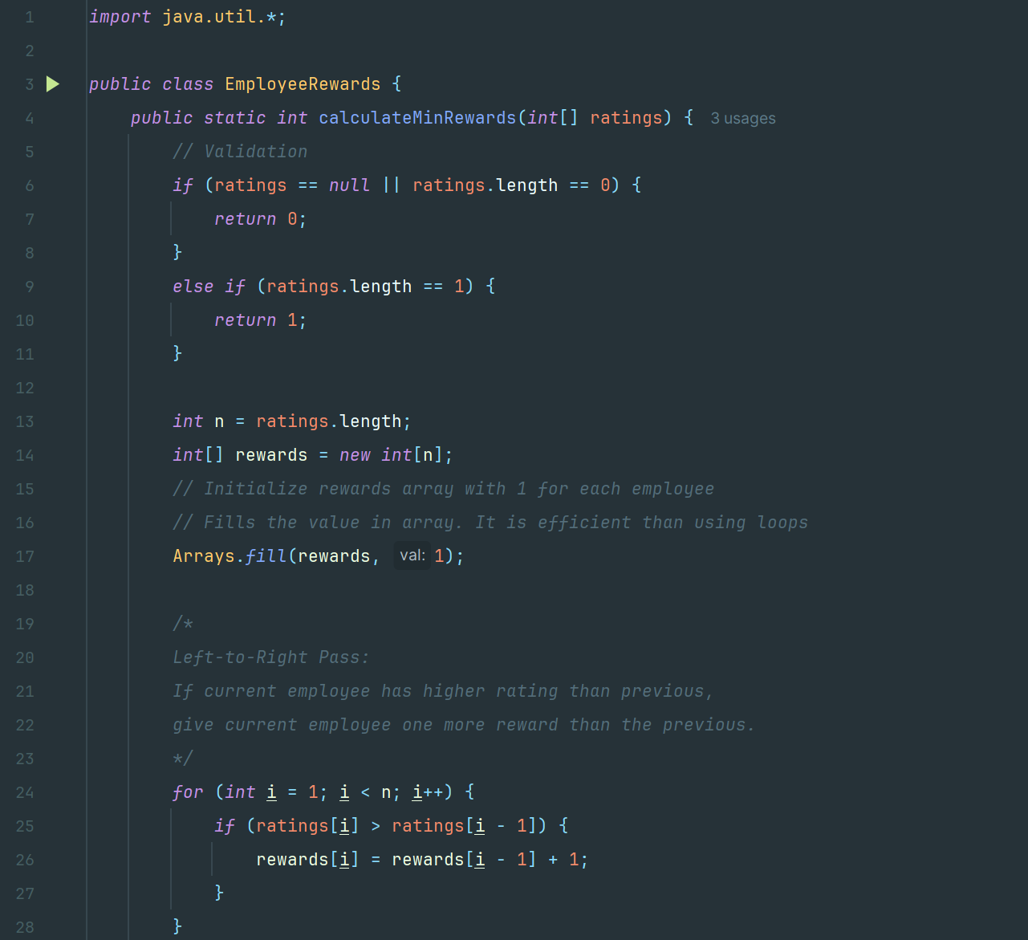

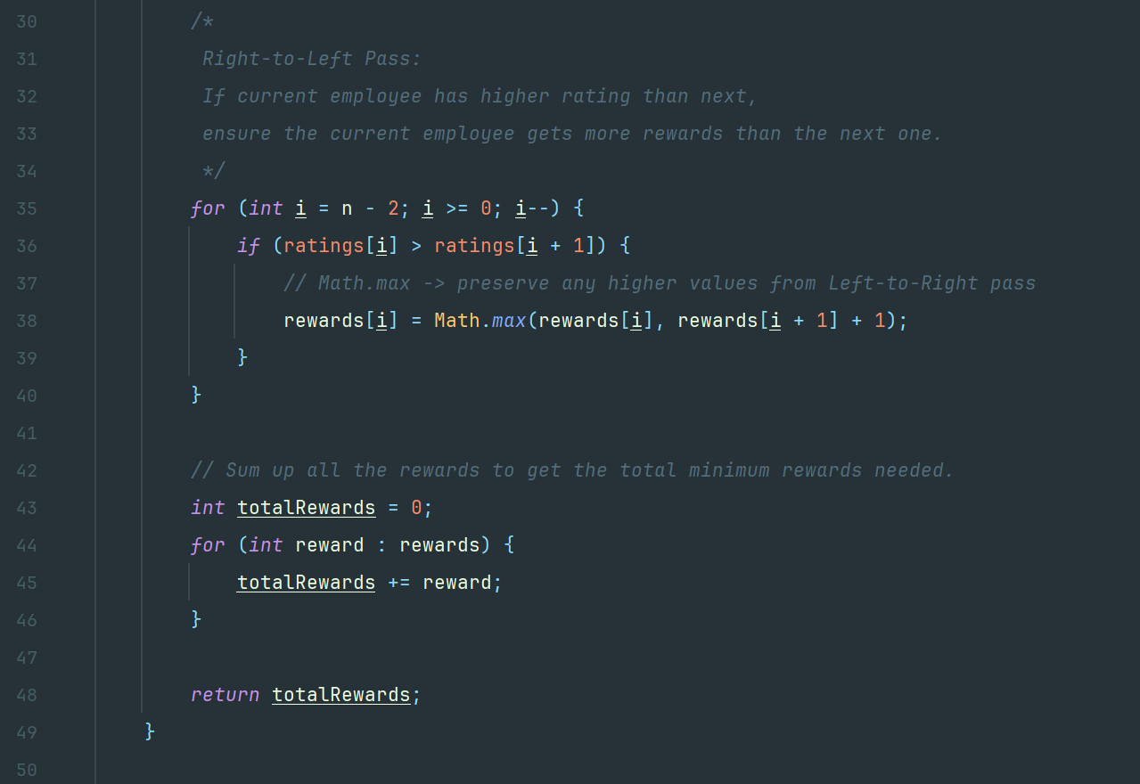

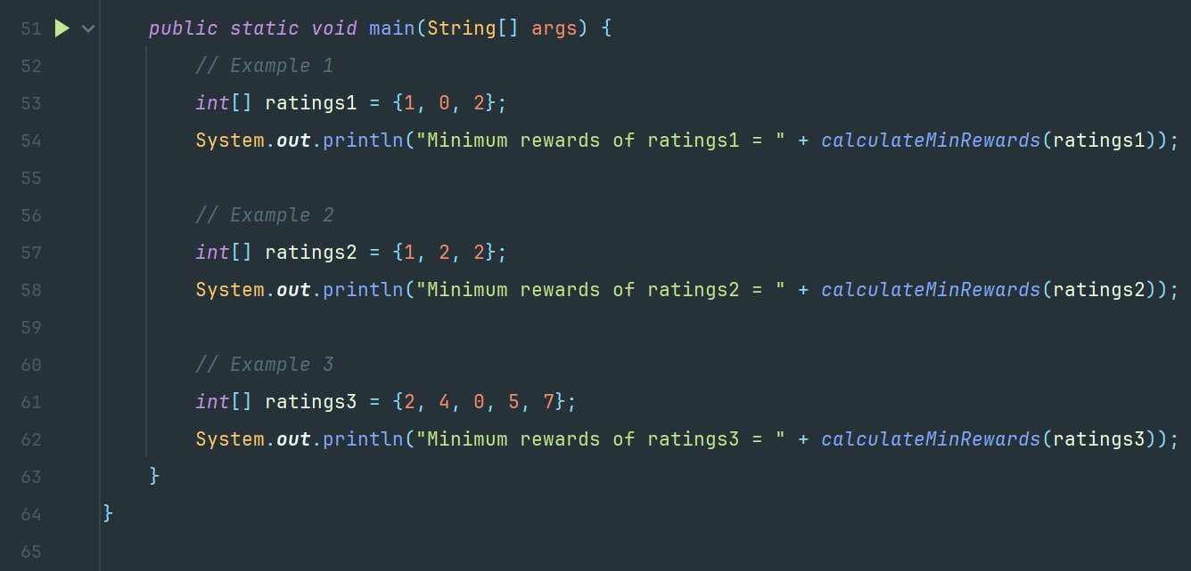

**Example-1**

Input: ratings = {1, 0, 2}

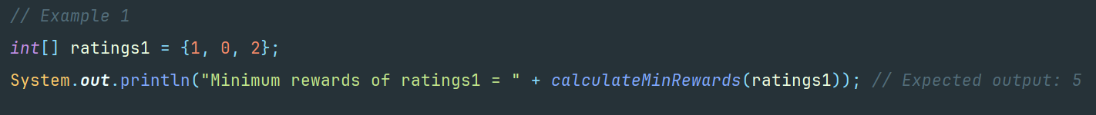

Output: 5



**Example-2**

Input: ratings = {1, 2, 2}



Output: 4



**Example-2**

Input: ratings = {2, 4, 0, 5, 7}



Output: 9



**2. b) Ans:**

The main goal is to find out the lexicographically close pair of points with the smallest distance where smallest distance is calculated using:

**| x_coords [i] - x_coords [j]| + | y_coords [i] - y_coords [j]|**

where **x_coords** and **y_coords** represent array of x-coordinates and y-coordinates of the points respectively.

**Approach**

In this problem, we apply Brute-force because this approach directly computes distances and is optimal for small to moderate points. It iterates through all pairs **(i, j)** with **i < j**, compute their distance and track the pair with the smallest distance. If multiple pairs have the same distance, then it selects the lexicographically smallest one.

**Algorithm and Steps**

* Declare a method **findClosestPair()** inside initialize variables **minDistance** to a large value **Integer.MAX_VALUE**, **bestI** and **bestJ** to store the indices of the best (closest) pair.
* Start a nested iteration that iterates over all the pairs **(i, j)** with **i < j**. The outer loop runs from **i=0** to **n-1** and inner loop from **j=i+1** to **n-1**.
* For each iteration in the nested loop, the distance is calculated i.e.

**distance = Math.abs(x_coords[i] - x_coords[j]) + Math.abs(y_coords[i] - y_coords[j])**

* Similarly, check the conditions in each iteration:
* If **distance < minDistance**, then update **minDistance=distance** and set **bestI = i**, **bestJ = j**.
* If **distance == minDistance**, check lexicographical order i.e., if **i<bestI** or **i==bestI** and **j<bestJ**, update **bestI=i** and **bestJ=j**.
* After checking all pairs, return the array pair **[bestI, bestJ]** as the result.

**Time and Space Complexity**

1. Time Complexity:

* The nested loops to compare every pair through two arrays co-ordinates takes **O(n2)** in worst case where **n** is the length of array co-ordinates.

1. Space Complexity:

* The space used is **O(1)** in worst case.

**Code Implementation**

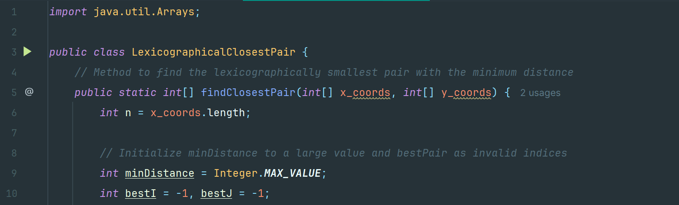

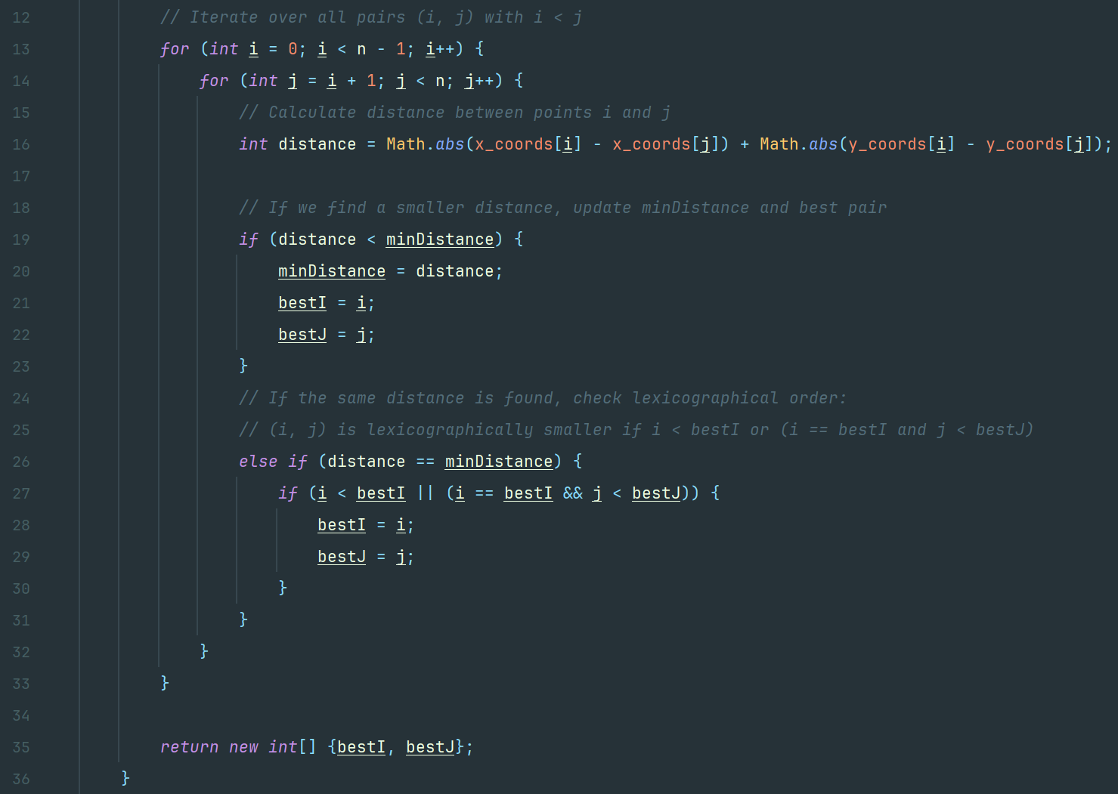

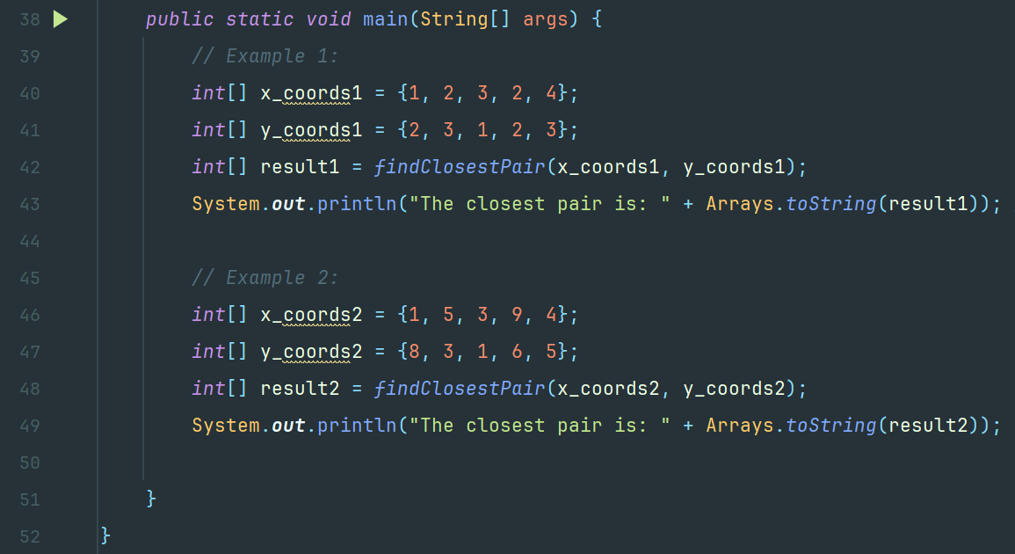

**Example-1**

Input: x_coords = {1, 2, 3, 2, 4}, y_coords= {2, 3, 1, 2, 3}

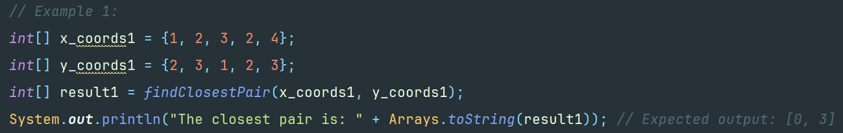

Output: result = [1, 3]

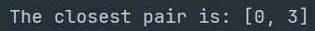

**Example-2**

Input: x_coords = {1, 5, 3, 9, 4}, y_coords= {8, 3, 1, 6, 5}

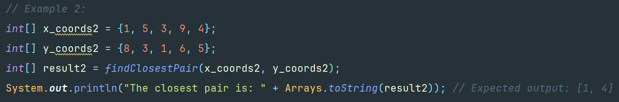

Output: result = [1, 4]

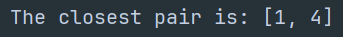

**3. a) Ans:**

The goal is to find the minimum total cost to connect **n** devices in the network where each device can either install a communication module at a given cost which is specified by the **modules** array or be connected using a direct connection which is specified in **connections** where **connections[j] = [device1j, device2j, costj]** which represents the cost to connect devices **device1j and device2j**.

**Approach**

For this problem, we assume a Minimum Spanning Tree (MST) problem on an augmented graph.

* Add a special virtual node (node 0) which represents module installation.
* For each device **i**, add an edge from the virtual node to device **i** with weight **modules[i]**.
* Add the given bidirectional connections as edges between devices.

We use Kruskal’s algorithm to build an MST that connects all nodes (the virtual node and all devices) at the minimum total cost and Disjoint Set Union (DSU) structure the algorithm.

**Algorithm and Steps**

* Define classes **Edge** represents an edge in the graph with endpoints u, v and a connection cost and **DSU** to perform efficient union-find operations in Kruskal's algorithm.
* Declare a method in main class **minCostToConnect()** where the minimum total cost is calculated to connect all devices using an MST approach.
* Start a loop such that for each device **i** from 1 to **n**, add an edge between the virtual node (node 0) and device **i**. The cost of this edge is the module installation cost given in **modules[i-1]**.
* Similarly, for each connection provided (an array like [u, v, cost]), add an edge between device **u** and device **v** with the given cost. The connections should be bidirectional.
* Sort all edges in ascending order of cost to ensure we pick the lowest cost edges first.
* Initialize a **DSU** to manage which devices are connected.
* Start an iteration through sorted edges where for each **DSU** edge, check whether the two nodes are in different sets. If they are not connected i.e., adding the edge does not create a cycle, then add the cost of edge to the total cost and merge the two sets. Stop when **n** edges are added where edges connect **n+1** nodes.
* Return the **totalCost** as minimum total cost required all the devices.

**Time and Space Complexity**

1. Time Complexity:

* The nested loops to compare every pair through two arrays co-ordinates takes **O(n2)** in worst case where **n** is the length of array co-ordinates.
* To build graph, it took **O(v + e)** where **v=n+1** and **e** is the total number of edges (the virtual node and the provided connections).
* To sort edges, it took **O(e log e)**.
* The Kruskal’s Algorithm took **O(e log e)**.

Overall time complexity is **O(e log e)** in worst where **e** is the number of edges.

1. Space Complexity:

* The space used to store graph which is edges list is **O(e)**.
* The space used by DSU is **O(v)**.

Overall space complexity is **O(v + e)** in worst case where v = n+1 and e is the number of edges.

**Code Implementation**

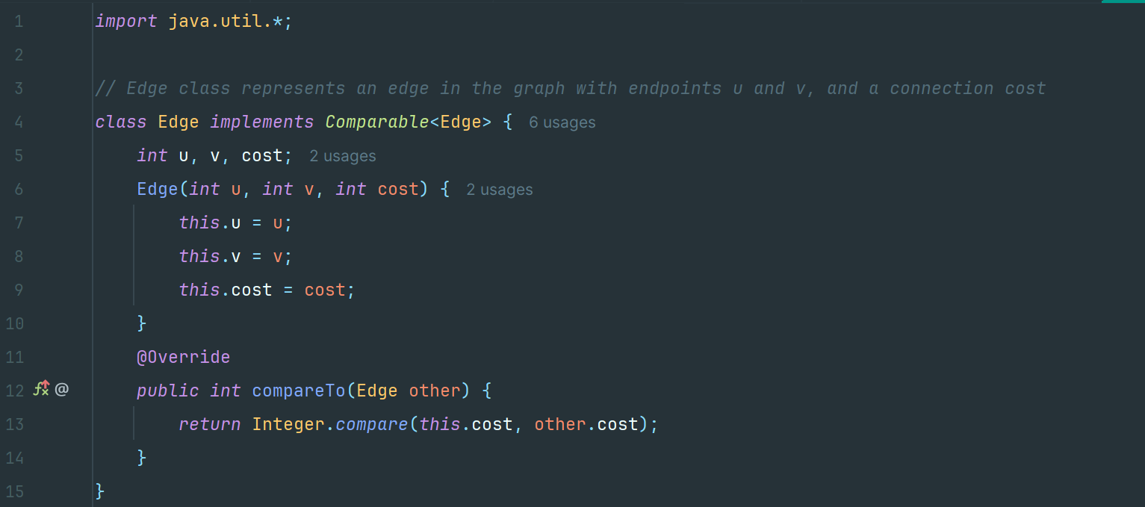

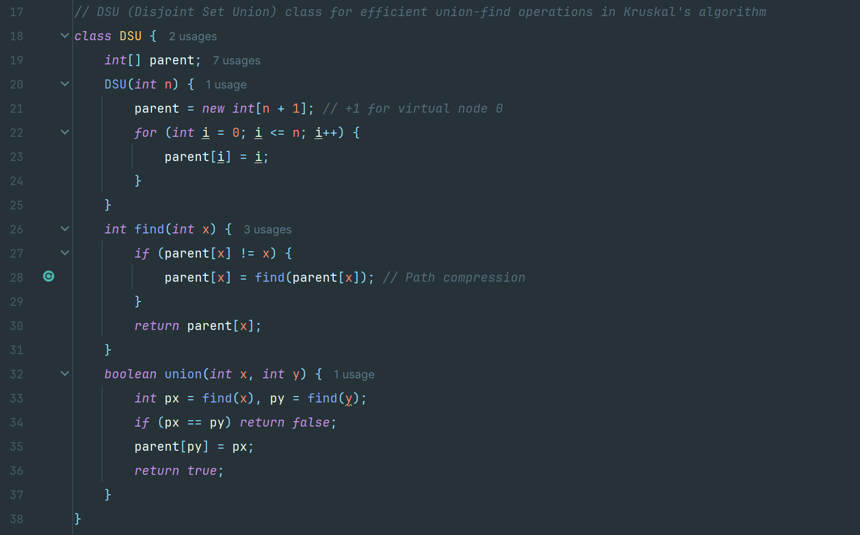

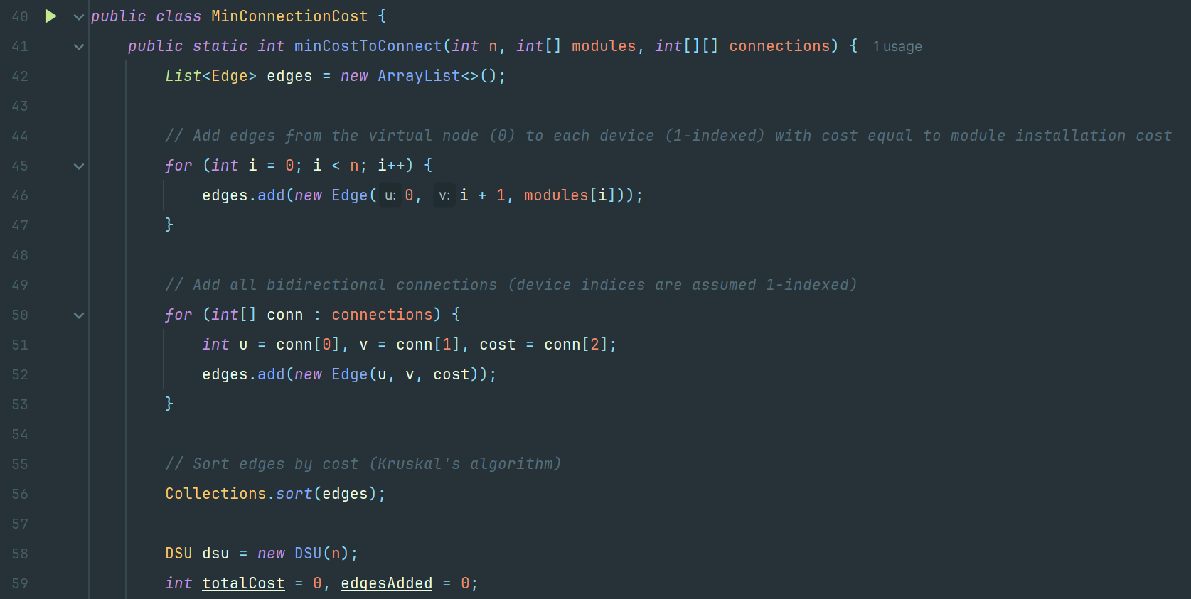

**Example-1**

Input: n = 3, modules = {1, 2, 3}, connections = {{1, 2, 1}, {2, 3, 1}}

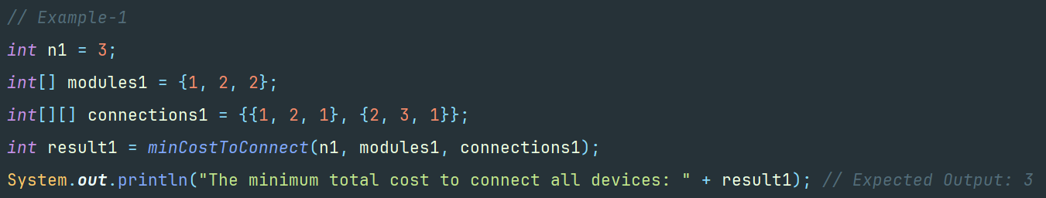

Output: 3



**Example-2**

Input: n = 4, modules = {2, 3, 1, 4}, connections = {{1, 2, 1}, {1, 3, 3}, {2, 4, 2}, {3, 4, 4}}

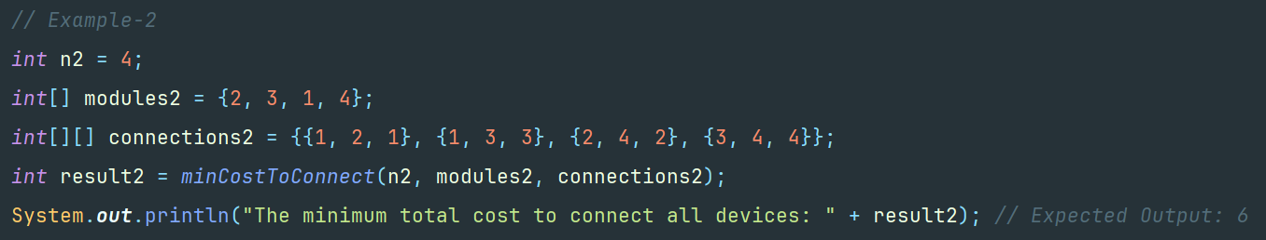

Output: 6

**Example-3**

Input: n = 1, modules = {5}, connections = {}

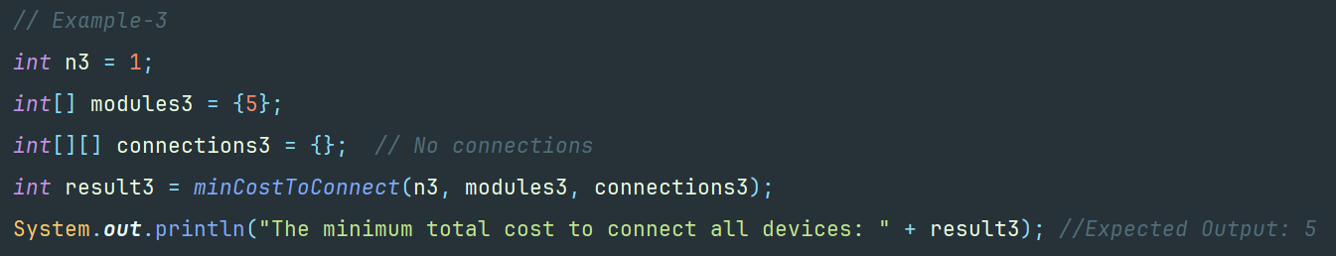

Output: 5



**3. b) Ans:**

The goal is to create a Tetris Game using queue **pieceQueue** to store the sequence of the falling blocks and stack **boardStack** to represent the current state of the game board like a matrix.

**Approach**

The solution uses simple data structures to model Tetris. A queue is used to store the falling tetris block pieces **pieceQueue** so that the game can easily display a preview of the next piece. A stack (implemented as a list of rows and columns) **boardStack** is the game board, where each row is an array of fixed length. The game loop is driven by a timer: on each tick, the current piece moves down; if it can't move down any longer (due to collision with the board or other blocks), it is locked into position down at bottom, full rows are cleared (which raises the score and level), and a new piece is spawned. Mouse (on‑screen image buttons) and keyboard (arrow keys and "**R**" for restart) controls are included to move, rotate, and drop pieces. A game‑over animation displaying a pulsating, fading "**GAME OVER**" message and a prompt to restart the game is triggered when a piece cannot be spawned because the top row is full.

**Algorithm and Steps**

1. Initialization:

* The board **boardStack** is initialized as an empty stack of rows, each row an integer arrays the size of the width of the board (composed of 10 cells), where there are 20 rows making a board. The value for each cell in the board is initialized to 0, meaning they are all empty.
* A queue **pieceQueue** is initialized to hold the pieces that are falling. Some (let's say three) random tetris block pieces are initialized and enqueued. The top of the queue is dequeued to form the currently falling tetris block.
* The main game panel (showing the board), a side panel for score, level, and next piece preview and buttons (with onboard graphics) for left, right, rotate and drop actions are initialized.
* Then the keyboard key bindings are established for keyboard key presses (**LEFT**, **RIGHT**, **UP**, **DOWN**, **R**) and mouse buttons that perform the same control methods.

1. Game Loop:

* Try to move the current piece one cell down. If the move is feasible (no collision), move to that position. If not (collided), freeze the piece by copying its matrix onto the board.
* Check for each row from bottom to top: if any row is complete (i.e., contains no zeros), remove that row from the board and add a new blank row on top. Add in the score by increasing (lines cleared × **100** × current level) and increase the level based on the new score.
* Take the next tetris block from the queue into the current piece. Enqueue a new random piece. Repaint the preview panel such that the next block is always displayed.
* Should the new piece already contact the board (the top row is filled), the start of the game over sequence will then be triggered.

1. Game Over & Reset

* The main game timer stops when the game ends, and an animation timer begins running with a pulsating effect on "**GAME OVER**" text and a transition from transparency (alpha) to scale. The game board has its semi-transparent overlay announcing "**GAME OVER**", with "Press **R** to restart."
* Will generate an instant reset of the game with the score, level, and the piece queue reinitialized. Press "**R**" to clear the board and begin the main game timer again.

1. User Input Handling

* Left and right arrow key move the piece left and right, respectively, up arrow key rotates the piece, down arrow key drops the piece to the bottom instantly. Pressing R will restart the game as soon as it ends.
* On-screen buttons (implemented as custom image buttons) in the side panel also call the same control methods.

**Time and Space Complexity**

1. Time Complexity:

* Each collision detection, motion, and locking operations are on a small tetris block matrix (of constant size) and the board has fixed dimensions (20 x 10). Therefore each update tick runs in **O(1)** time.
* Checking through the board for complete rows is **O(BOARD_HEIGHT × BOARD_WIDTH)**, habitually constant because **BOARD_HEIGHT and BOARD_WIDTH** are fixed.

Overall: Each tick of the game loop is **O(1)** time, which means the total time spent by the update in-between ticks is **O(1)**. In n ticks, this gives **O(n)**, which is likely to work in practice given the fixed board size.

1. Space Complexity:

* The board uses a fixed amount of space - 20 rows x 10 columns, giving **O(1)** space.
* The queue stores a constant number of tetris block pieces - for example, 3-giving **O(1)**.
* Other game state variables (score, level, timers, etc.) use constant space.

Overall: In terms of board and game state sizes, the space complexity is **O(1)**.

**Code Implementation**

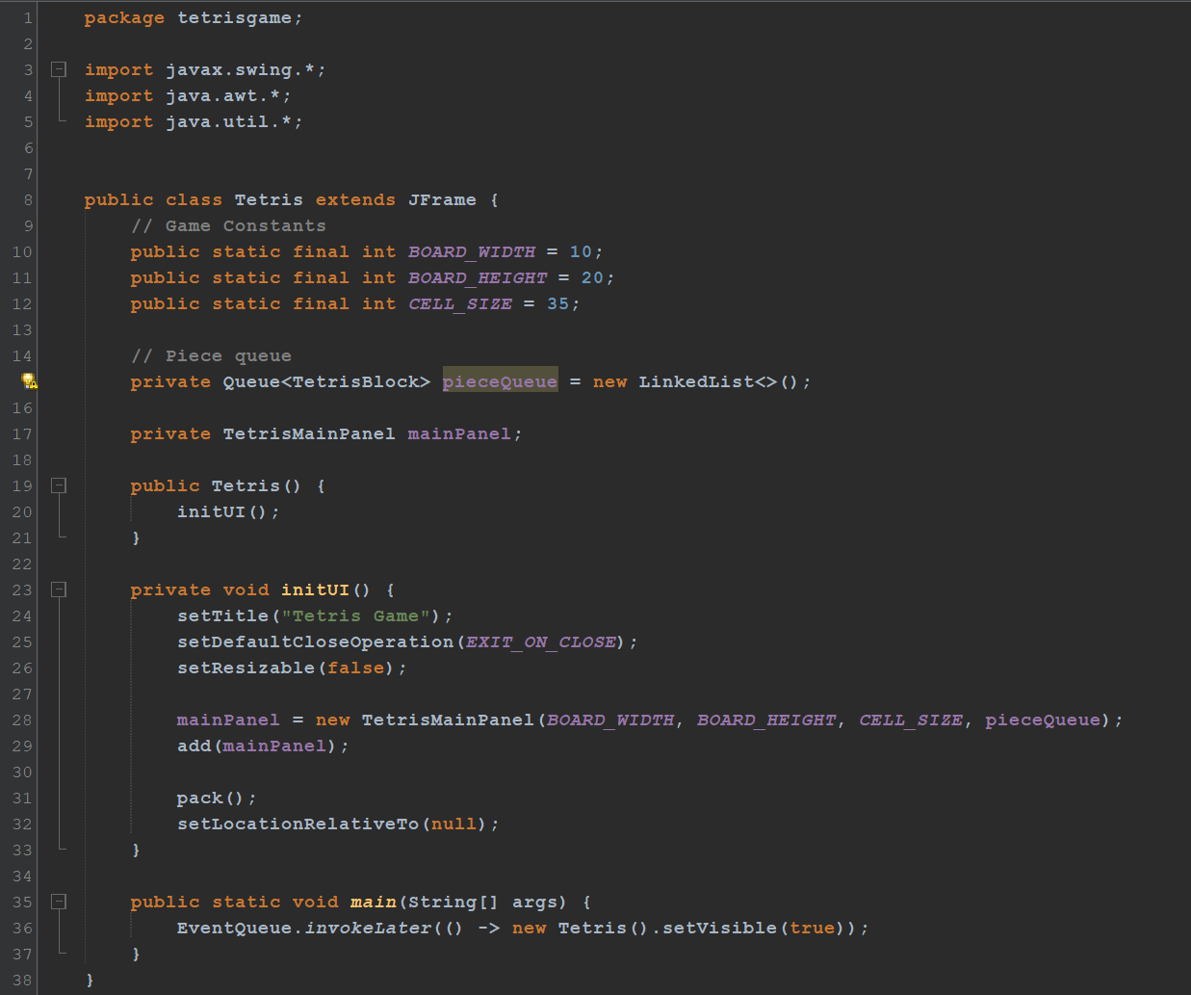

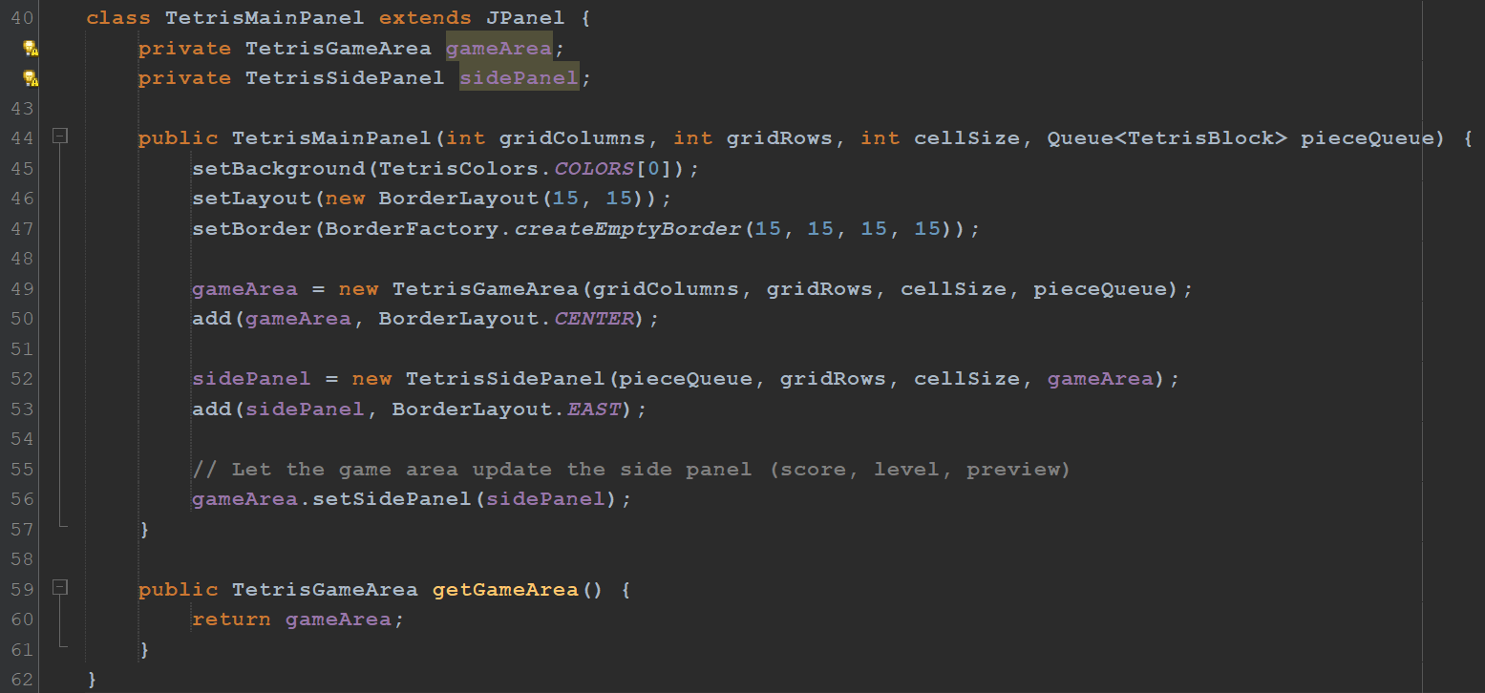

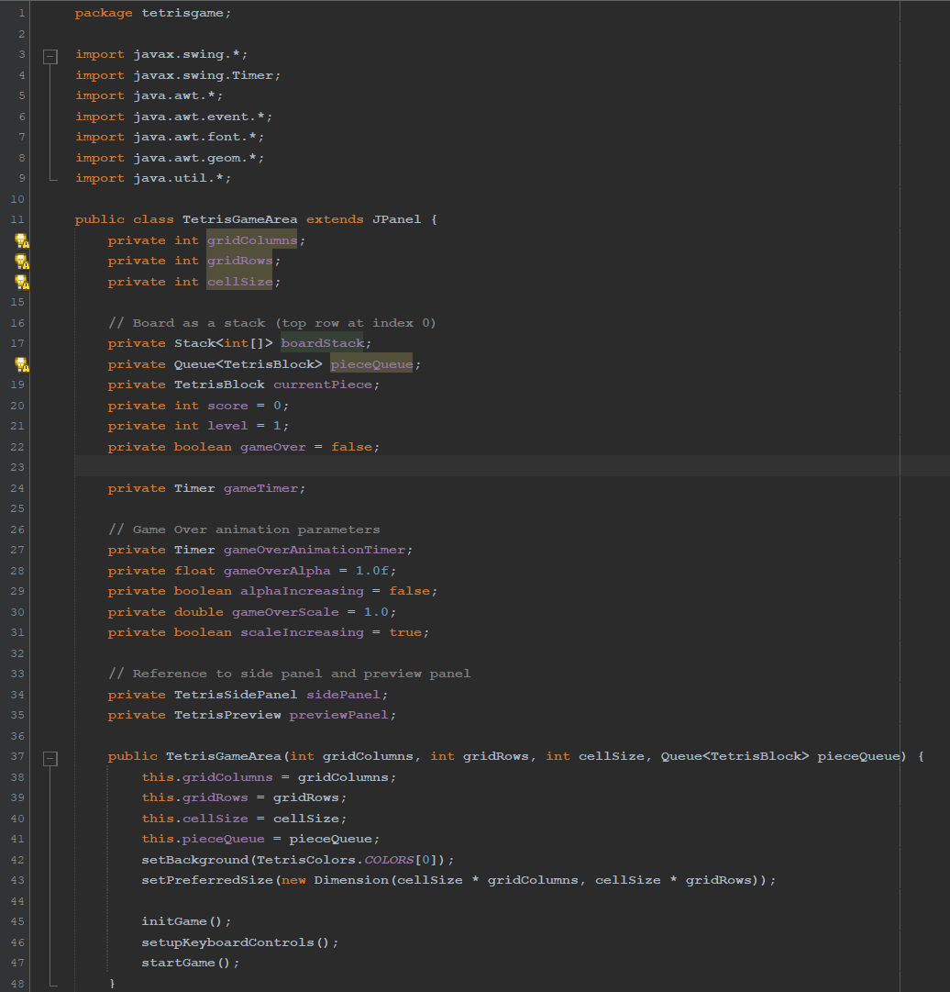

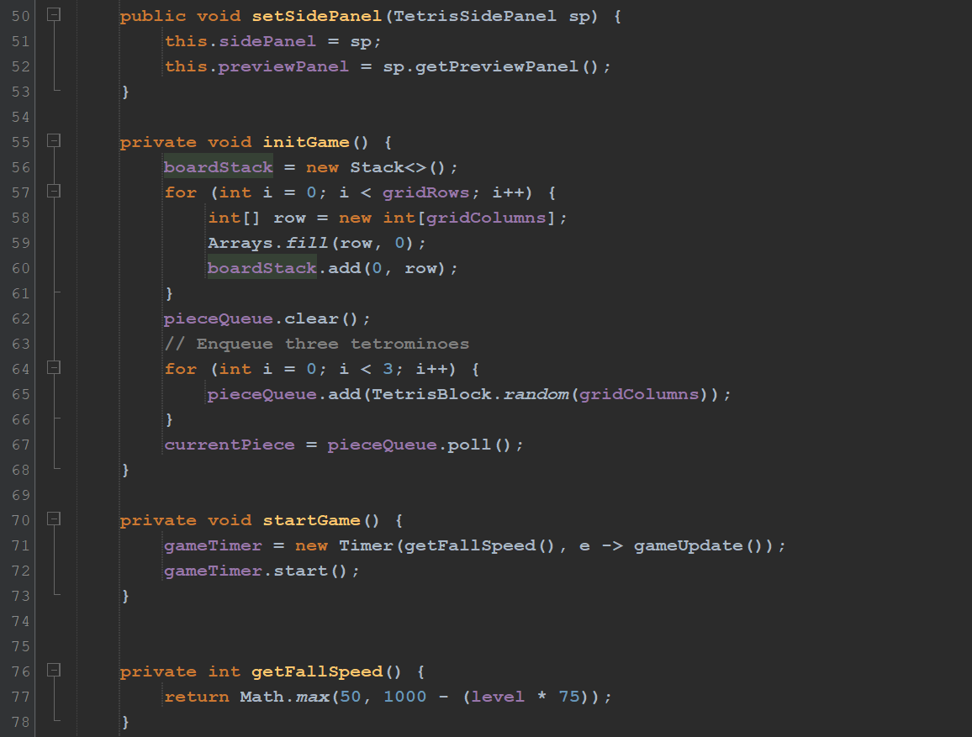

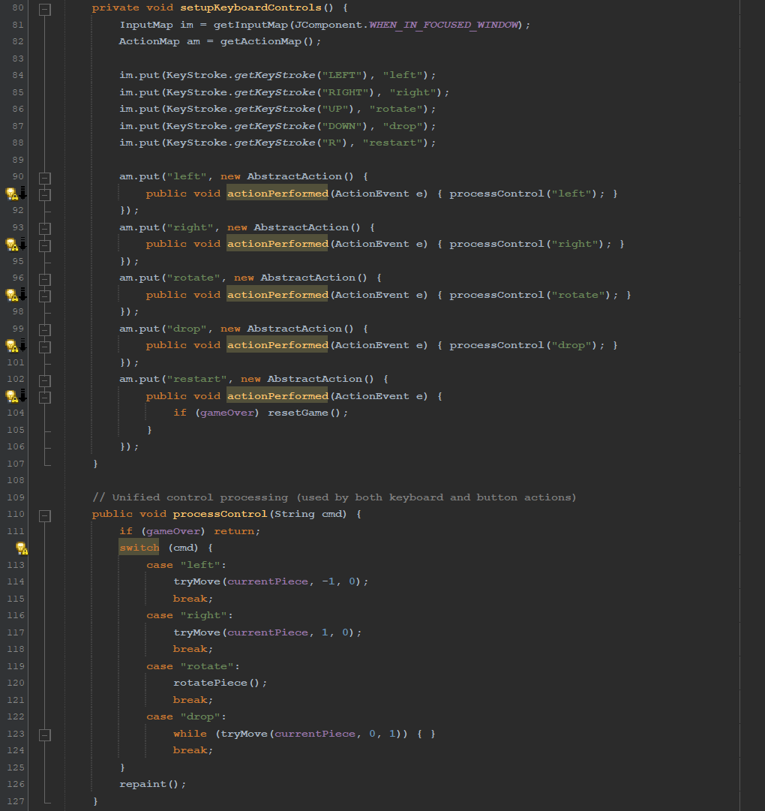

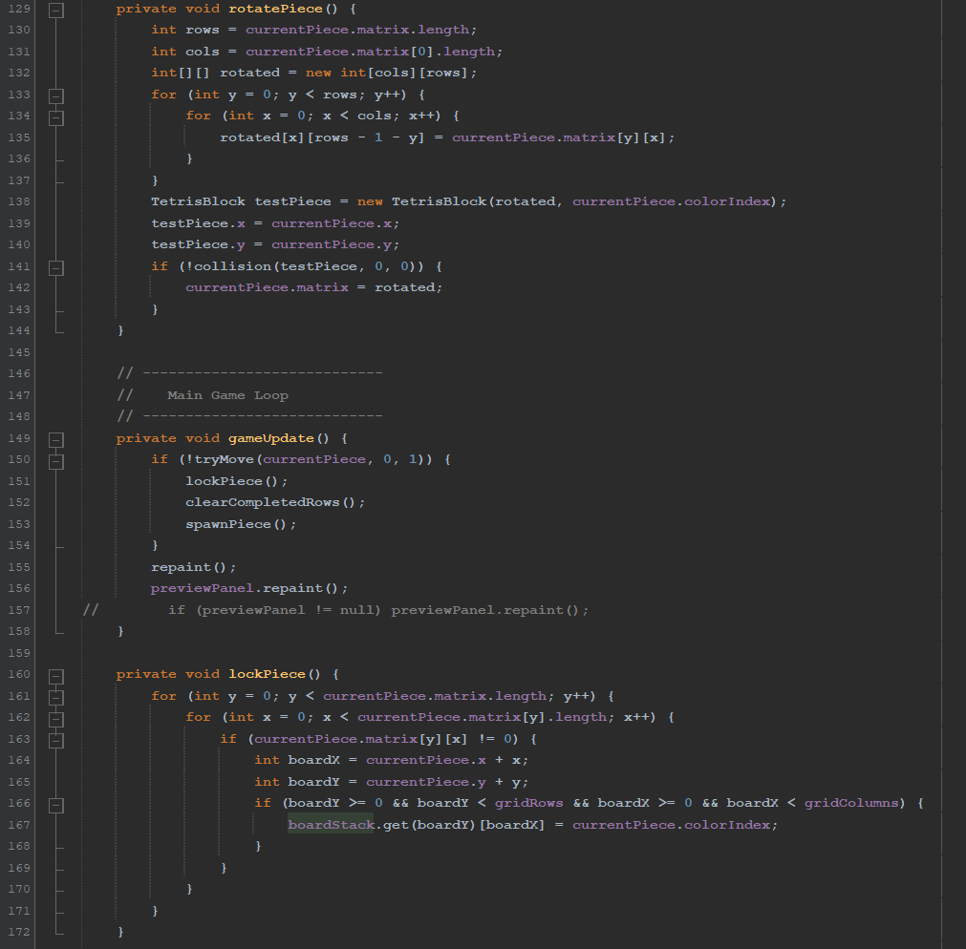

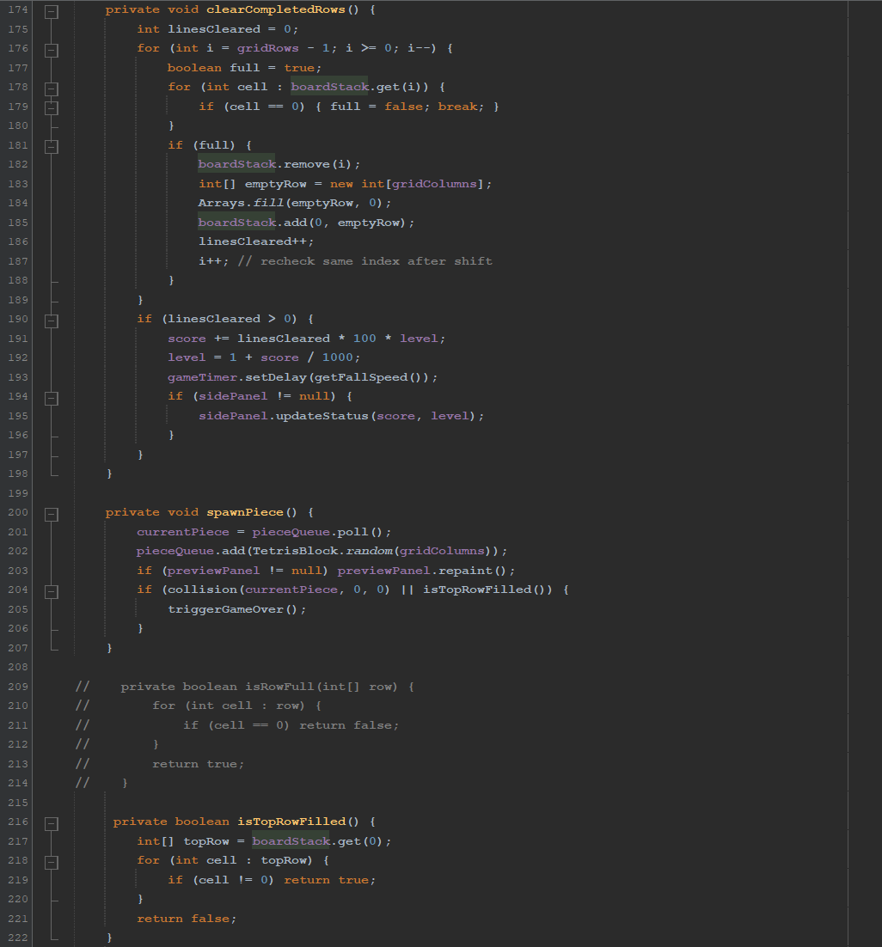

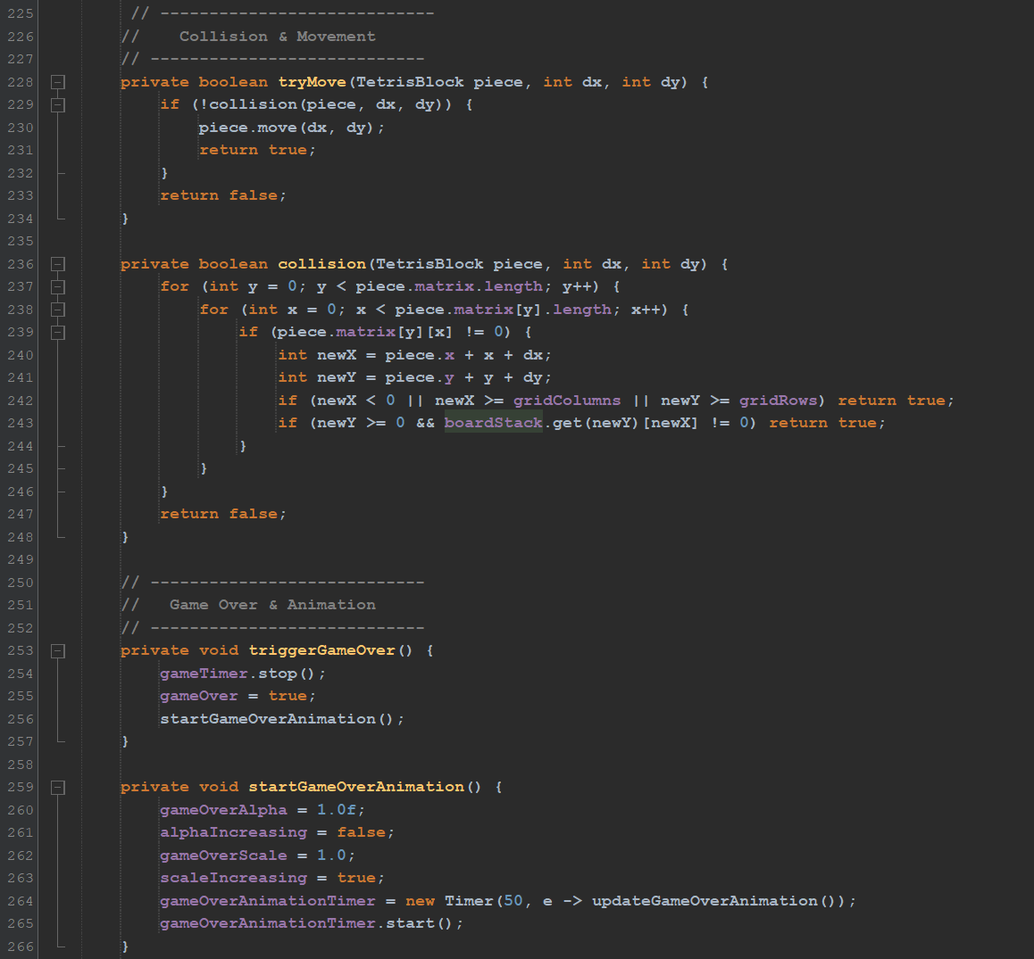

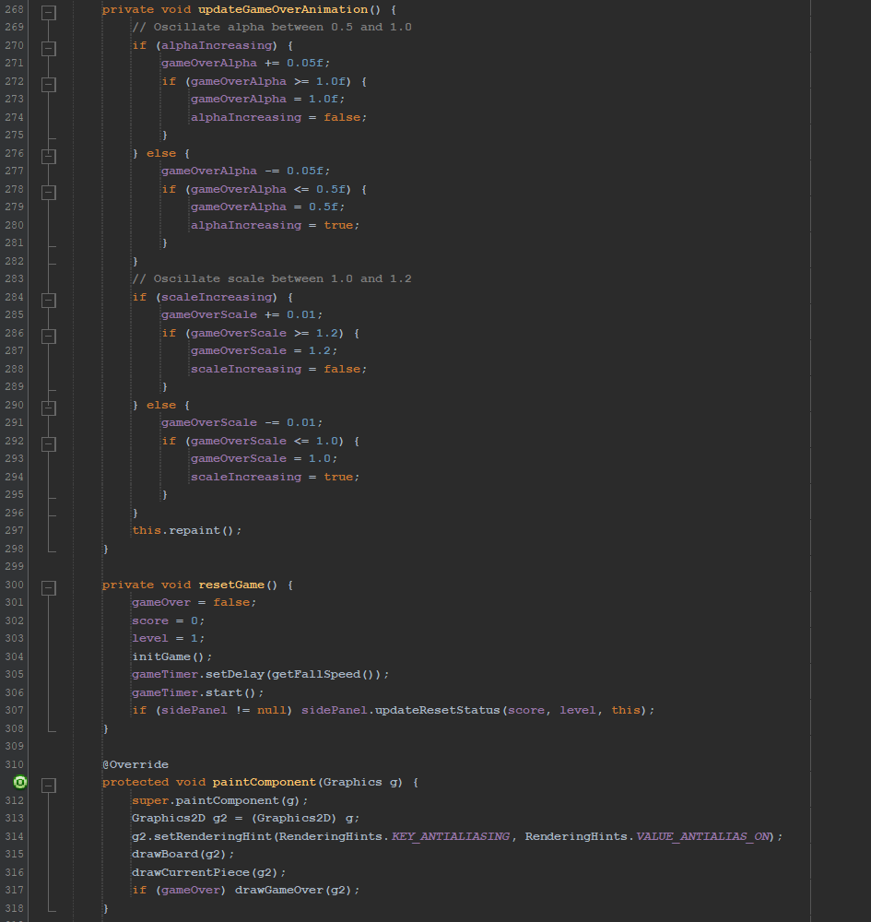

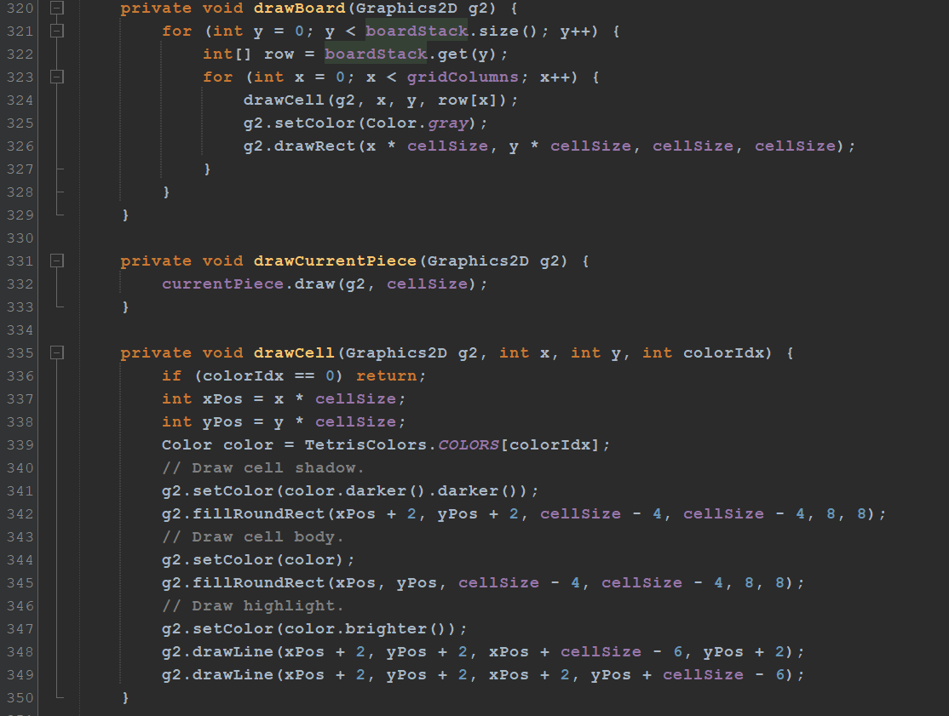

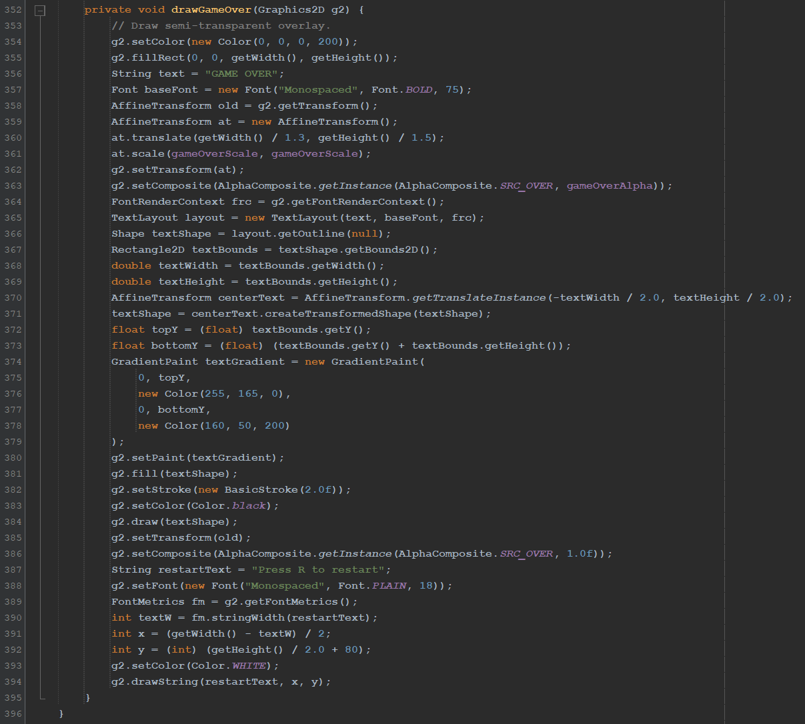

**Output**

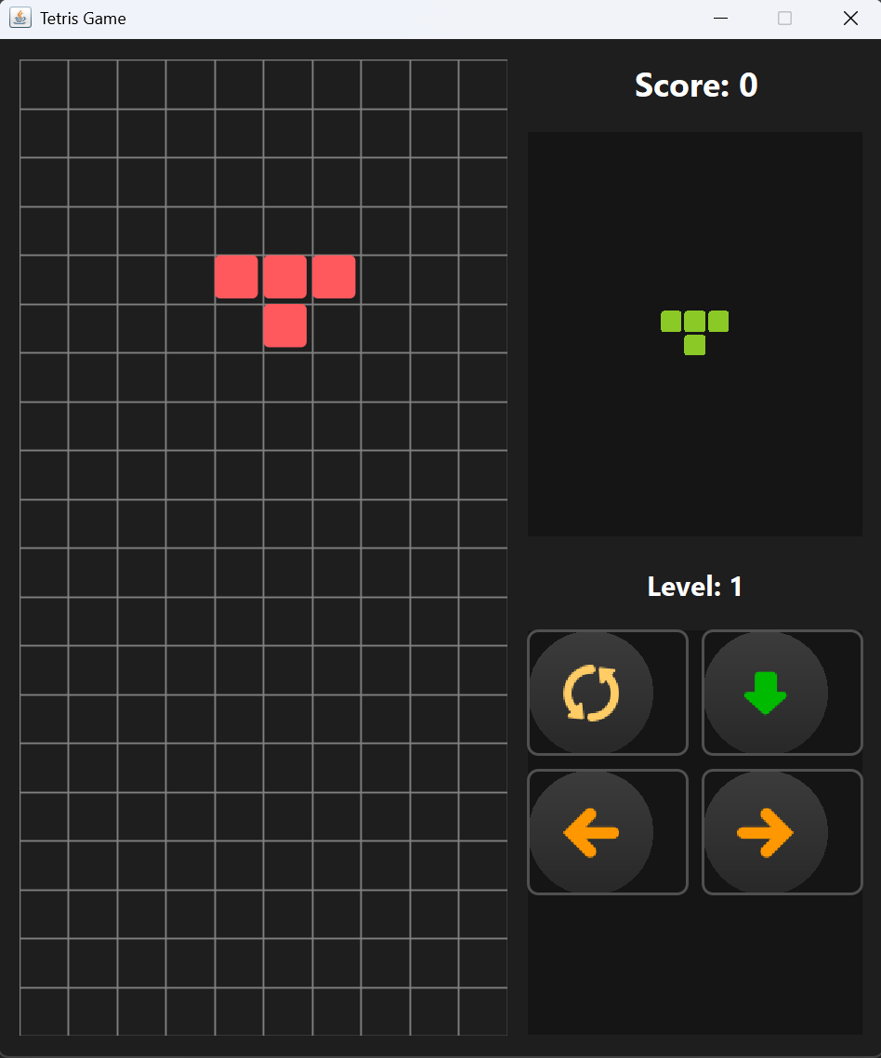

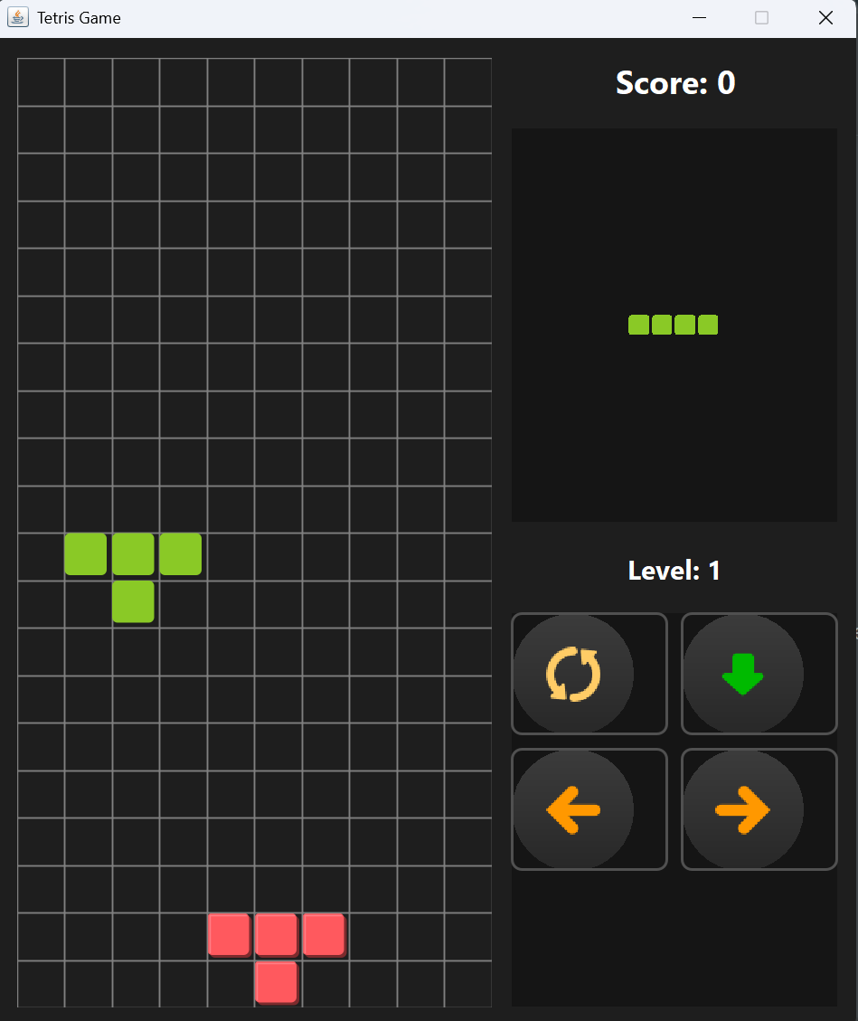

**4. a) Ans:**

The main goal is to return the result table ordered by count of hashtag which is in descending order. An input data (in table) is passed with **userId**, **tweetId**, **tweetDate**, **tweetText** where **userId** and **tweetId** are primary keys which uniquely identify the user and tweet respectively.

**Approach**

To solve this, we use file handling to persist auto-incrementing primary keys i.e., userId and tweetId so that every new tweet gets a unique ID even when the program restarts. Each tweet is represented by a **Tweet** object that extracts hashtags from its text. The program then prints the tweets in a table and computes the top 3 trending hashtags for February 2024 by counting every hashtag occurrence. When two hashtags have the same count, they are sorted alphabetically in ascending order.

**Algorithm and Steps**

* Initialization a class **PrimaryKeyGenerator** which reads from a file ("ids.txt") that contains two lines in the format "userId: <value>" and "tweetId: <value>". If the file exists, it initializes the counters from it. Otherwise, it starts with 0.
* Start a loop where each time a new **Tweet** is created, the generator returns the next available userId and tweetId, increments the counters and updates the file.
* Initialize a class **Tweet**. When a **Tweet** object is created, it uses the **PrimaryKeyGenerator** to get unique IDs.
* Declare a **printInputTable()** method which formats and prints each tweet along with its details (IDs, text, hashtags, and date) in an table.
* Declare a method **findTopTrendingHashtags()** which performs:
* It filters the tweets to only those dated in February 2024.
* It then counts every occurrence of each hashtag with duplicates ones using a HashMap.
* The hashtags are sorted by count in descending order. if two hashtags have the same count, they are sorted alphabetically in ascending order.
* Hashtags with maximum count are returned.
* Finally, the top 3 trending hashtags and their counts are printed in another output table.

**Time and Space Complexity**

1. Time Complexity:

* For **PrimaryKeyGenerator**, reading and writing the file is constant time (**O(1)**) since the file is very small.
* For **Tweet**, extracting hashtags from a tweet takes O(m), where m is the length of the tweet.
* For **findTopTrendingHashtags**:
* Filtering and counting hashtags over n tweets takes **O(n * m)** time in the worst case.
* Sorting the unique hashtags takes **O(k log k)**, where **k** is the number of unique hashtags.

Overall time complexity is **O(n * m + k log k)** in worst case.

1. Space Complexity:

* The tweet objects and their extracted hashtags require **O(n * m)** space.
* The counting HashMap uses **O(k)** space.

Overall space complexity is **O(n * m + k)** in worst case.

**Code Implementation**

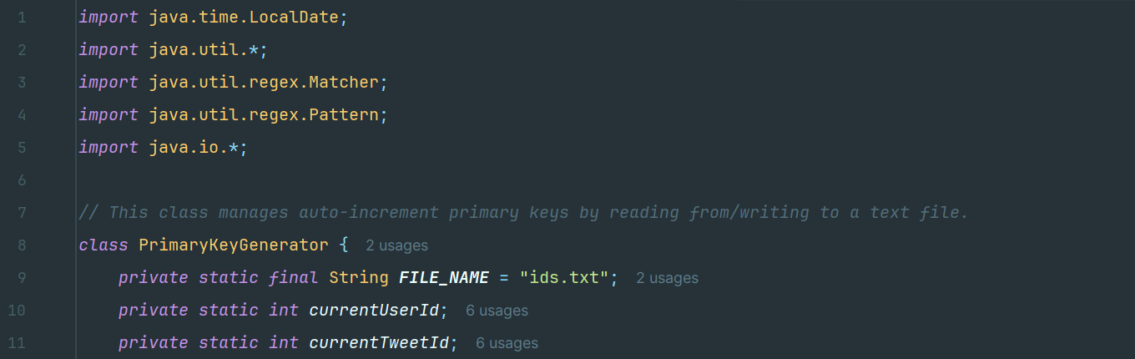

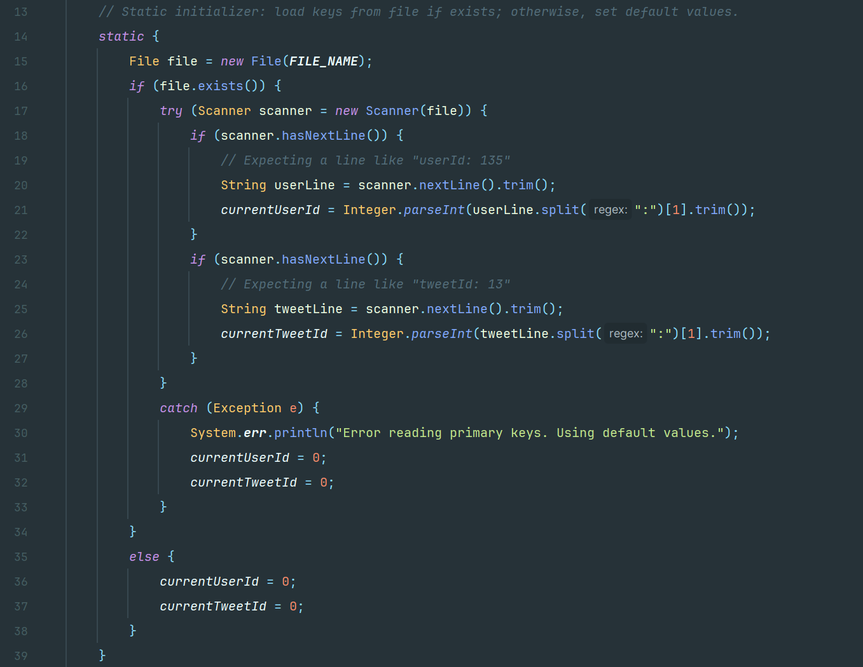

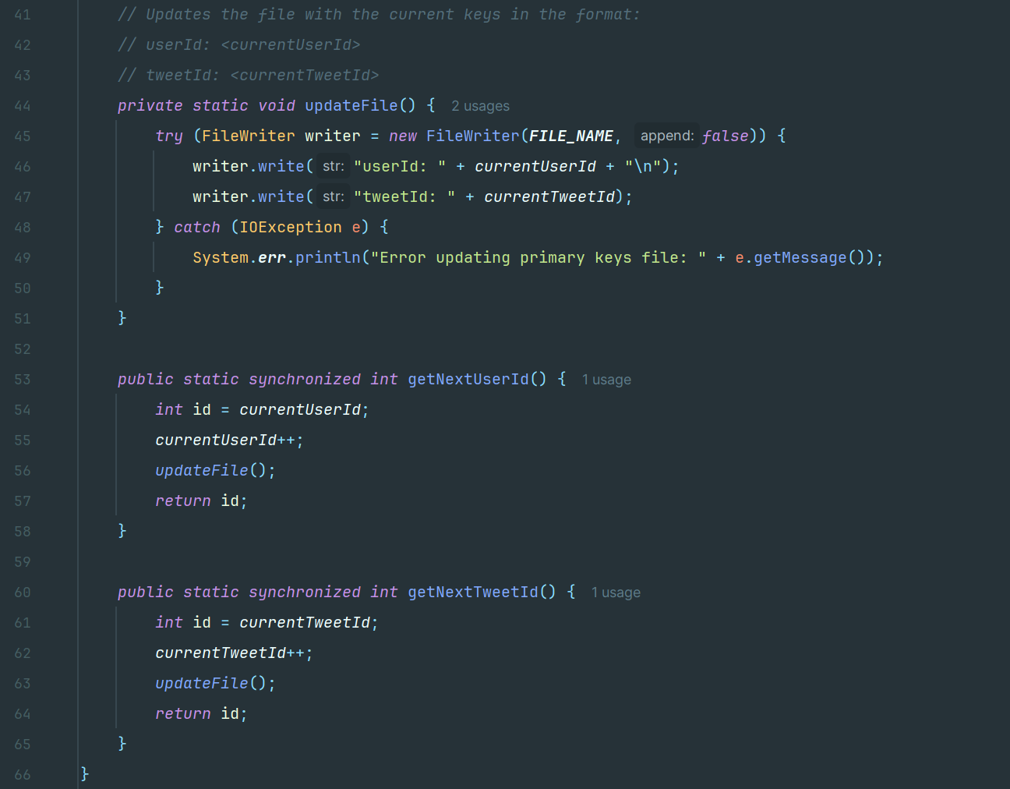

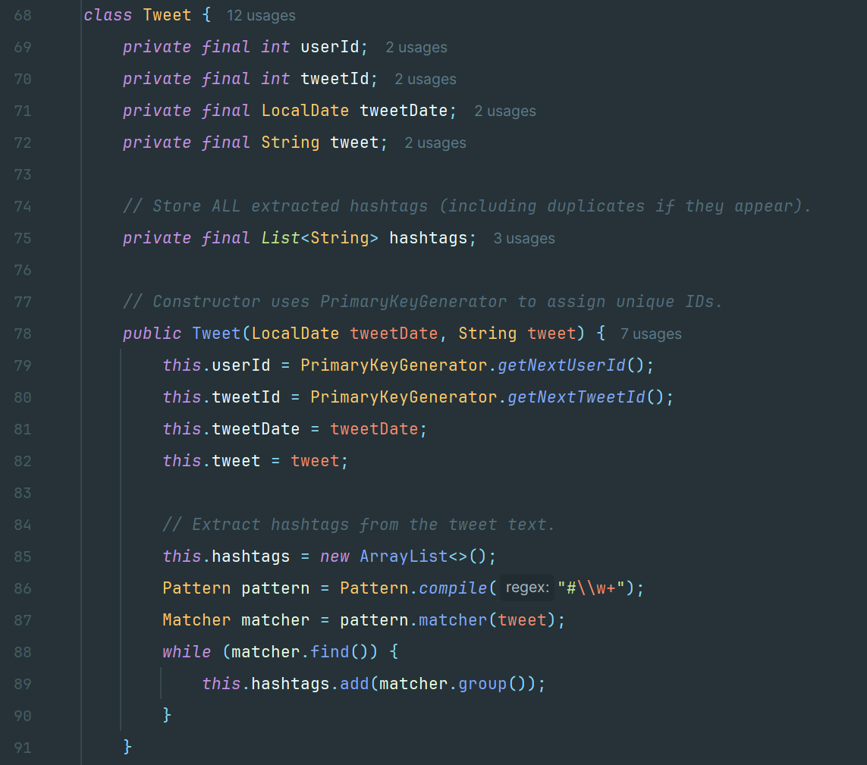

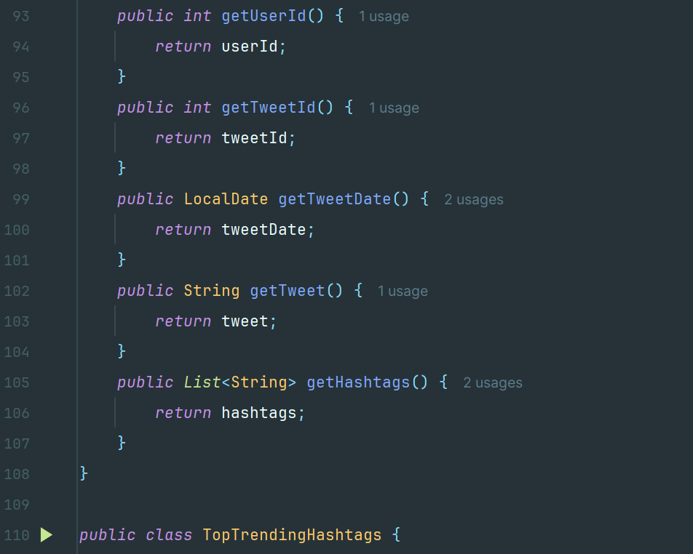

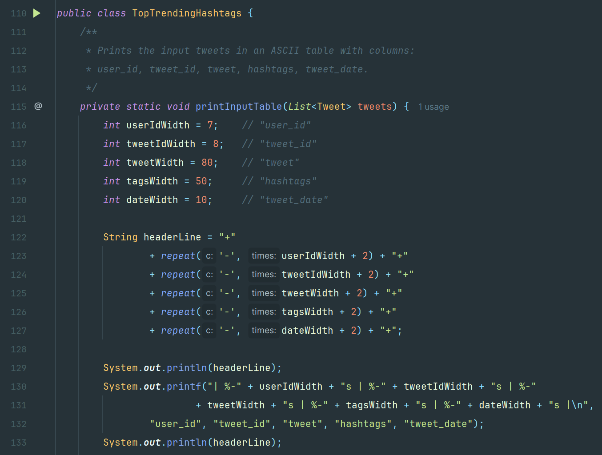

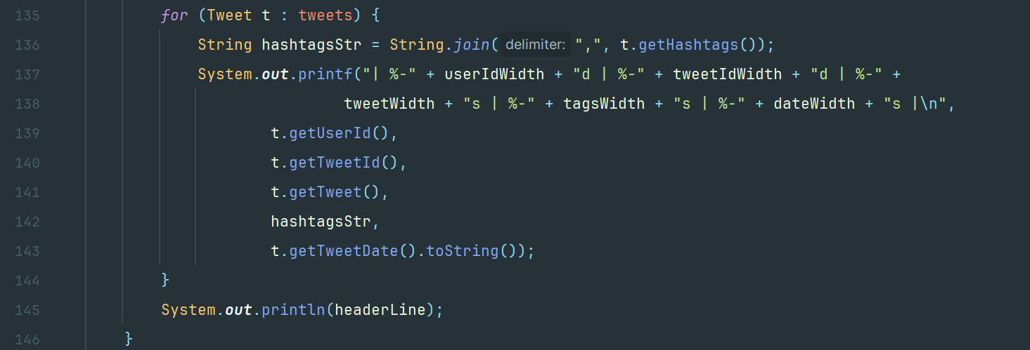

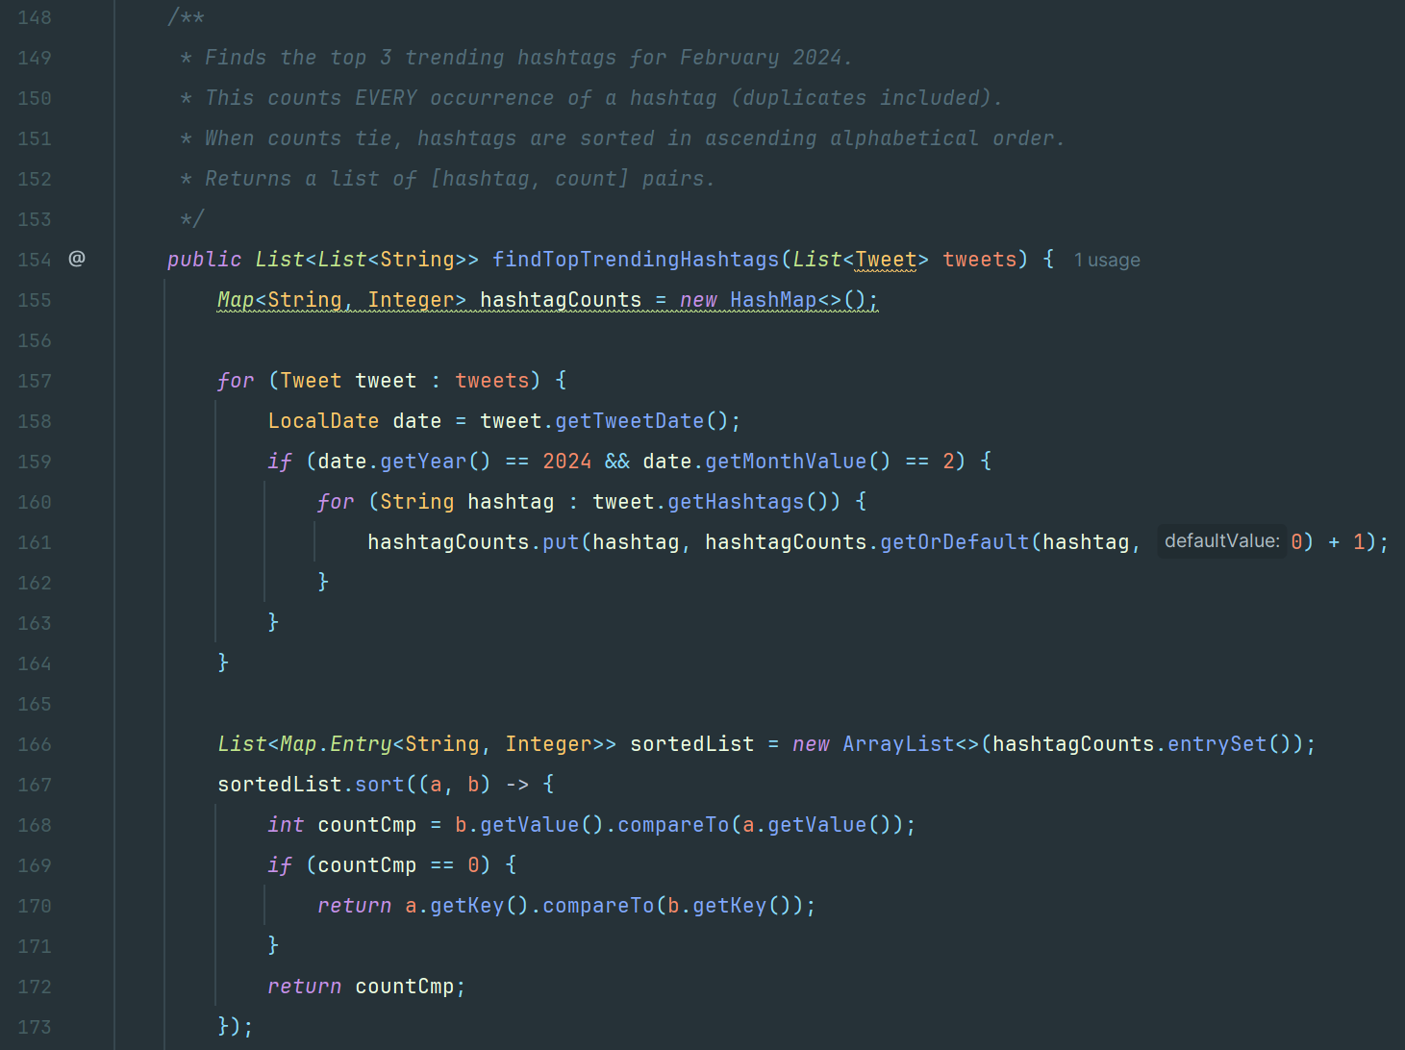

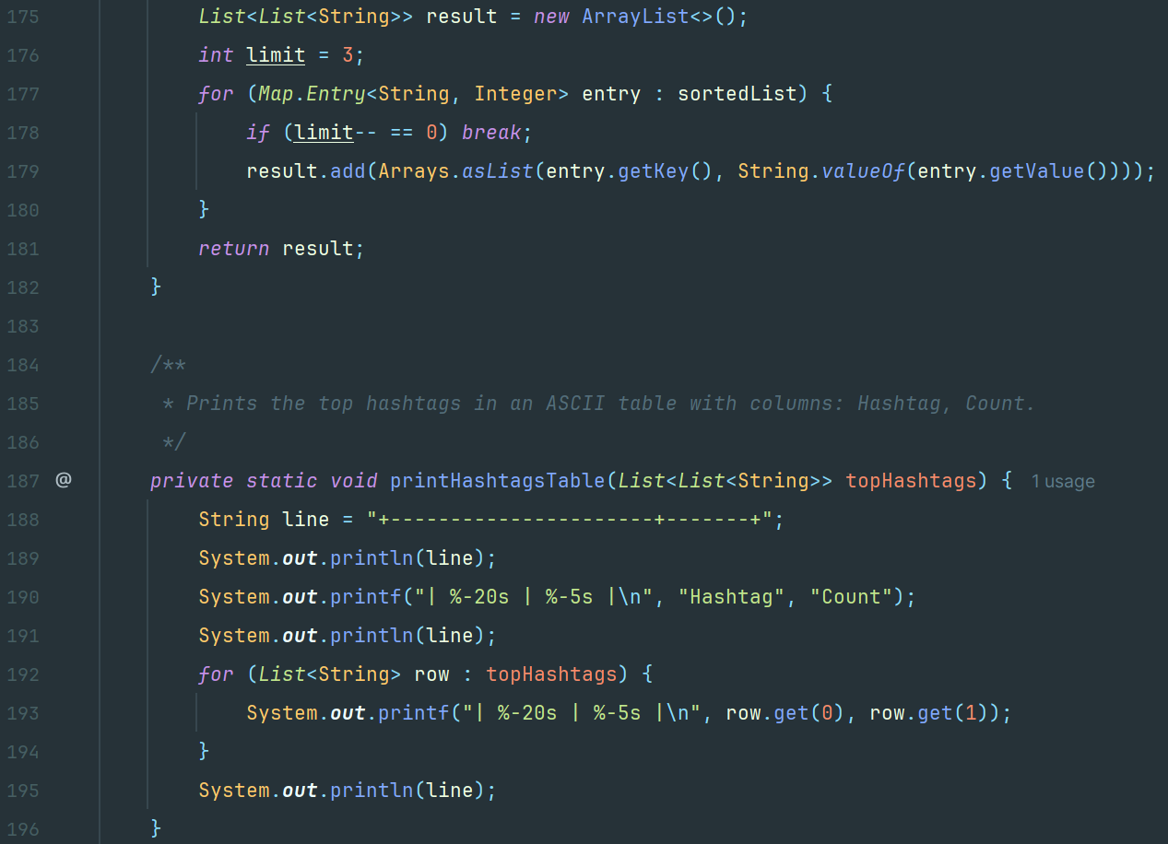

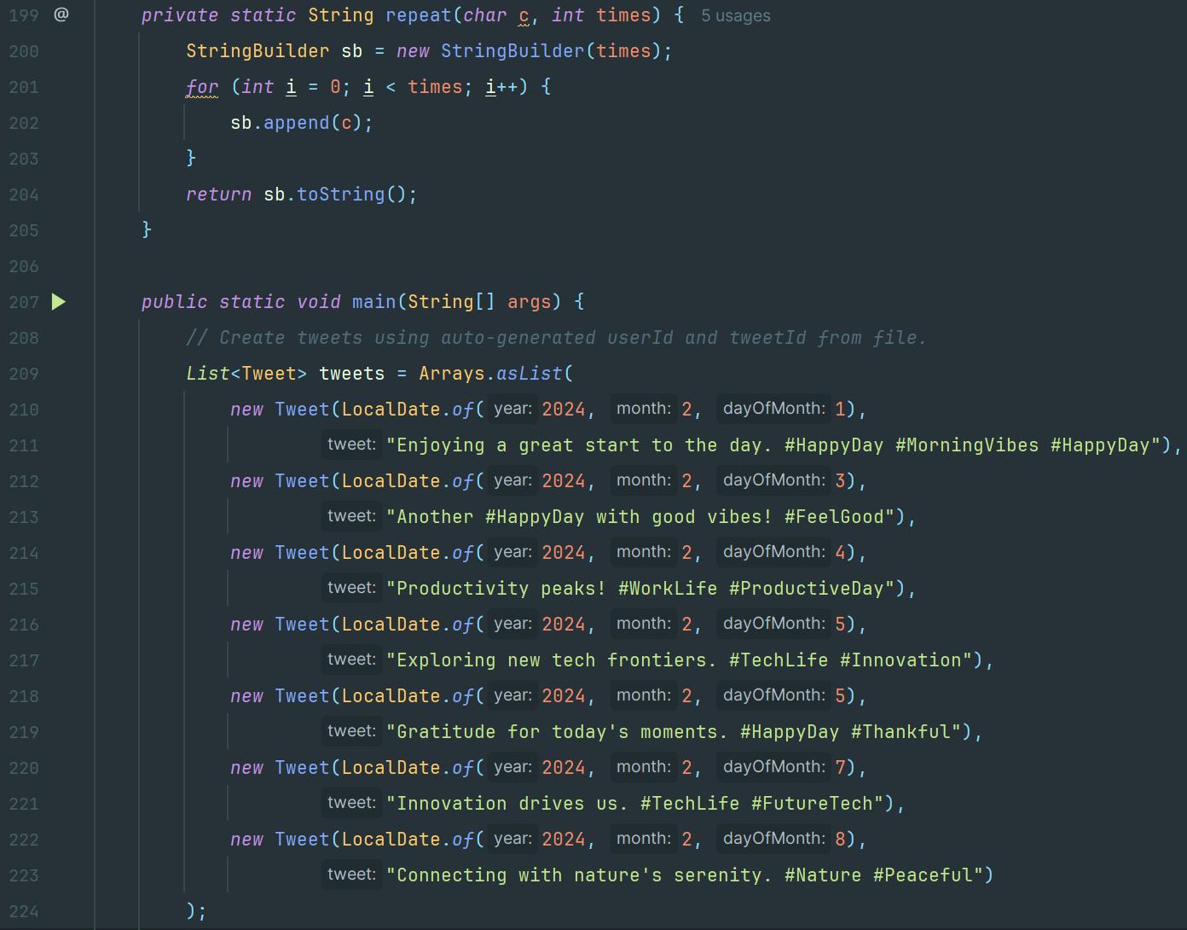

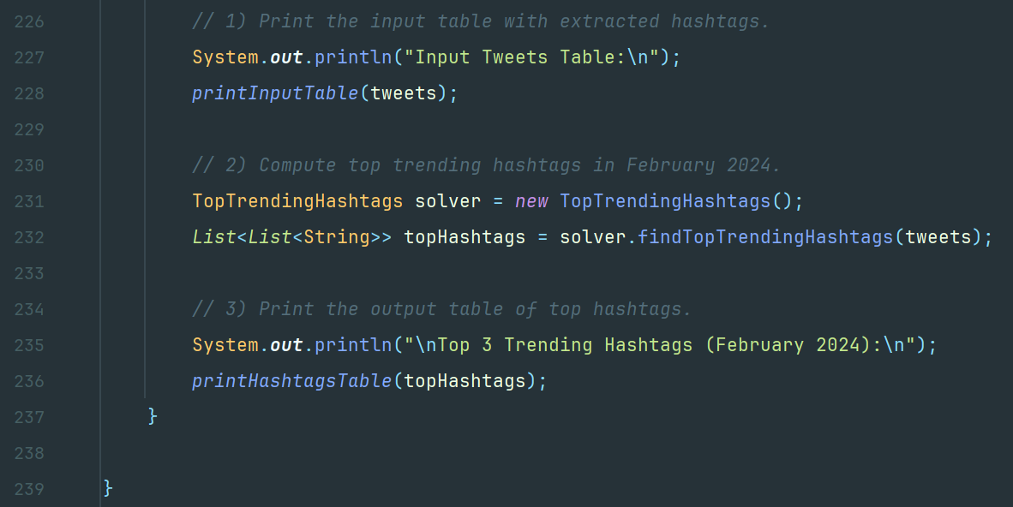

**Example-1**

Input:

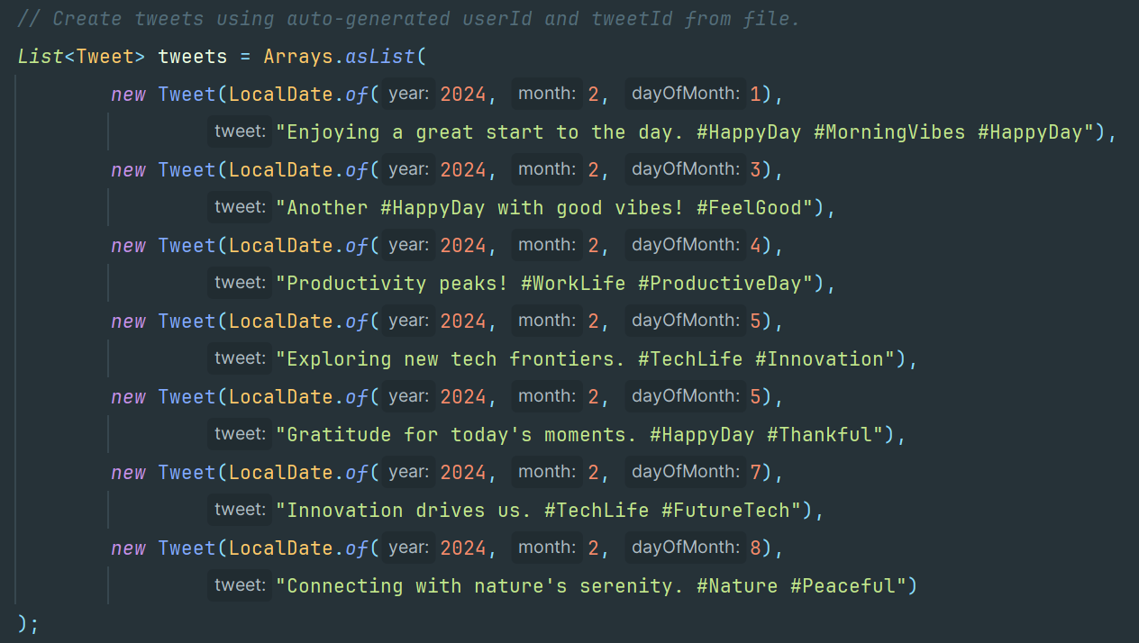

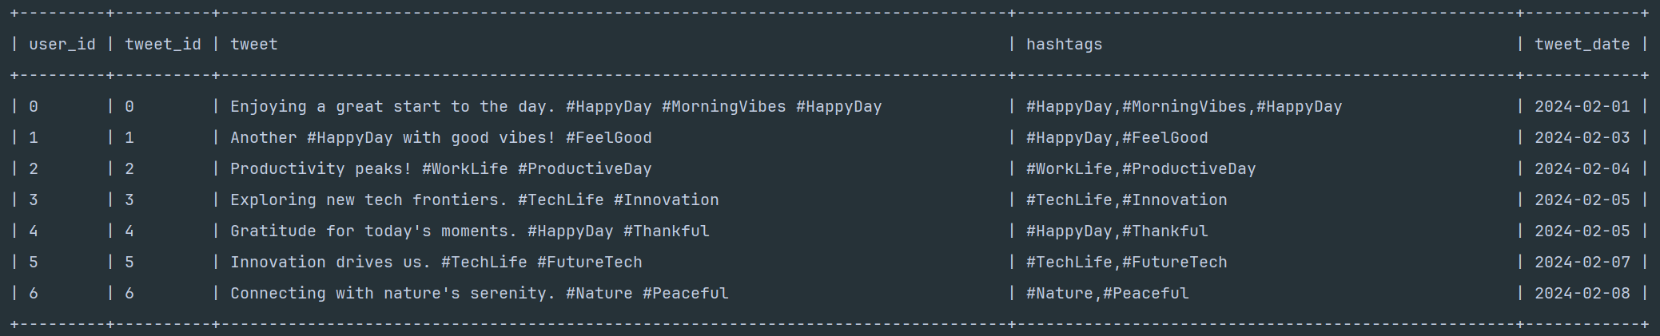

Output:

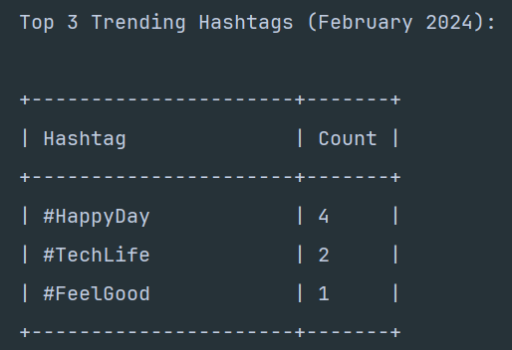

**4. b) Ans:**

The goal is to find the minimum number of roads i.e., **roads** needed to traverse to collect all packages i.e., **packages**.

**Approach**

We are given an undirected graph which represents a city of with **n** nodes where each node either has a package (**packages[i] =1**) or not (**packages[i]=0**)

We can start at any node and:

* Collect packages from all nodes within distance 2 (i.e., the current node, its neighbors, and neighbors-of-neighbors).
* Move to an adjacent node (costing 1 traversal of a road).
* Our main goal is to collect all packages and return to the same start node with minimal total road traversals.

To solve the problem correctly and with best optimal way, we can use a BFS approach. Each state is defined as: (**currentNode**, **bitmaskOfCollectedPackages**) where **bitmaskOfCollectedPackages** is a bitmask representing which package-nodes have been collected so far. From each state, we can:

* Collect packages in the radius-2 neighborhood of **currentNode** (updating the bitmask).
* Move to any neighbor of **currentNode**, incurring **+1** to the road count.

We search until all packages are collected (the bitmask indicates we have them all) and we have returned to the starting node. Among all ways to do this, we want the minimum road traversals.

**Algorithm and Steps**

* We need to identify which nodes have packages where **packages[i] == 1**).
* Build an adjacency list from roads for the undirected graph.
* For each node, precompute a function **collectMask(node)** that returns a bitmask of which package-nodes could be collected if we "stand" on that node, i.e., we can collect the packages from that node within a distance of less than or equal to 2.
* A state is (**node**, **collectedMask**, **startNode**). However, we can store startNode once per BFS run (or we can do a BFS from each possible start node).
* **collectedMask** is an integer bitmask of length p (where p is the number of package-nodes). If the j-th package-node is collected, bit j is 1.
* For each node start in [0 to n−1], do a BFS in the state-space. The initial state is (**start**, **collectMask(start)**) with cost 0. We keep a queue of states and a distance map **dist[state] = cost**.
* From a state (**u**, **mask**) with cost **costSoFar**:
* Already collect packages from u’s radius-2 neighborhood: newMask = mask OR collectMask(u).
* If newMask is the mask with all packages collected and u==start, we have a valid route back to start. Record costSoFar as a candidate answer.
* Otherwise, for each neighbor **v** of **u**, we can move to (**v**, **newMask**) with **cost = costSoFar + 1**. If we have not visited (**v**, **newMask**) or found a cheaper cost for it, we push it into the BFS queue.
* Among all BFS runs (one per possible start node) or among all solutions found in a single BFS that allows starting at each node, take the minimum cost that collects all packages and returns to the start.

**Time and Space Complexity**

1. Time Complexity:

* Precompute coverage for each node: **O(n * n1)** where **n1** is neighbors up to distance 2.
* BFS in state-space: up to **O(n×2p)** states, each with up to d neighbors, so **O(n*2p * d)**.

1. Space Complexity:

* We store an adjacency list for the graph: **O(n + e)** where **e** is edges.
* We store the BFS dist map for up to **n×2p** states.
* The **collectMask** array is size **n**.
* Overall **O(n×2p)** in the worst case for BFS state and distances, plus adjacency overhead.

**Code Implementation**

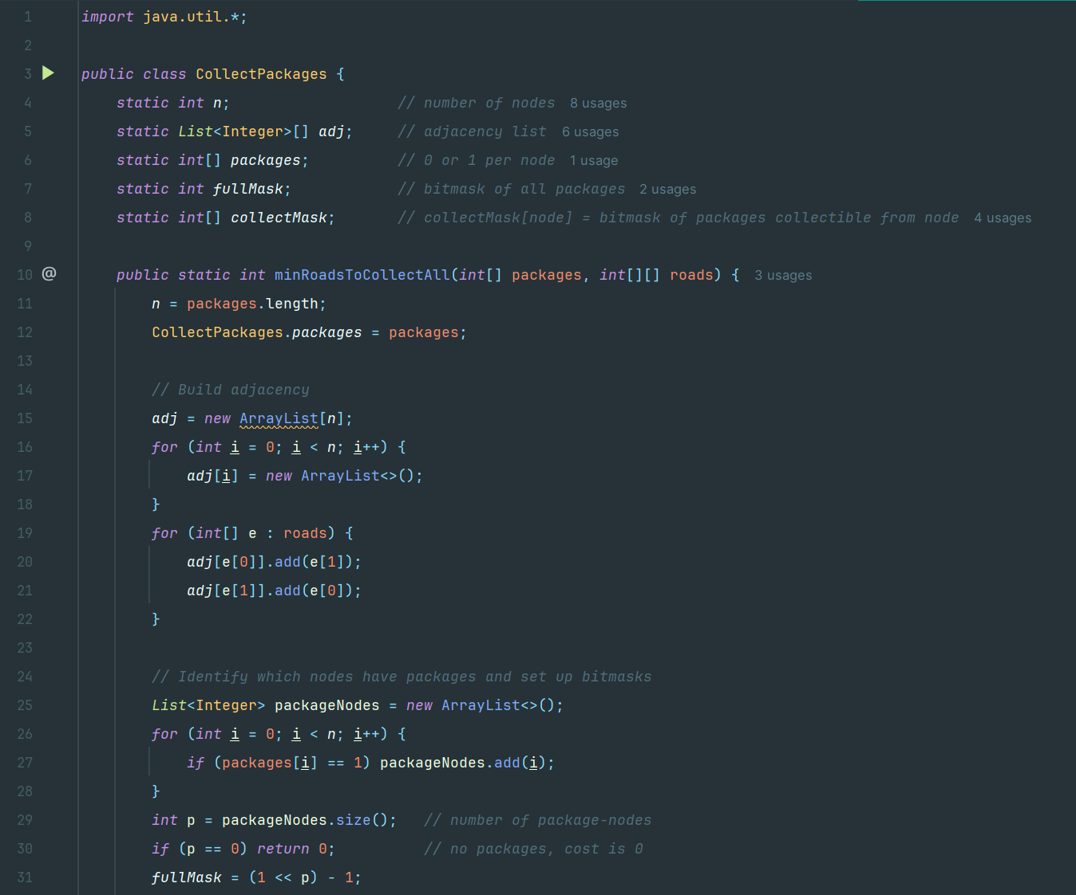

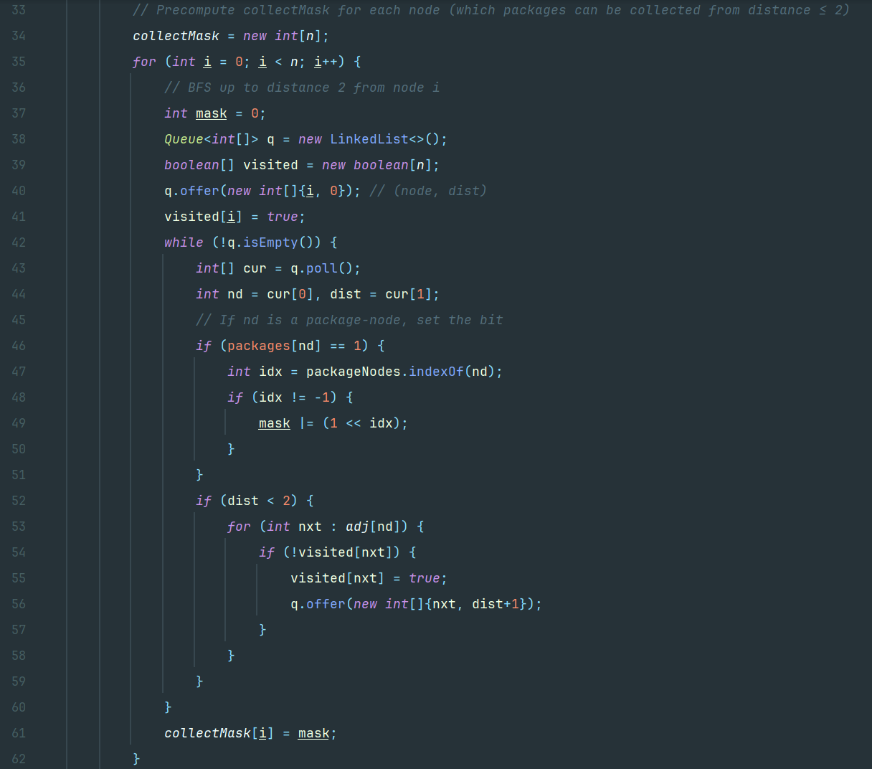



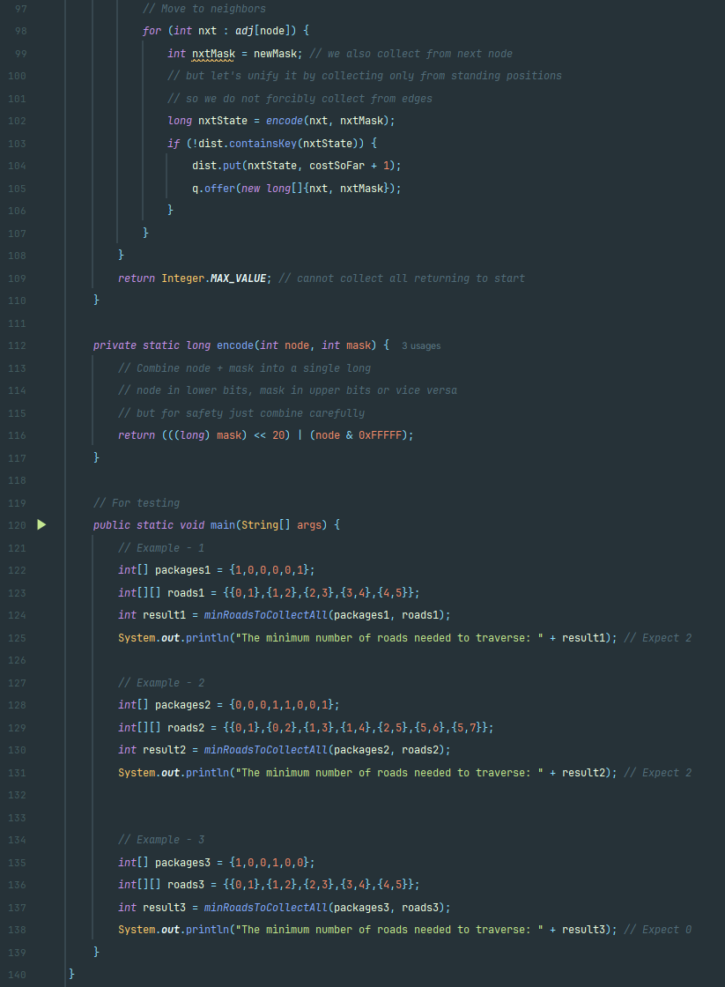

**Example-1**

Input: packages1 = {1,0,0,0,0,1}, roads1 = {{0,1},{1,2},{2,3},{3,4},{4,5}}

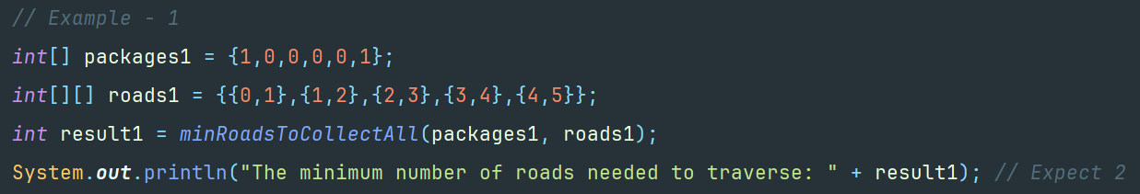

Output: 2



**Example-2**

Input: packages2 = {0,0,0,1,1,0,0,1}, roads2 = {{0,1},{0,2},{1,3},{1,4},{2,5},{5,6},{5,7}}

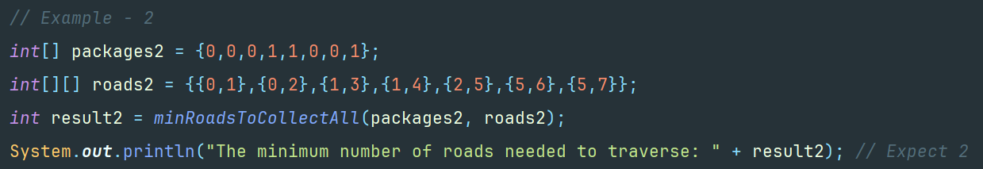

Output: 2



**Example-3**

Input: packages3 = {1,0,0,1,0,0}, roads3 = {{0,1},{1,2},{2,3},{3,4},{4,5}}

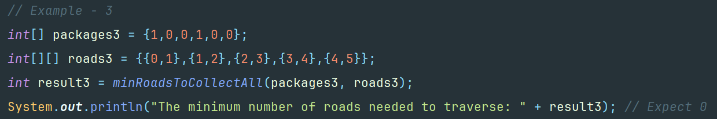

Output:



**5. Ans:**

**Approach**

We design a GUI-based network optimizer that aids administrators in visually designing and optimizing network topologies. The network is modeled as an undirected graph where nodes represent servers or clients, and edges represent possible network connections. Each edge is described with two significant attributes: cost and bandwidth. The requirements are twofold:

* Network Optimization: Find a subnetwork that minimizes total cost while reducing the likelihood of information transmission latency. This modified Kruskal algorithm takes each weighted graph edge with respect to a newly introduced combined metric:

**weight=α * cost * β * (LATENCY_FACTOR/bandwidth​)**

In this function description, **𝛼** and **β** represent user- specified weights.

* Shortest Path Calculation: Users select any two nodes and utilize Dijkstra's algorithm to discover the shortest (lowest latency) path from the first to the second, with each edge weight calculated by:

**LATENCY=LATENCY_FACTOR​/ bandwidth**.

The application supports interactive node and edge creation (editing and removal), dynamic visualization of the network, real-time display of total cost, and average latency, and implements a dual-functionality GUI with both optimization and pathfinding features.

**Algorithms**

* Graph Construction and GUI Setup:
* First, the nodes are created with unique IDs and positions.
* Edges connect nodes and include attributes: cost and bandwidth.
* The GraphPanel is created which renders nodes and edges (with gradient fills and labels).
* The ControlPanel is created which offers controls for network optimization (via input fields for α and β), path finding (using combo boxes for start and end nodes), and node management (e.g., removing nodes).
* The ToolPanel is created which allows the user to switch between selection, node creation, and edge creation modes.
* Users can add, edit (double-click to change cost/bandwidth), or remove nodes/edges via mouse and context menus.
* Dragging a node updates its position, and combo boxes are refreshed to reflect current nodes.
* Network Optimization (modified Kruskal):
* For each edge:

**weight = α×cost+β*(LATENCY_FACTOR / bandwidth​)**

* Sort all edges in order of the calculated weights, in ascending order.
* Using Union-Find (Kruskal's algorithm), select the edges one at a time, such that cycles are avoided until connections are made between all nodes.
* Include the chosen edges among active ones to be accentuated in the GUI.
* Shortest Path Calculation (Dijkstra):
* The combo boxes are at the disagreement, allowing selecting a start node and an end node.
* Each edge's weight is computed as **LATENCY=LATENCY_FACTOR/ bandw**idth.
* Run Dijkstra’s algorithm on a starting node and backtrack from the end node once the shortest path is found.
* Visually highlight the edges along the shortest path.
* Real-Time Evaluation and Metrics:
* In ControlPanel, metrics like total costs incurred while traversing the network and average latencies are continuously updated.
* The re-rendering of the graph takes place whenever a change is applied to the network, thus allowing users to interactively update the topology and observe the outcome immediately.

**Time and Space Complexity**

1. Network Optimization (Kruskal's Algorithm):

* Time Complexity:
* The first step is to sort all edges in **O(e log e)**, where **e** is the number of edges.
* The time to perform union-find operations will be about **O(e α (v))** where 𝛼 is the inverse Ackermann function and v is the number of nodes/vertices.
* Finally, the optimization continues in **O(e log e)**.
* Space Complexity:
* Storing the list of edges and nodes takes **O(v + e)**.
* The union-find data structure uses **O(v)** space.

1. Shortest Path (Dijkstra Algorithm):

* Time Complexity:
* Using a priority queue, Dijkstra’s algorithm runs in **O(e log v)**.
* Space Complexity:
* Requires **O(v)** space for the distance and predecessor maps.

**Code Implementation**

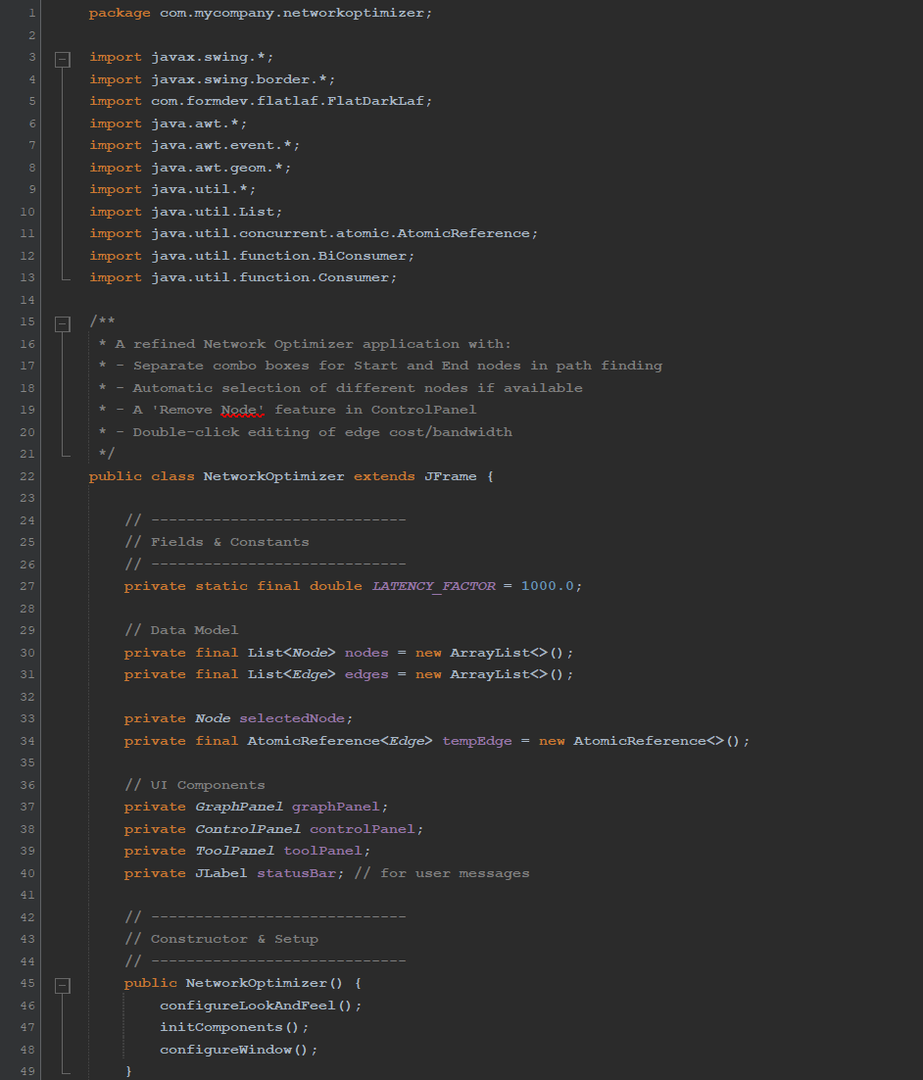

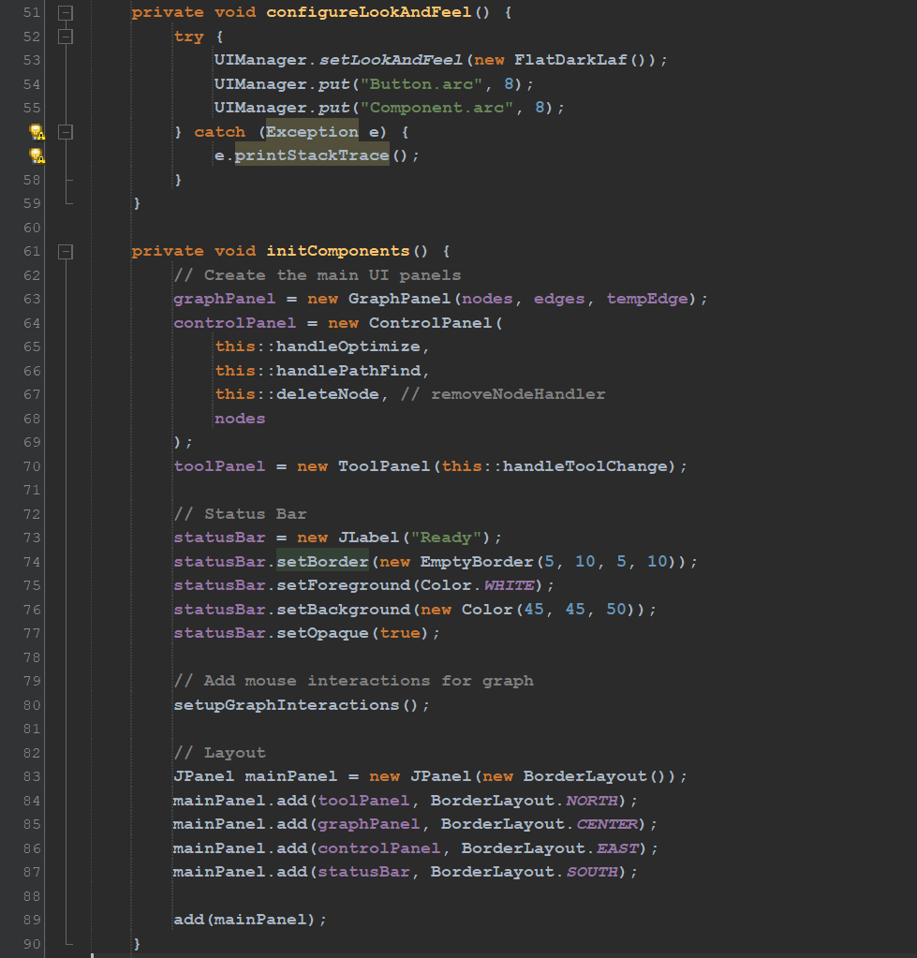

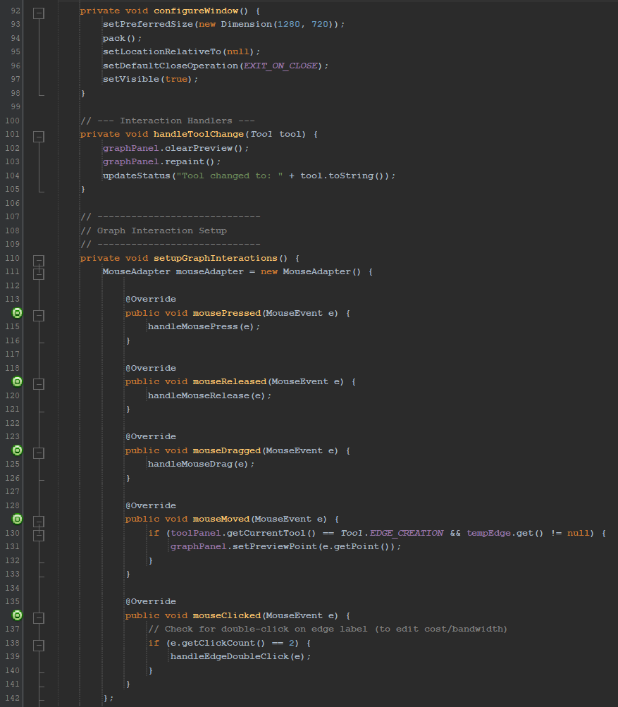

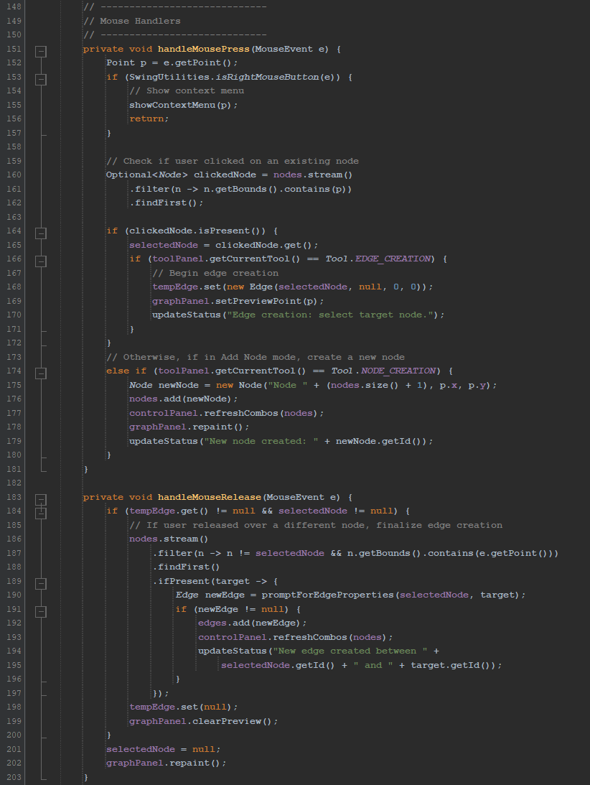

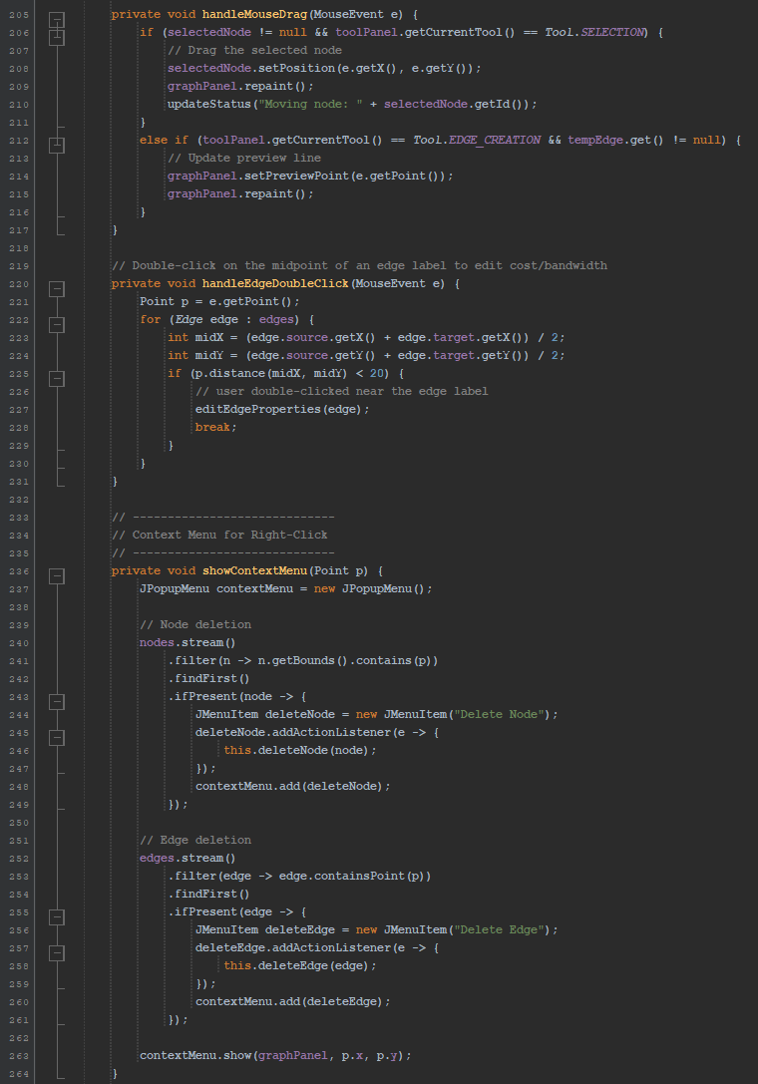

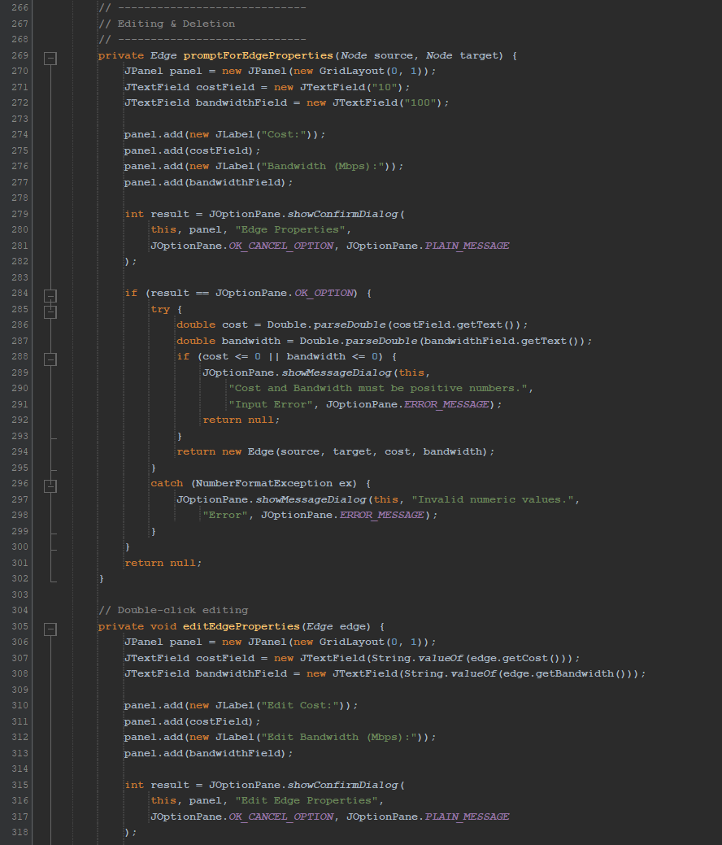

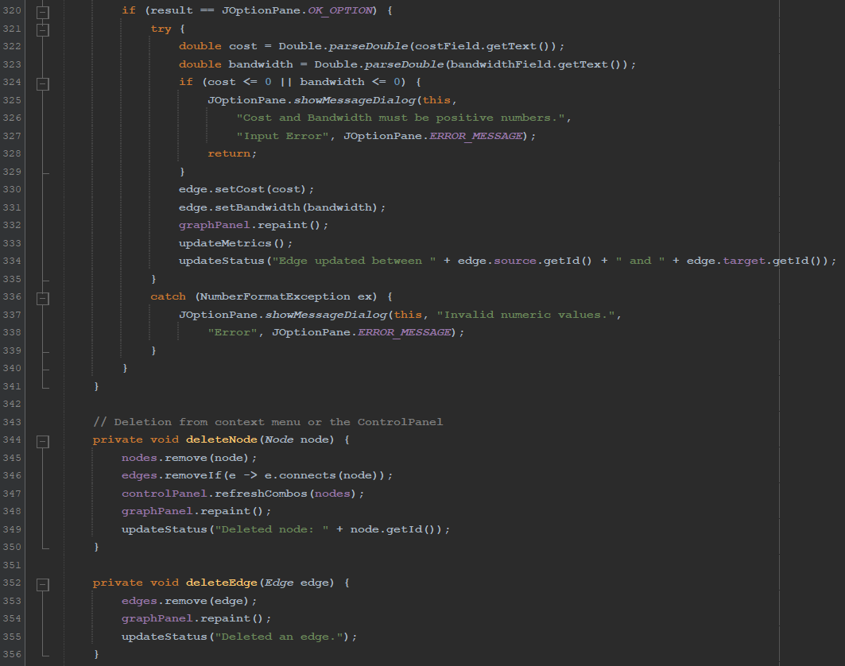

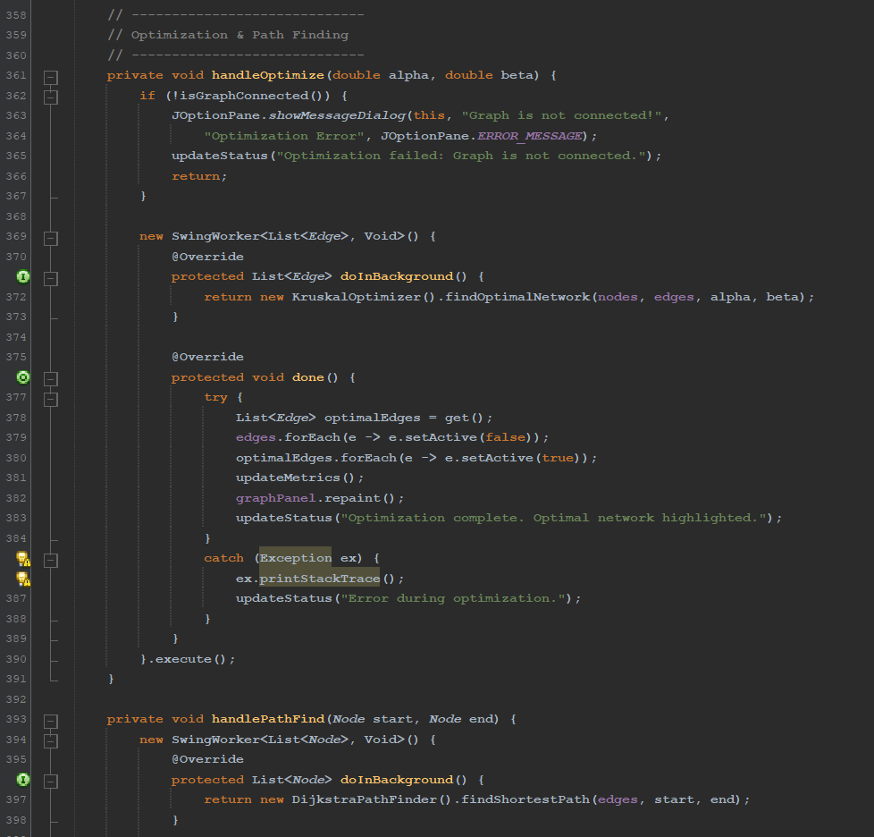

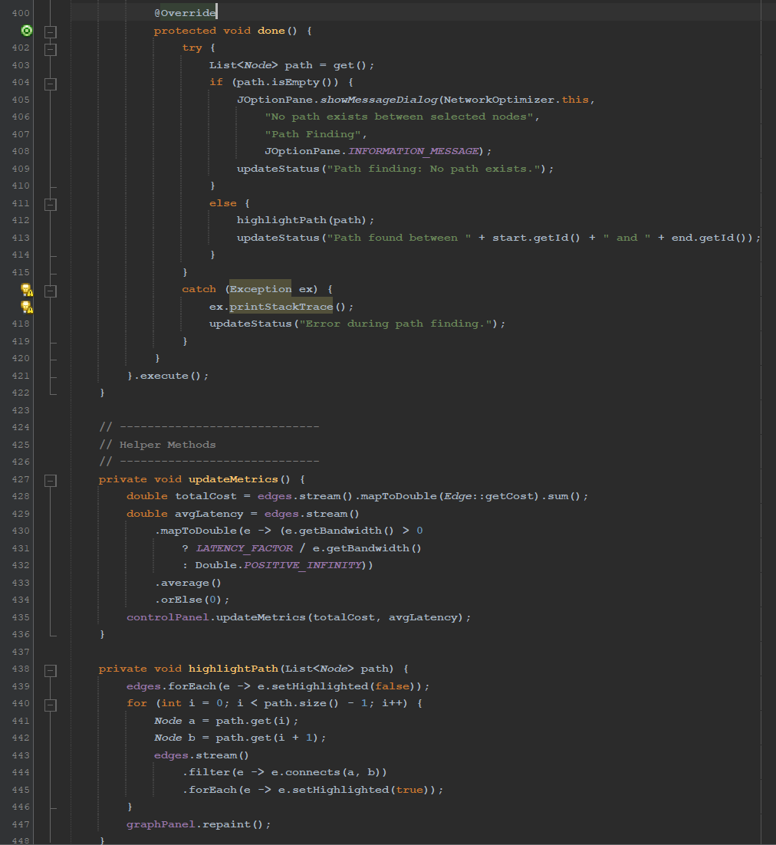

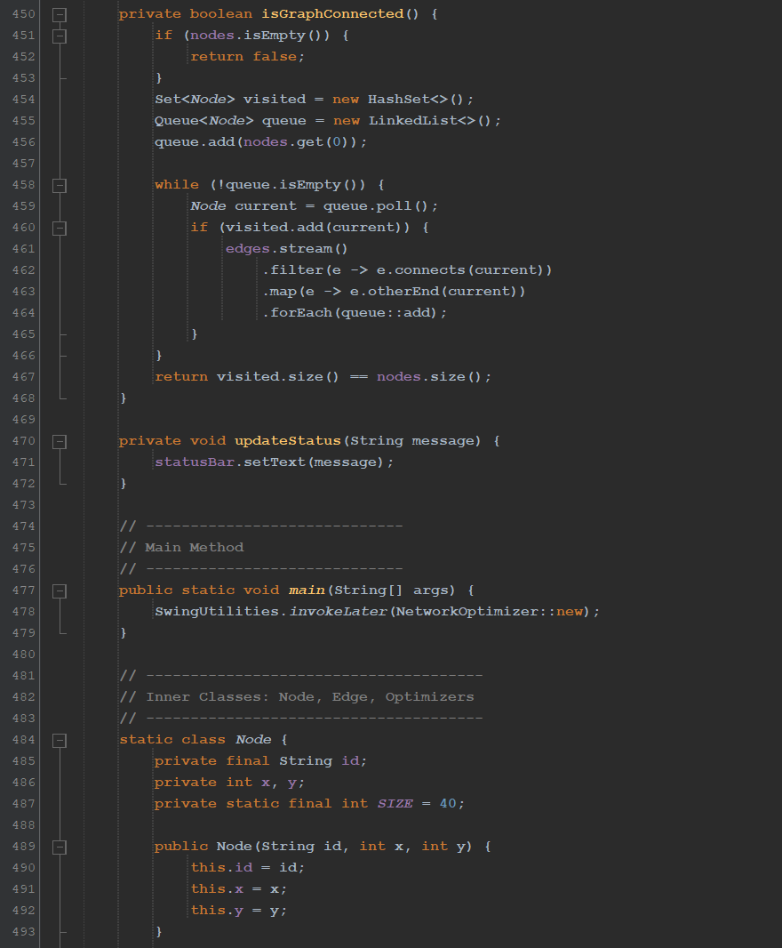

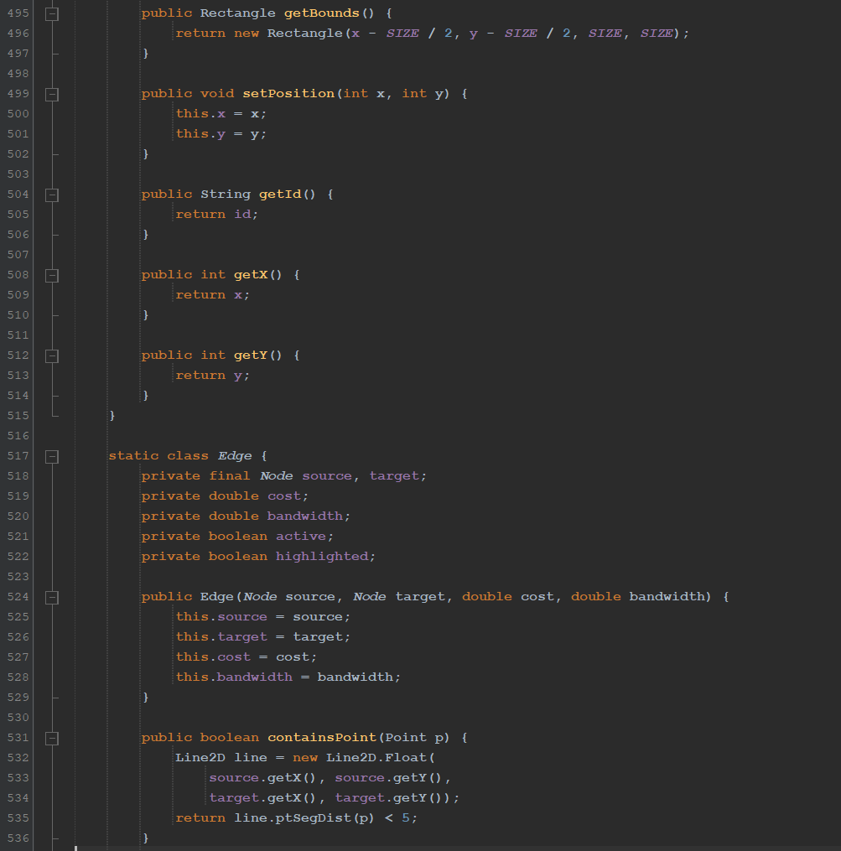

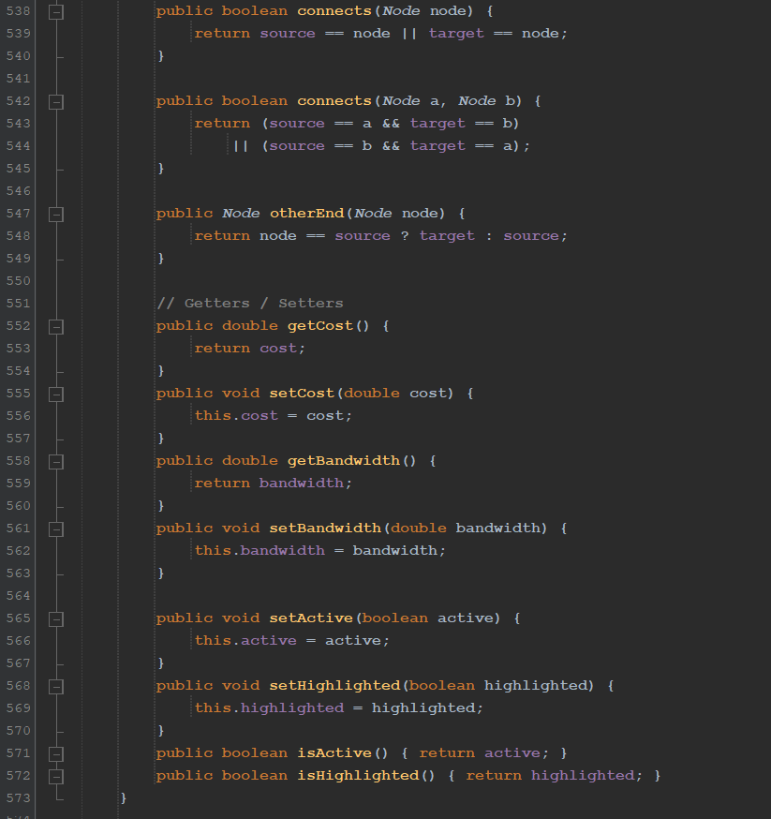

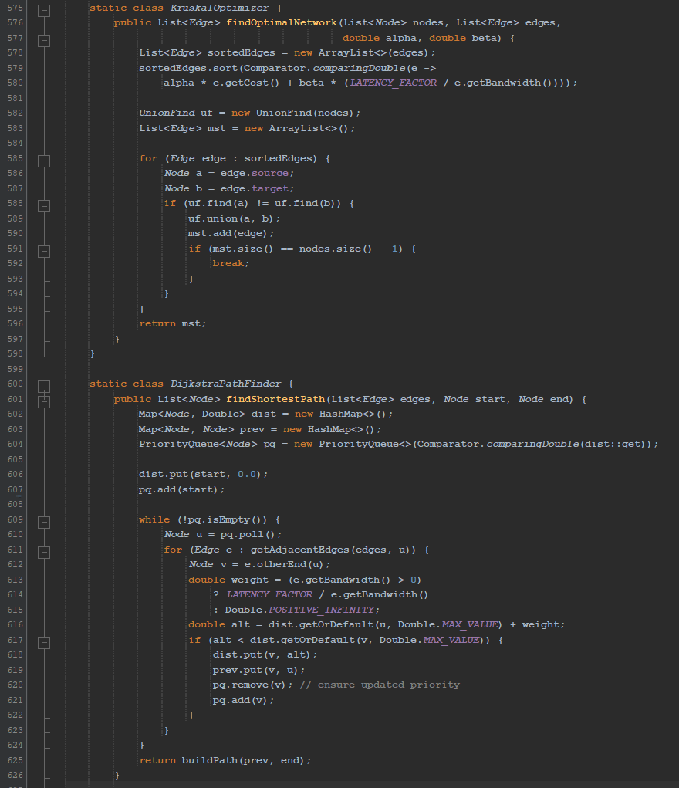

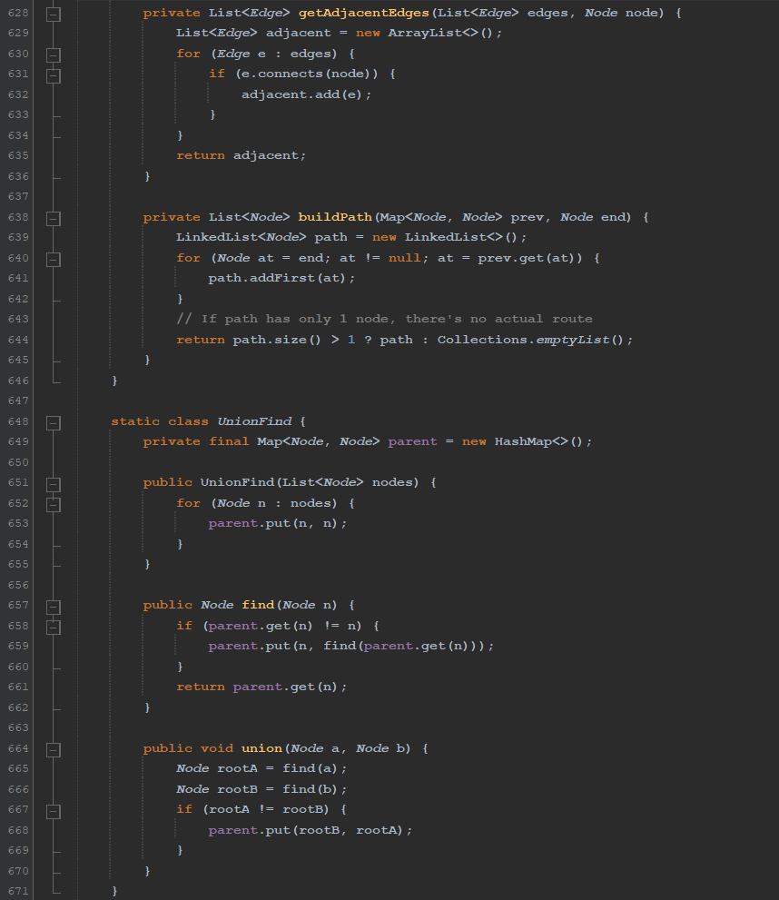

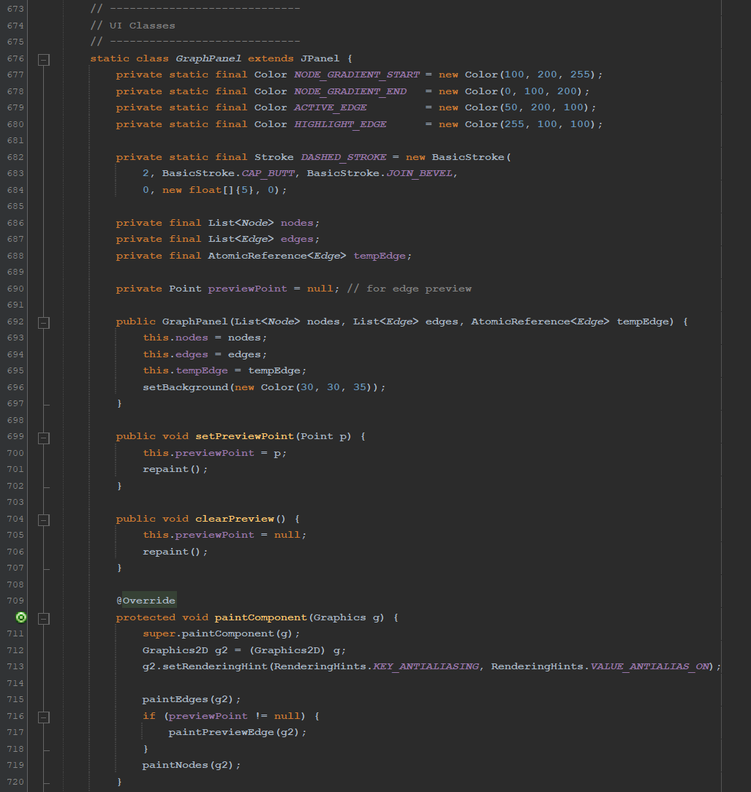

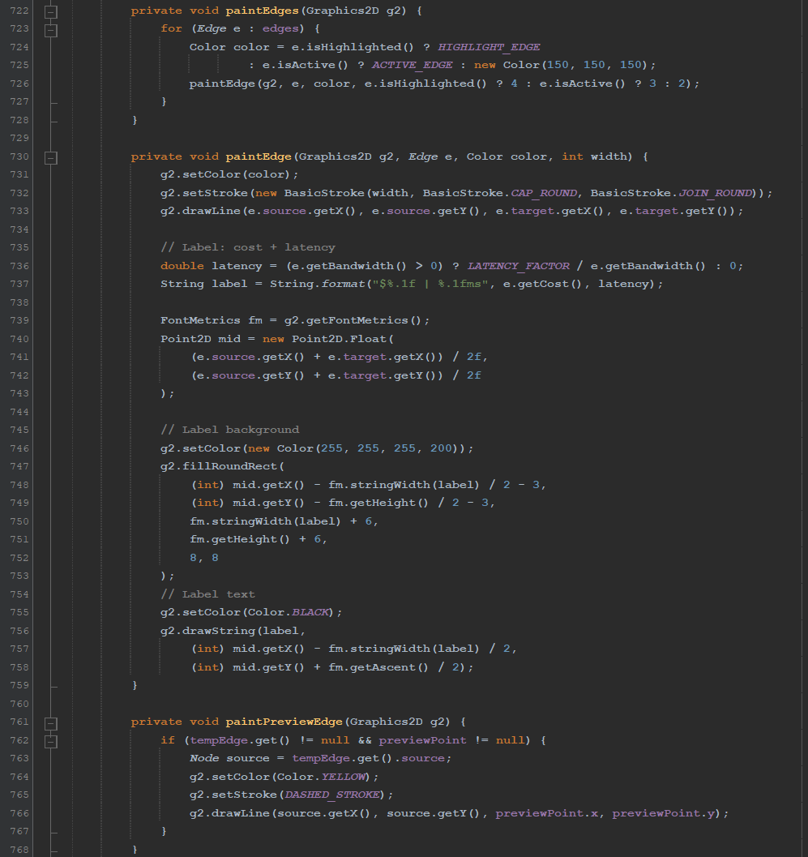

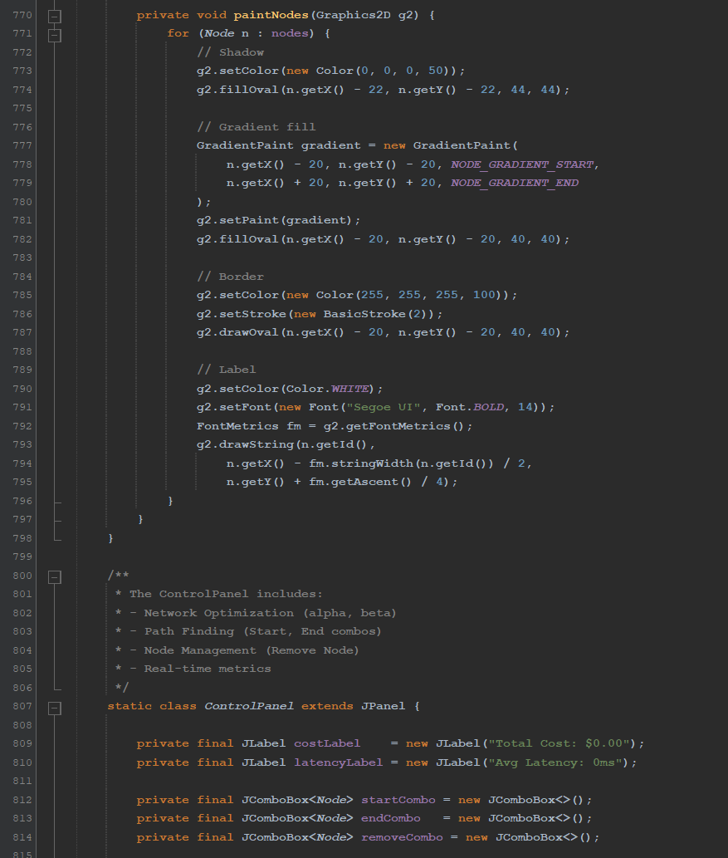

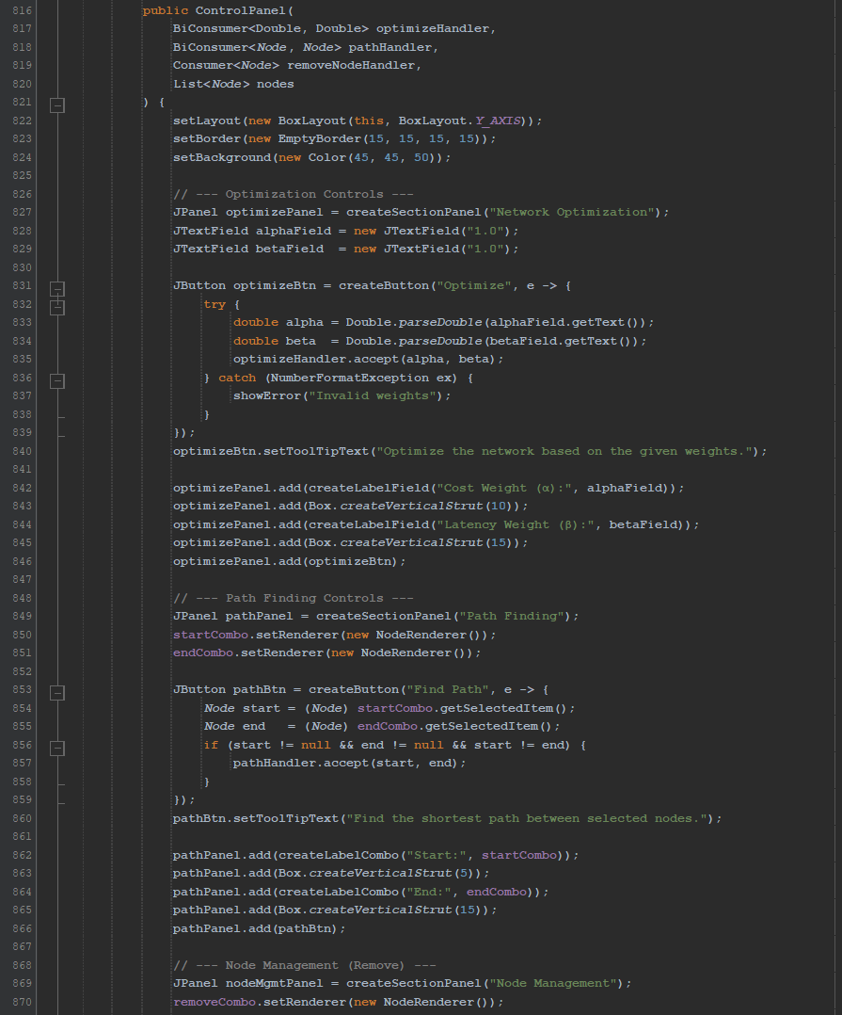

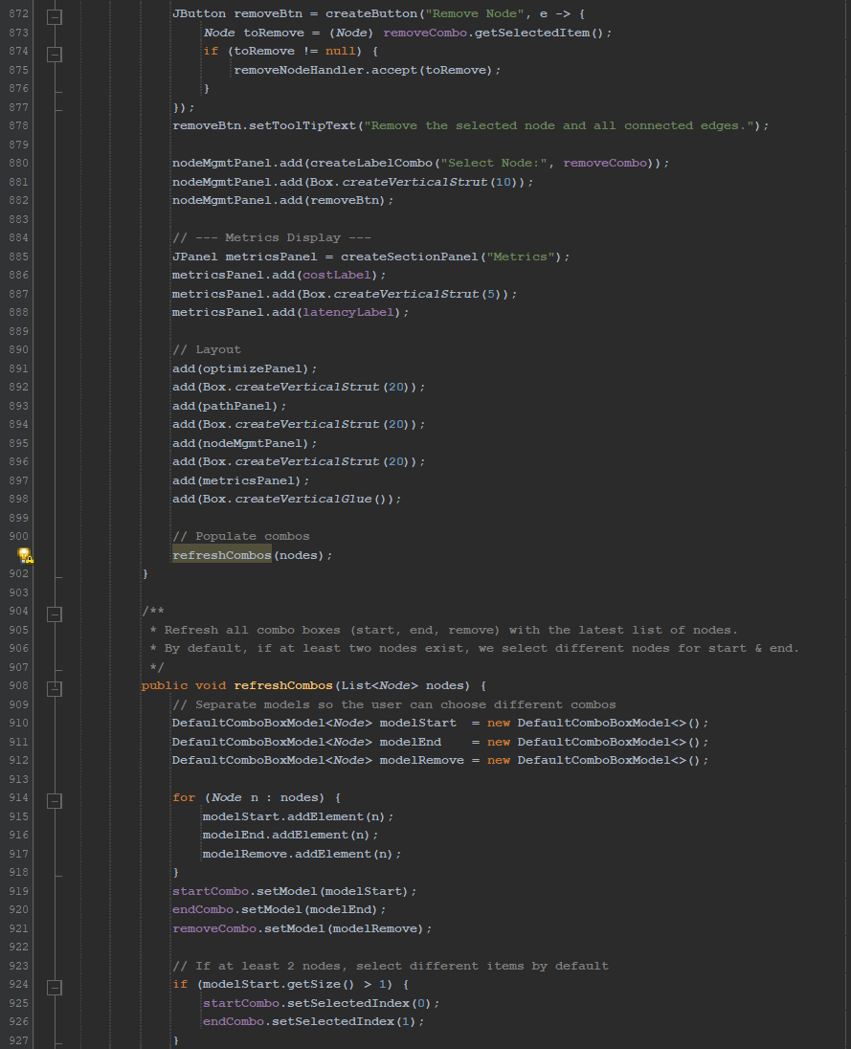

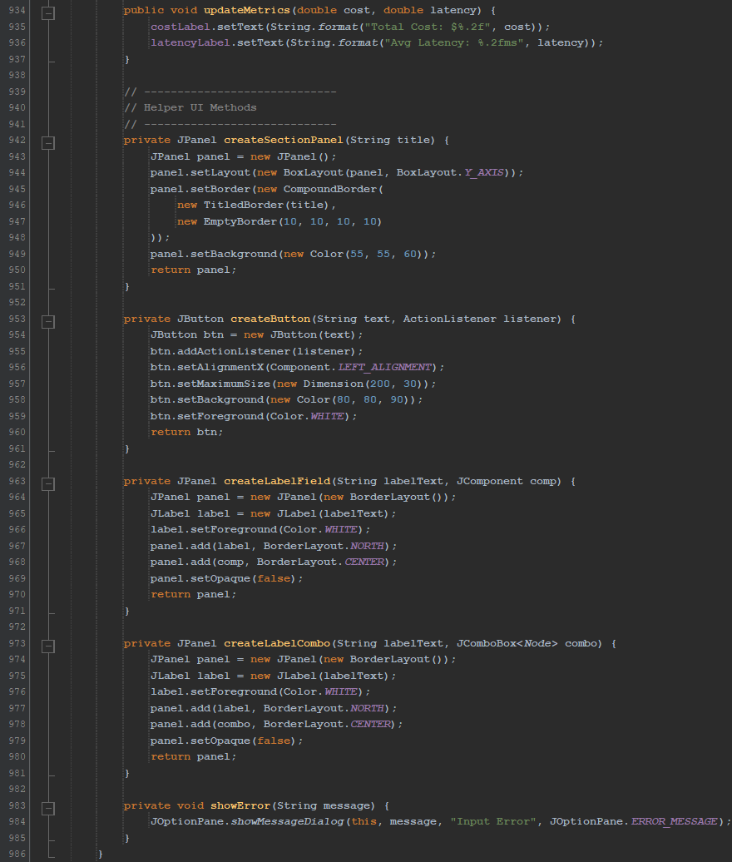

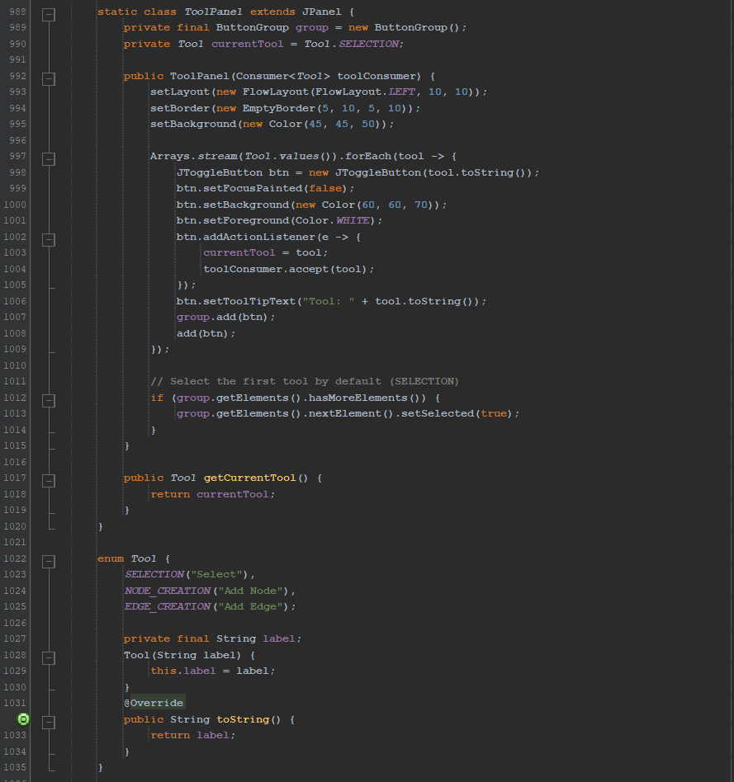

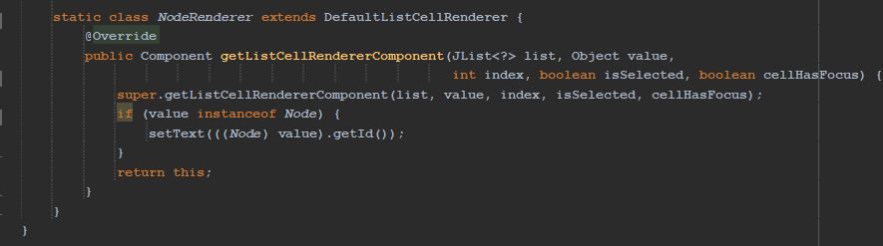

**Output**

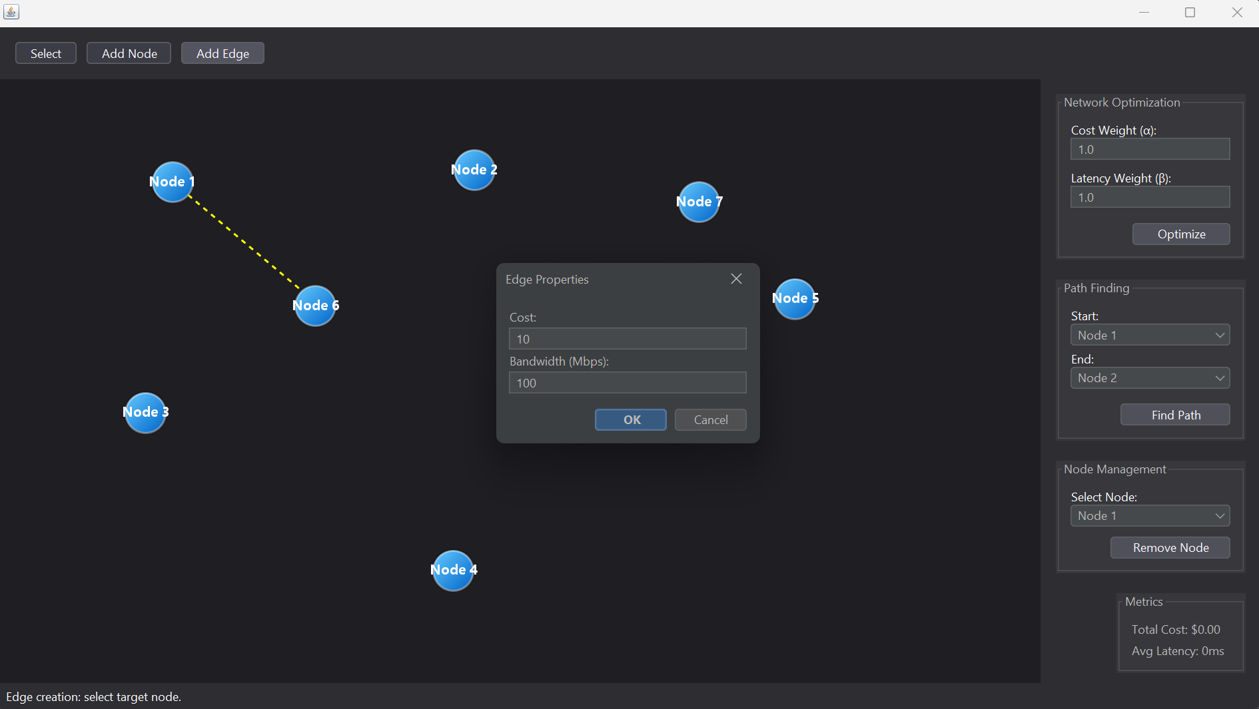

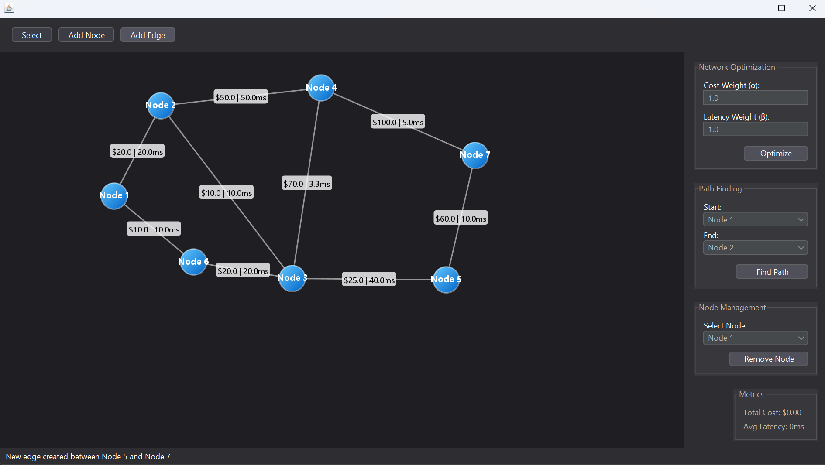

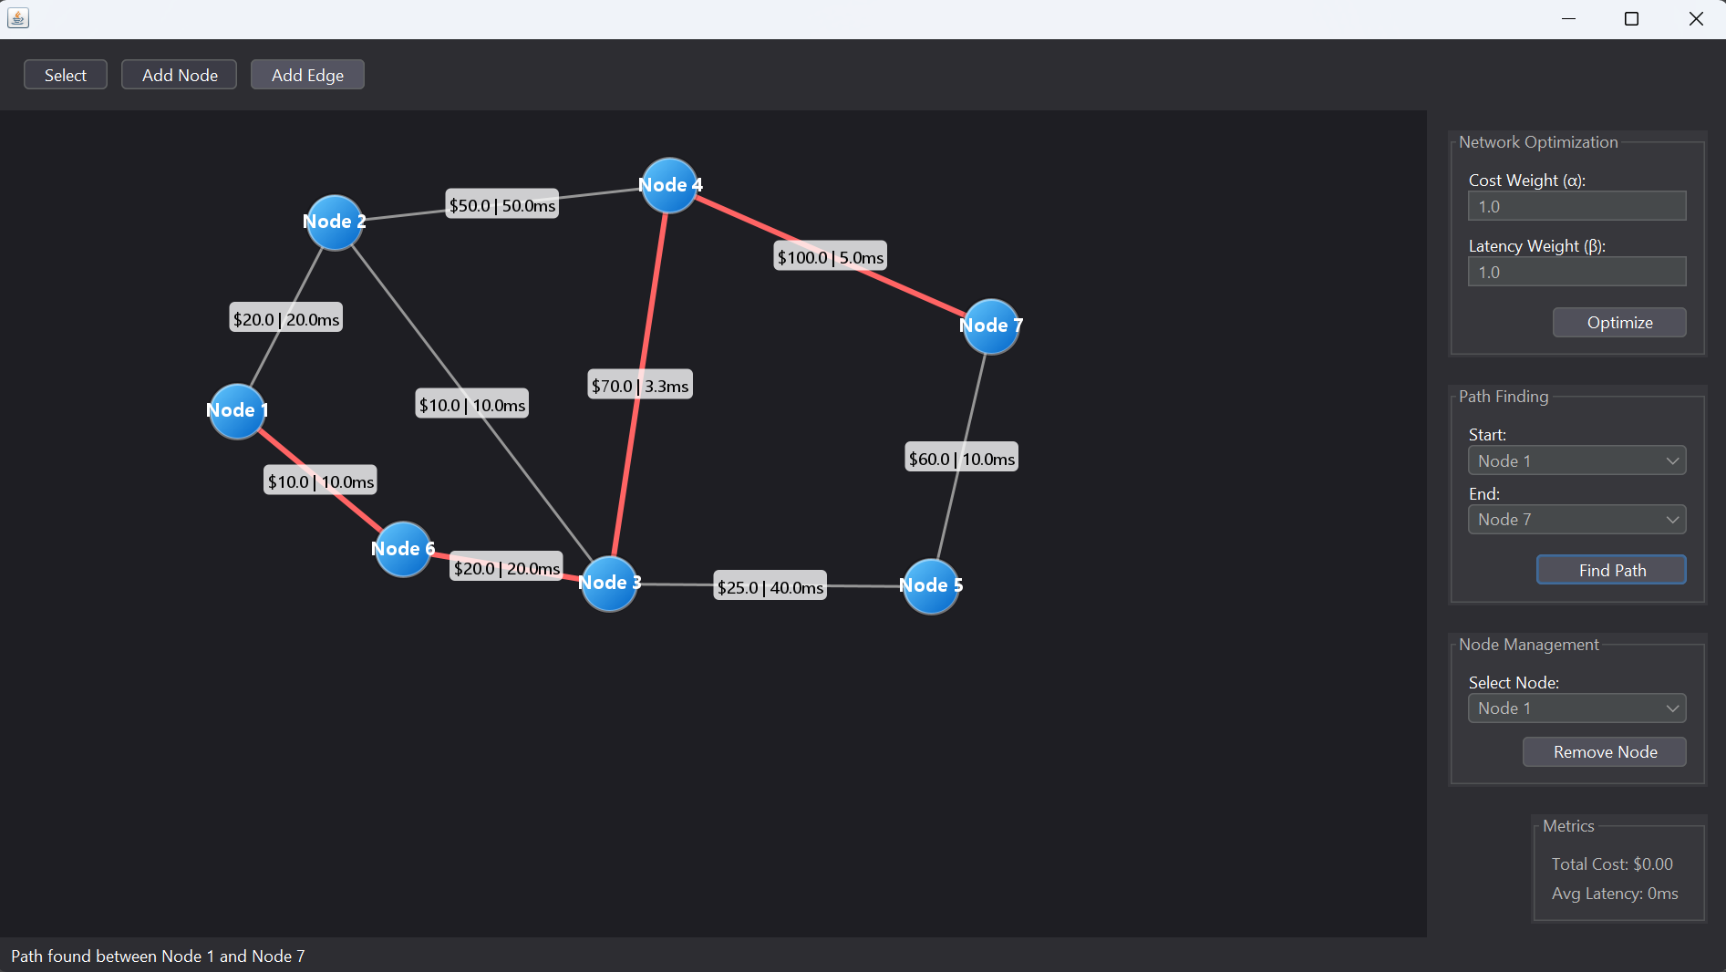

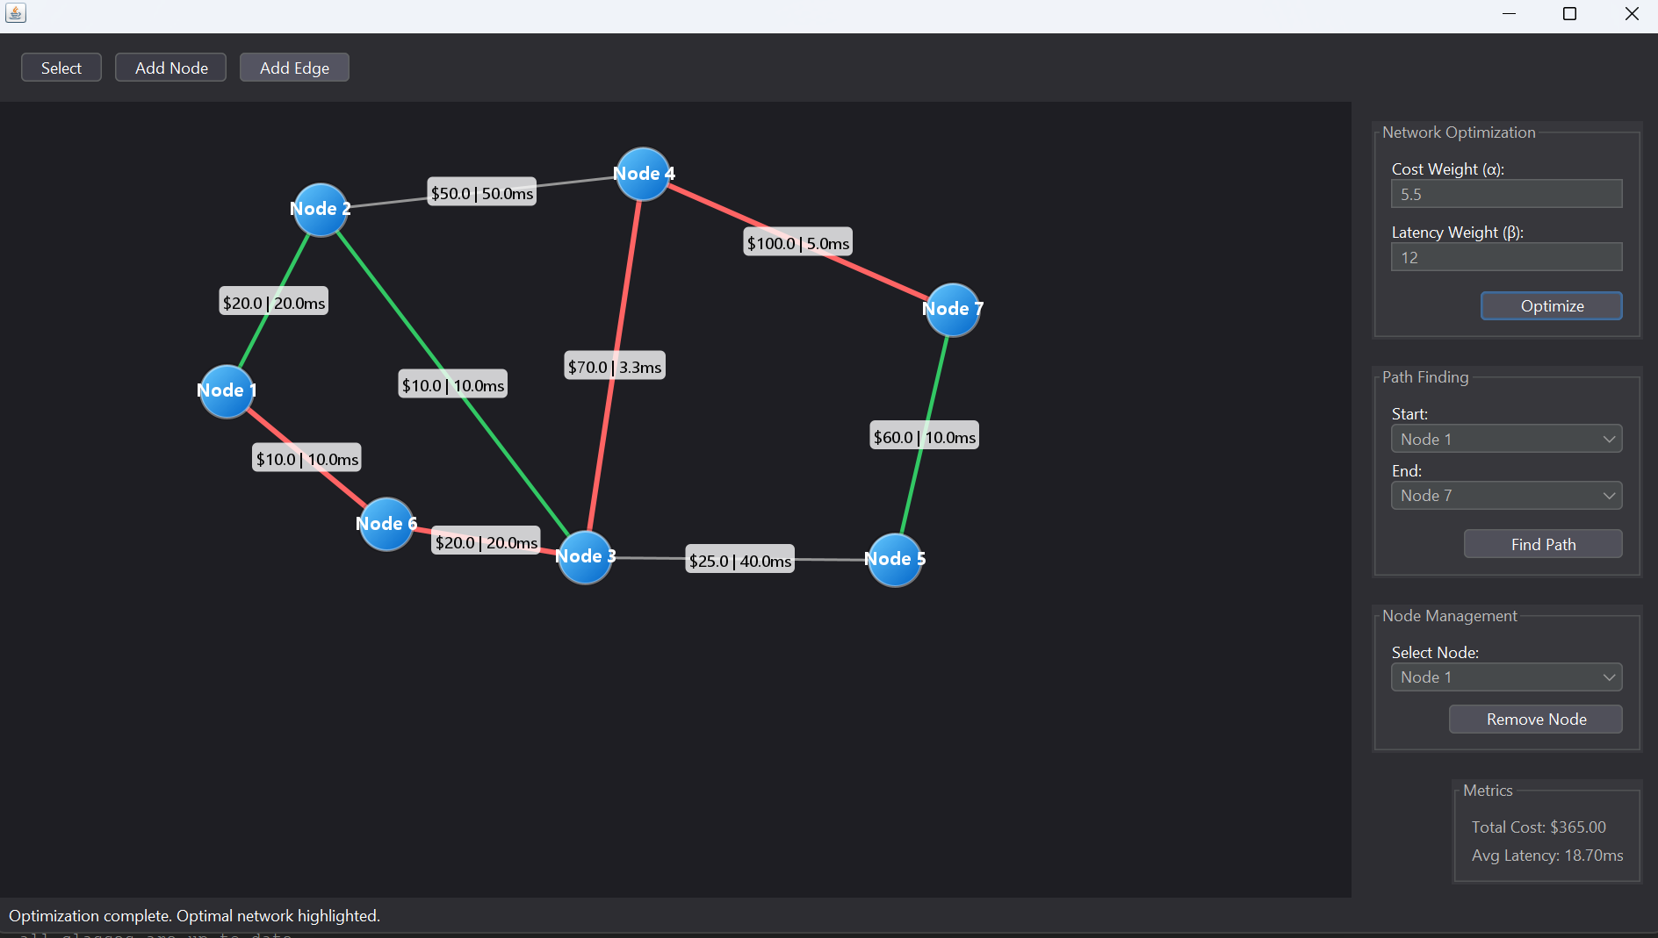

**6. a) Ans:**

The goal is to sequence "0102030405..." up to number **n** using three threads **ZeroThread**, **EvenThread** and **OddThread**. A class **NumberPrinter** is given with three methods: **printZero()**, **printEven()** and **printOdd()** to print zeros, even numbers and odd numbers respectively in a correct order.

**Approach**

To solve this problem, we use a shared state with synchronization through **Lock** and **Condition**. The state transitions control which thread is allowed to execute next.

* **ZeroThread**: It prints "0" and then signals **OddThread** if the next number is odd or signals **EvenThread** if even.
* **OddThread** and **EvenThread**: Wait for the turn, print the corresponding number, increment the counter and signal ZeroThread.

**Algorithm and Steps**

* Initialize variables **current = 1** and **state = 0**. Also initialize a class **NumberPrinter** and a controller with the maximum number **n** and a **NumberPrinter** instance as parameters.
* For **ZeroThread**, start a loop which iterates while **current <= n**.
* If **state != State.ZERO**, it waits on the condition.
* After the condition is met, **printer.printZero()** is called with prints “0”.
* Check if **current** is odd, it sets state to **State.ODD**; otherwise, it sets it to **State.EVEN**. Then, **condition.signalAll()** is called which signals all waiting threads so that the correct thread can proceed.
* For **OddThread**, start a loop which iterates while **current <= n**.
* If **state != State.ZERO** and **current** is odd, it waits on the condition.
* After the condition is met, **printer.printOdd(current)** is called with prints “0”.
* The **current** is incremented i.e., **current++**
* Set the state to **ZERO** i.e., **state = State.ZERO** and signals all threads so that the **ZeroThread** can print the next zero.
* Similarly, just like for **EvenThread**, same process is repeated.
* The threads keep on repeating until **current** exceeds **n**.
* Finally, any remaining threads are signaled to ensure proper termination and the output is printed.

**Time and Space Complexity**

1. Time Complexity:

* The loops through **n** takes **O(n).**
* Each thread operation (print and state update) is done in **O(1)**.

Overall time complexity is **O(n)** in worst where **n** is the **nth** of the number.

1. Space Complexity:

* A fixed number of variables are such as lock, condition, state, and counter which takes **O(1)**.

Overall space complexity is **O(1)** in worst case.

**Code Implementation**

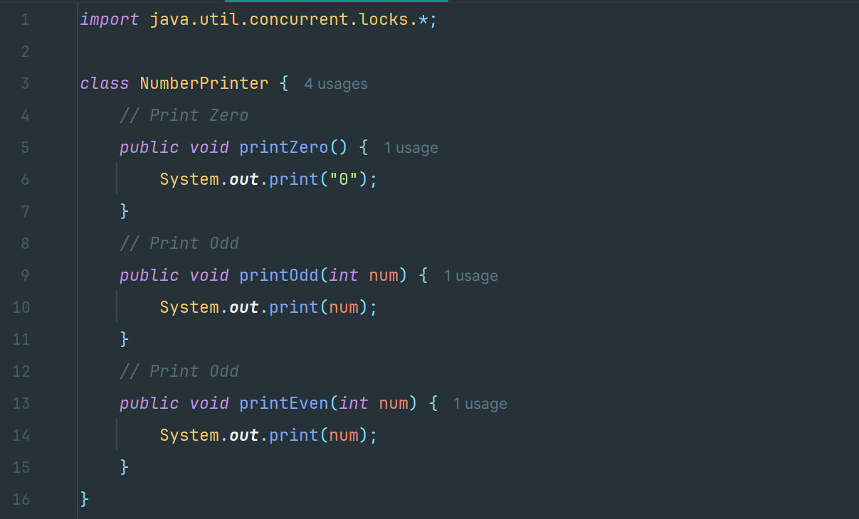

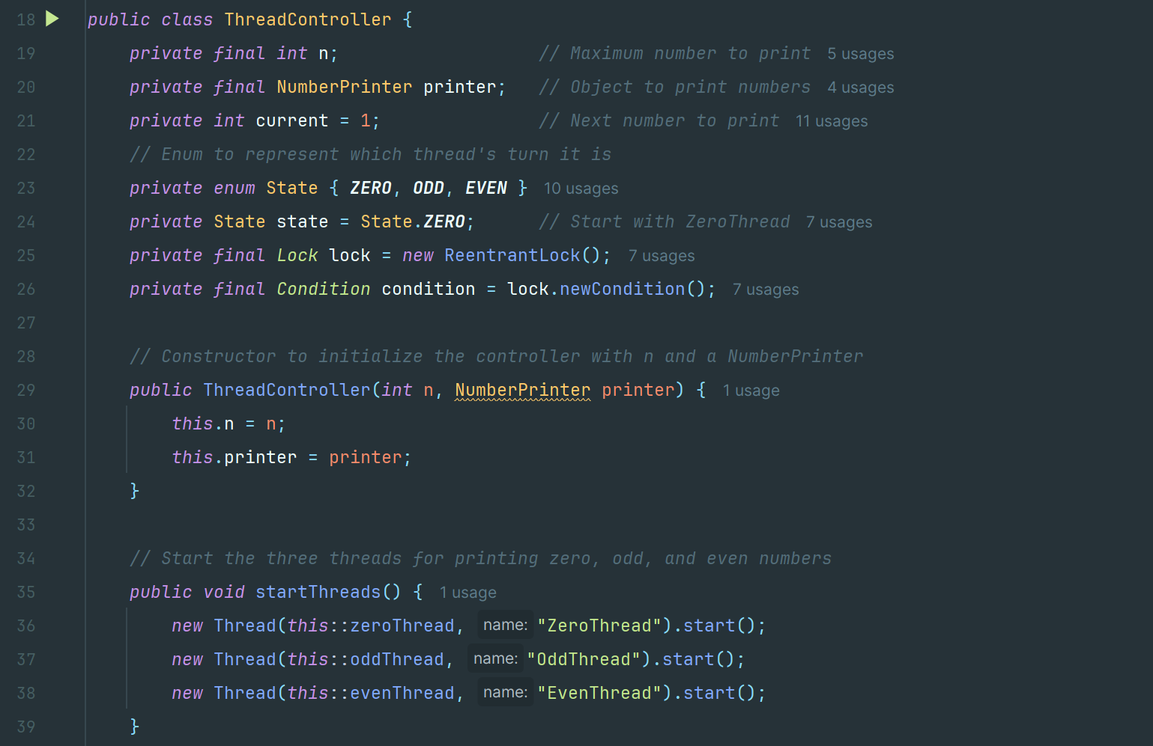

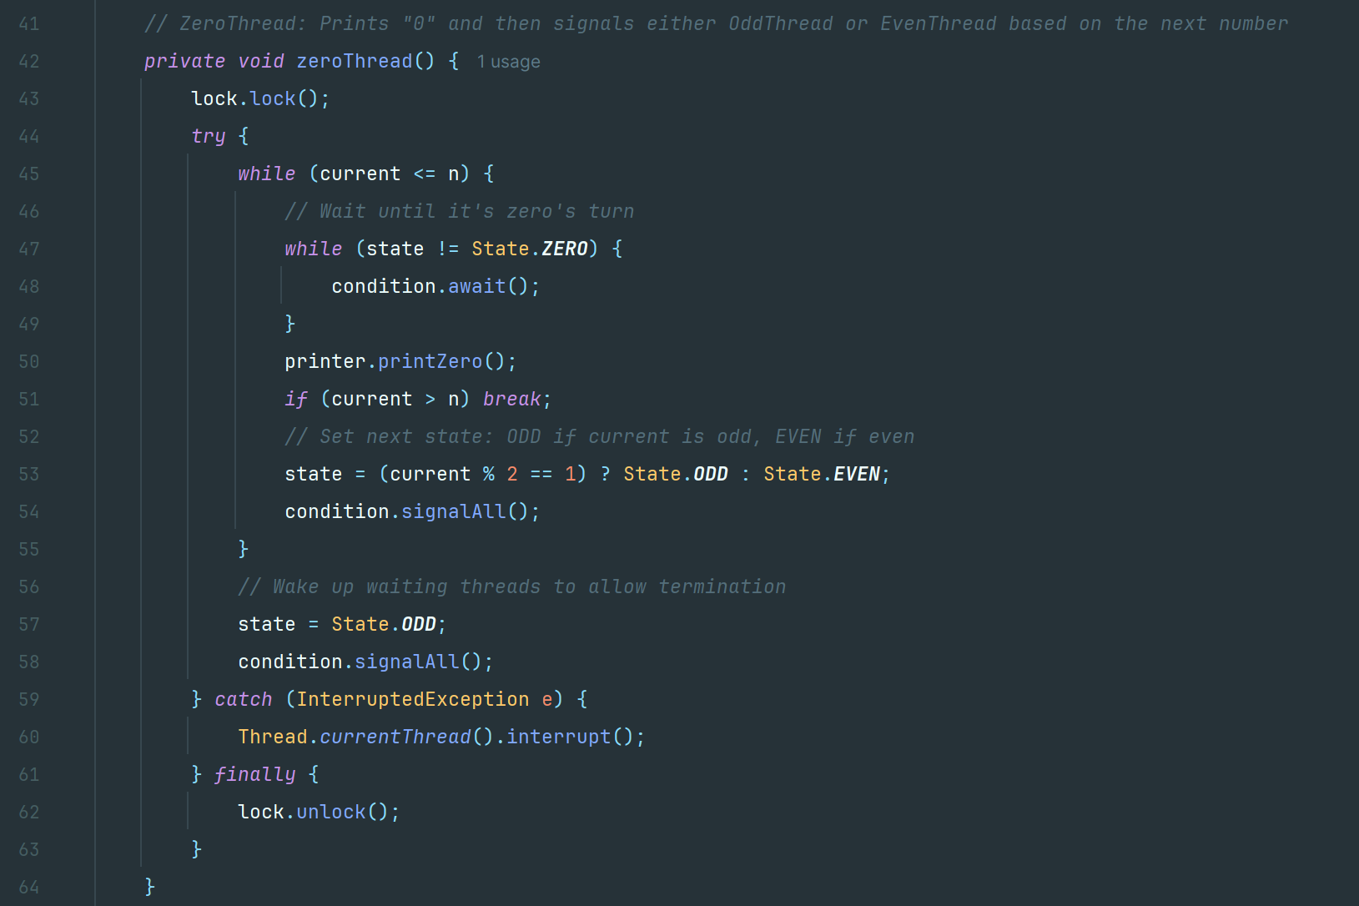

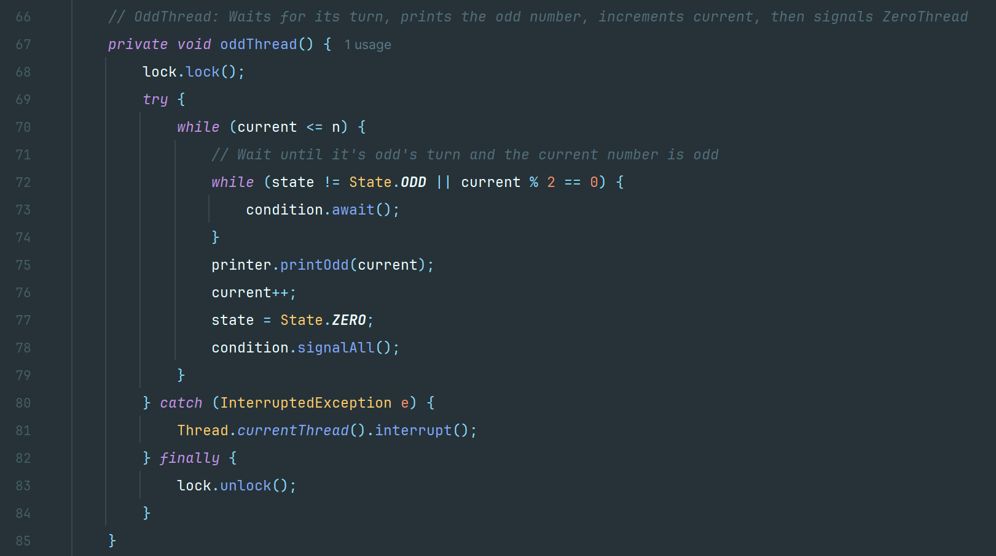

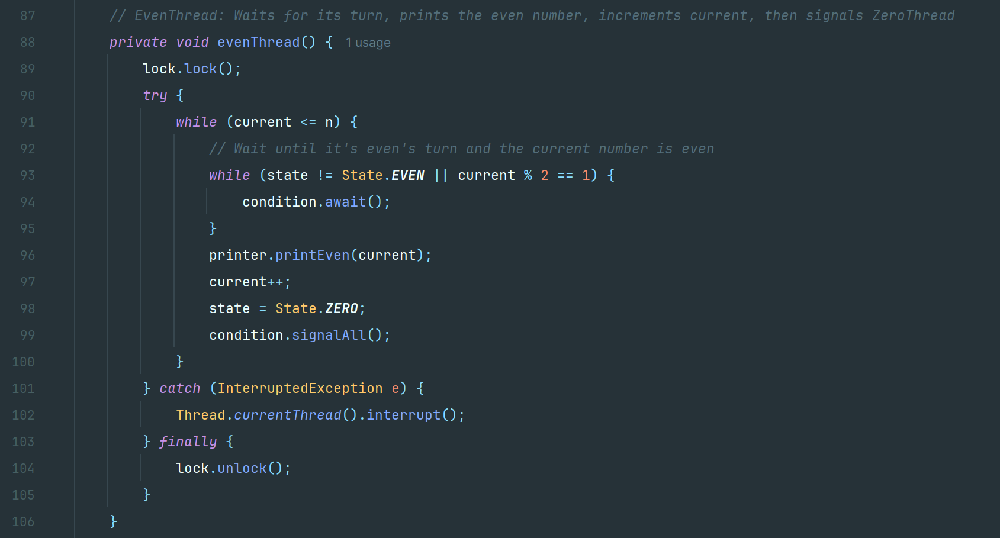

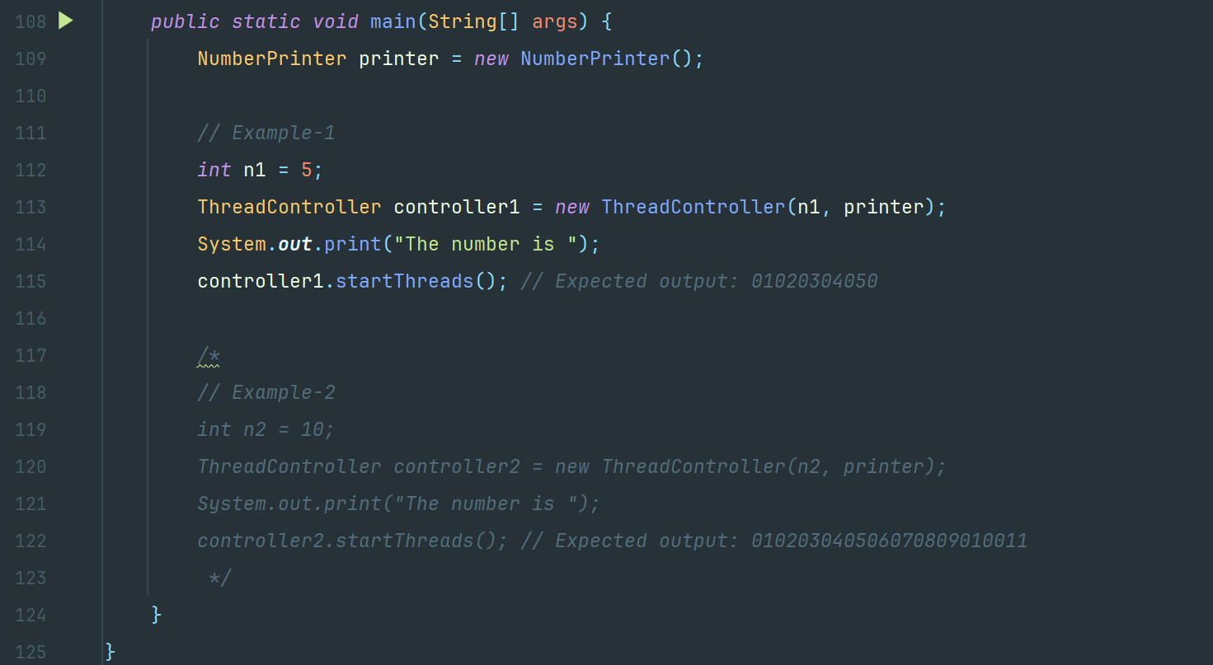

**Example-1**

Input: n = 5

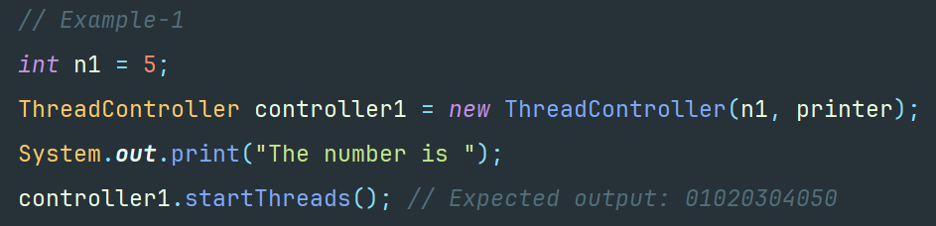

Output: 01020304050

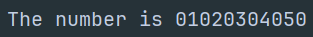

**Example-2**

Input: n = 10

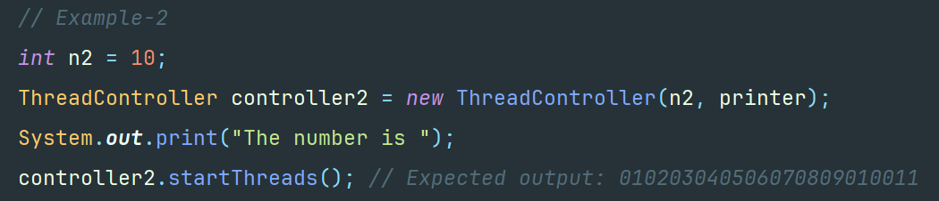

Output: 010203040506070809010011



**6. b) Ans:**

The main goal is to create a web crawler application that can crawl multiple web pages concurrently using multithreading to improve performance.

**Approach**

In this solution, we build a multithreaded web crawler that improves performance by processing multiple URLs concurrently.

The design comprises:

* Thread-Safe Data Structures:
* A **BlockingQueue** (in particular, a **LinkedBlockingQueue**) that contains URLs yet to be crawled.
* A **ConcurrentHashMap-based** set to keep tabs on URLs which have been visited (guaranteeing that each URL is processed once).
* A **ConcurrentMap** for holding crawled page content.
* Thread Pool (ExecutorService):
* A fixed thread pool (while its limit is configurable) submits and executes crawling tasks concurrently.
* Task Design:
* Each task peeks from the queue, attempts to download a specific page using Jsoup with retry logic, harvests hyperlinks off that page within a stream-based filter excluding unwanted ones, and adds new URLs to the queue.
* Crawl Delay Enforcement:
* The crawler shall initiate a delay per domain in being polite not to overload any given site.
* Error Handling:
* Each task retries unsuccessfully fetched URLs several times and handles exceptions so that a single failure doesn't disrupt the entire process.
* Result Printing:
* Pages retrieved are printed after the thread pool is done (with title and little text).

**Algorithm and Steps**

* Initialization:
* Set up a URL Queue: Seed URLs are put inside a thread-safe blocking queue.
* Visited Set and Data Map: Create a concurrent set to track visited URLs and a map to store the HTML content of each crawled URL.
* Thread Pool: Create a fixed thread pool (using ExecutorService) with a predefined number of threads.
* The Crawling Task (executed by each thread):
* Polls a URL from the queue repeatedly within 500 ms waiting time.
* If the URL has not been visited, mark it as a visited one and then proceed it:
* Crawl Delay: Introduce crawl delay for all domains to obey crawl policies.
* Fetch Web Page: Try to download the page using Jsoup. If the request fails, try a fixed number of attempts.
* Store Result: Save the content of the page in the crawled data map.
* Get More Active Links: Examine the page for links that satisfy certain criteria and place all unseen URLs in the URL queue.
* Termination:
* Once tasks are submitted to all threads, shut down the executor and wait for termination, with timeout.
* When finished (or timed out), print the results after parsing the saved HTML for each URL.
* Additional Handling:
* This **isCrawlAllowed ()** method is stubbed just to check the robots.txt of the site; in this case, it allows any crawls.
* The concurrent visited set ensures that the same URL is never processed twice.

**Time and Space Complexity**

1. Time Complexity:

* Each URL is processed by doing a fixed number of network operations (using as many as **MAX_RETRIES**), parsing the HTML and extracting the links. While this will depend on many factors, since we are measuring for the actual work in processing a URL, it's considered **O(1)** in computational complexity.
* If **n** URLs are finally processed, we have **O(n)** total work done in processing all the URLs, because each URL is processed exactly once. However, the running time may be reduced greatly through concurrency (if there are t threads, then the total work for coming up with the link list may approximately be **O(n/t)**, not accounting for overhead).

1. Space Complexity:

* Worst case, near all discovered URLs come from settings will give O(**n**) space, in which **n** is the number of unique URLs visited.
* Storing the content of each page will also take up a space of O(**n**).
* Indeed, the delays in domain access and temporary objects are also O(**n**) space.

Thus, space complexity is O(**n**).

**Code Implementation**

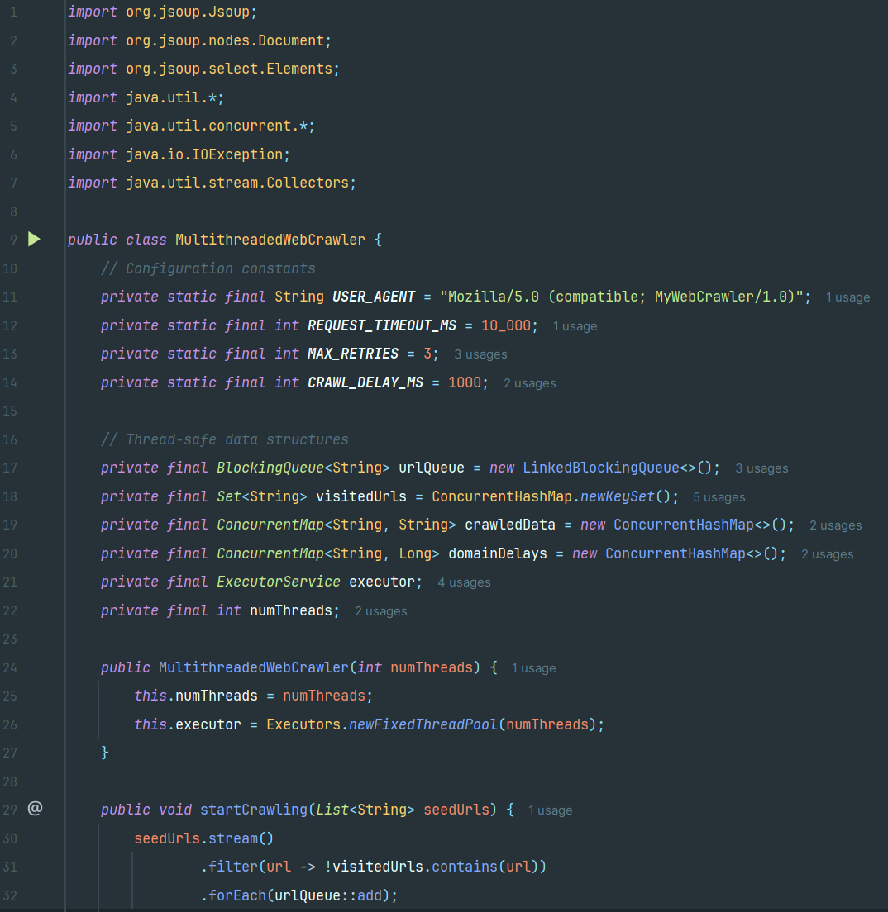

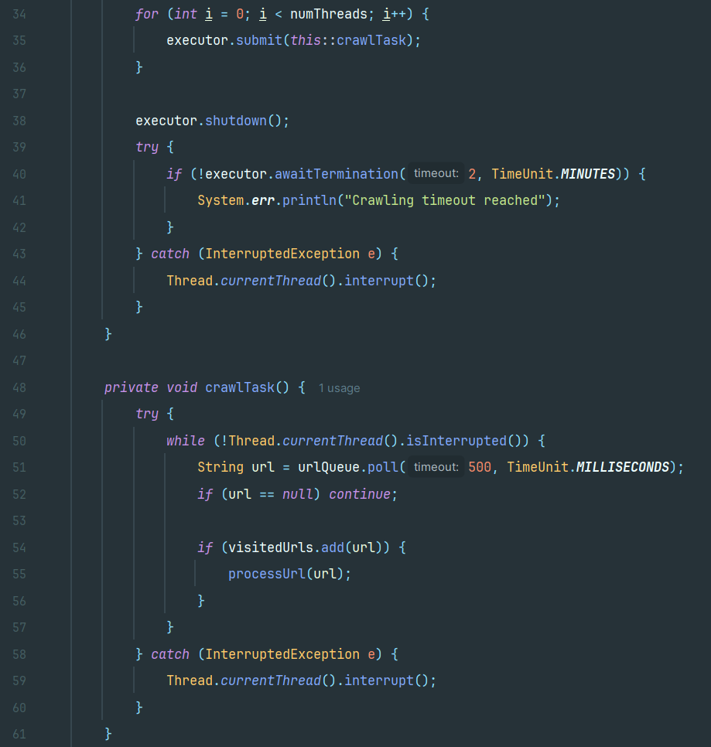

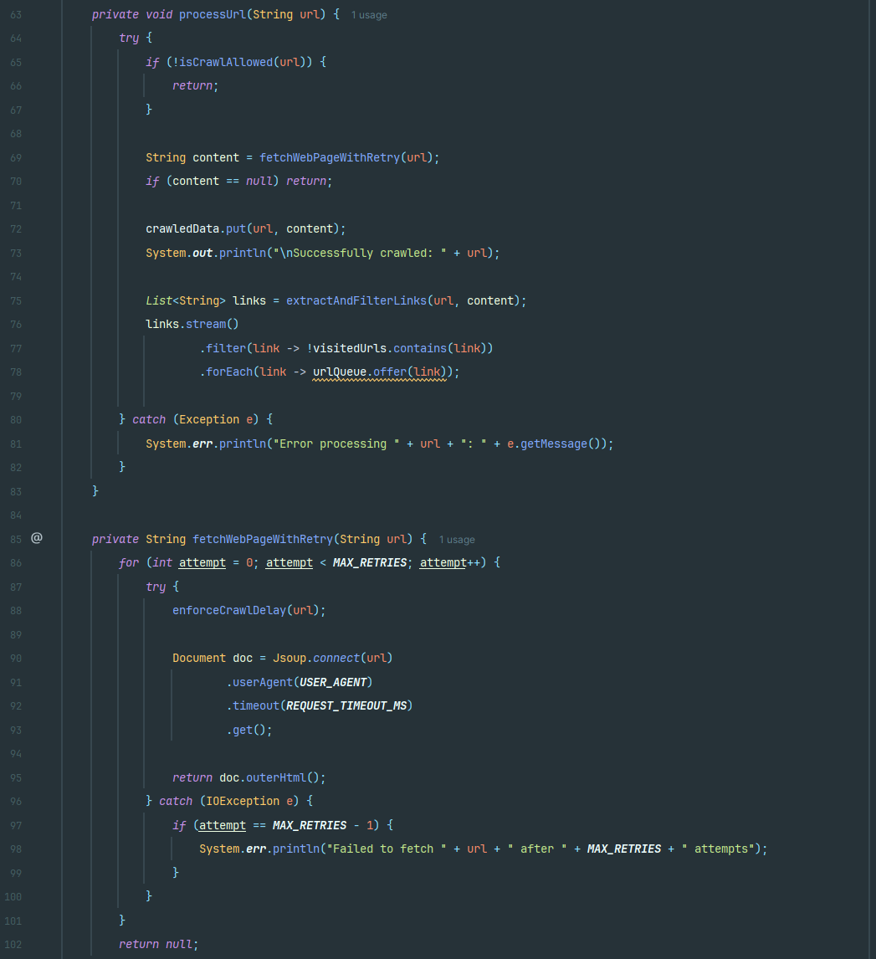

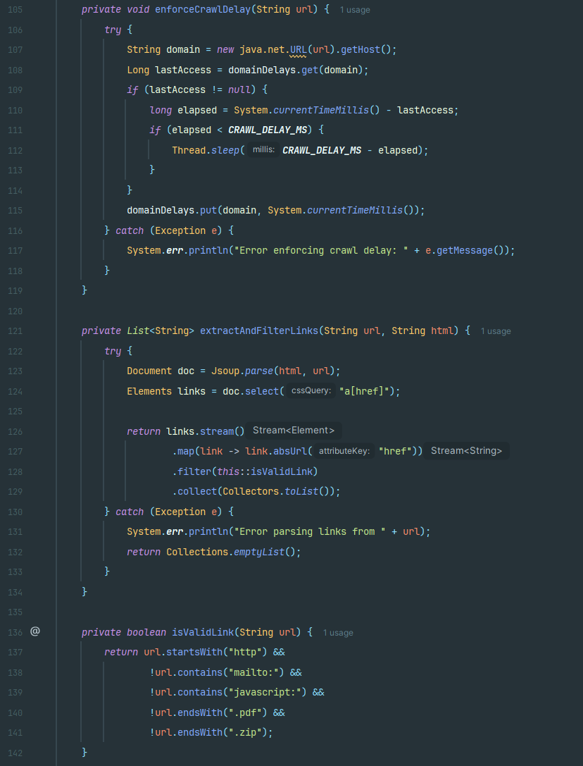

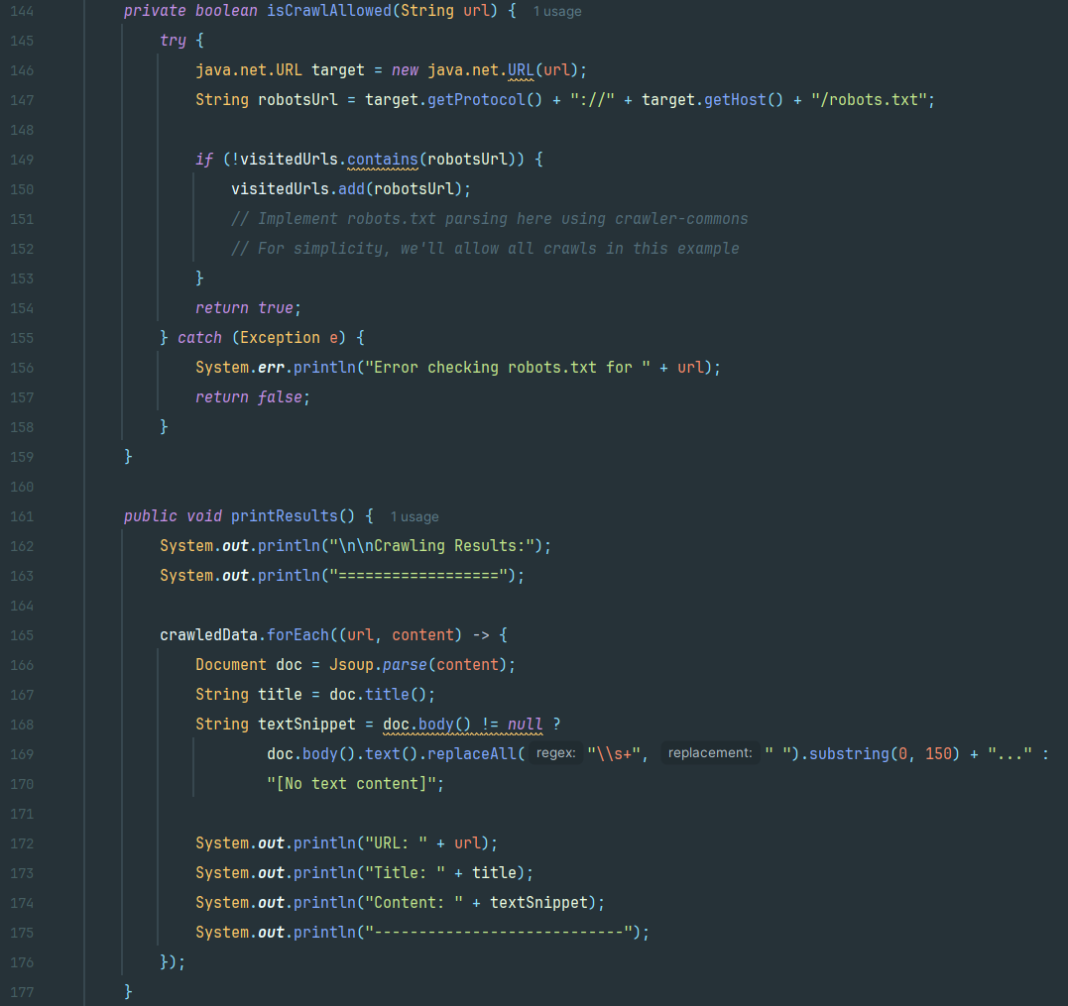

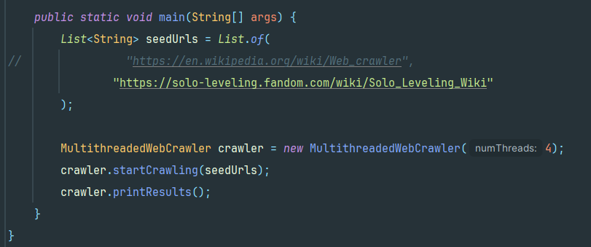

**Output**

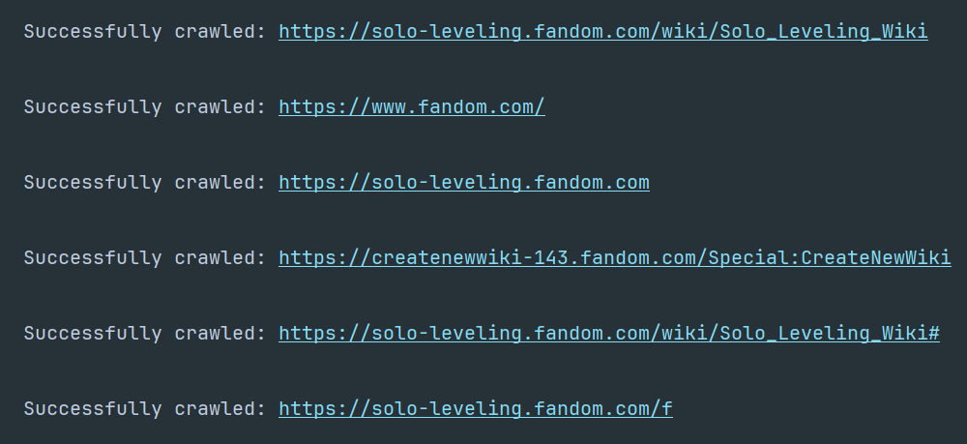

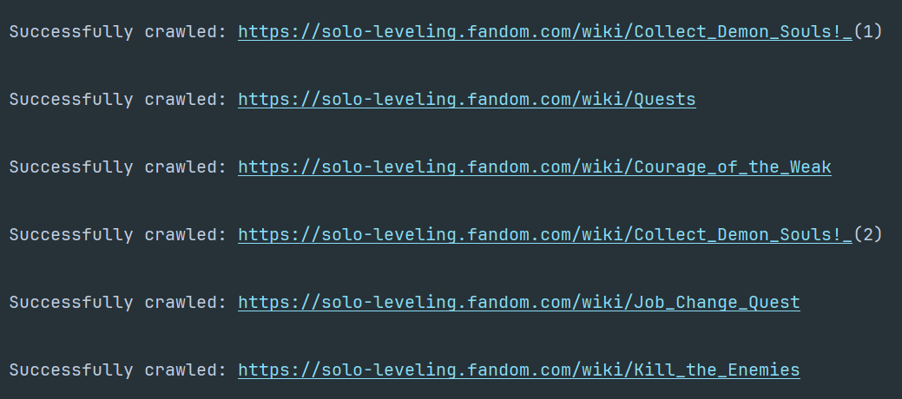

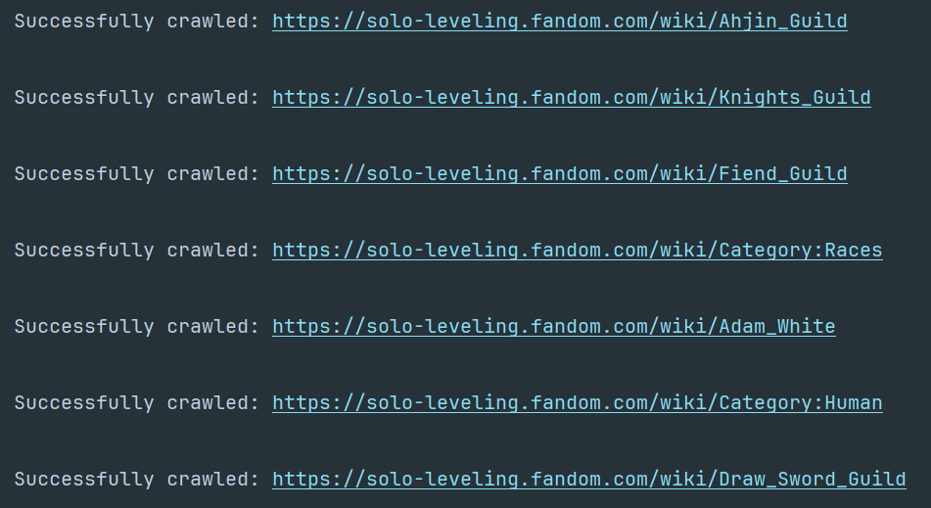

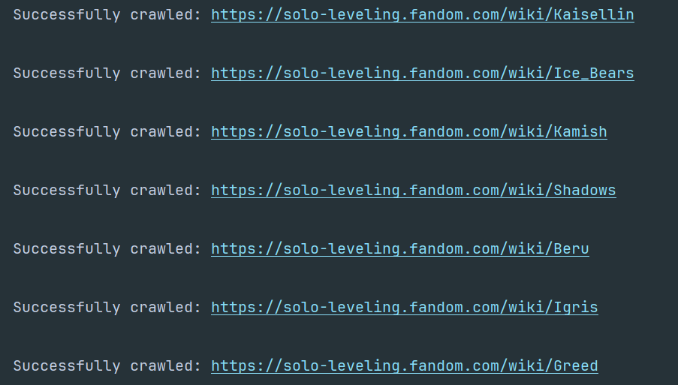

# Appendix

**GitHub Link:** - <https://github.com/SubhamAdhikari20/Programming-for-Developers-Coursework>